Netgate initial Setup

Lab Goal:
Initial Netgate configuration
Lab Requrenments:
- Netgate Security Appliance
- VMWare workstation Pro or Fusion
- Internet Connection
- Client PC



Contents
Netgate initial Setup 1
Contents 2
Task 1: Start you Rack Pods 3
Task 2: Connect your devices as per topology 3
Task 3: Configure your Network adapter 3
Step 1: Configure your IPv4 Network Adapter to be bridged. 3
Set Debain to obtain IPv4 via DHCP 4
Task 4 – Connecting to Web Interface of pfSense 4
Step 2: Connect to pfSense WebGUI 4
Step 3 – pfSense Configuration Wizard 5
Task 5 – Create a new user 13
Step 1: Create a new Administrator account. 13
Step 2: Disable Admin login. 19
Task 6 – Create a new Group 24
Step 1: Create DHCP Group 24
Step 2: Add correct permissions to group. 24
Task 6 – Create a new Group 27
Lab Challenge. 28

Task 1: Start you Rack Pods

Task 2: Connect your devices as per topology.

Task 3: Configure your Network adapter

Step 1: Configure your IPv4 Network Adapter to be bridged.

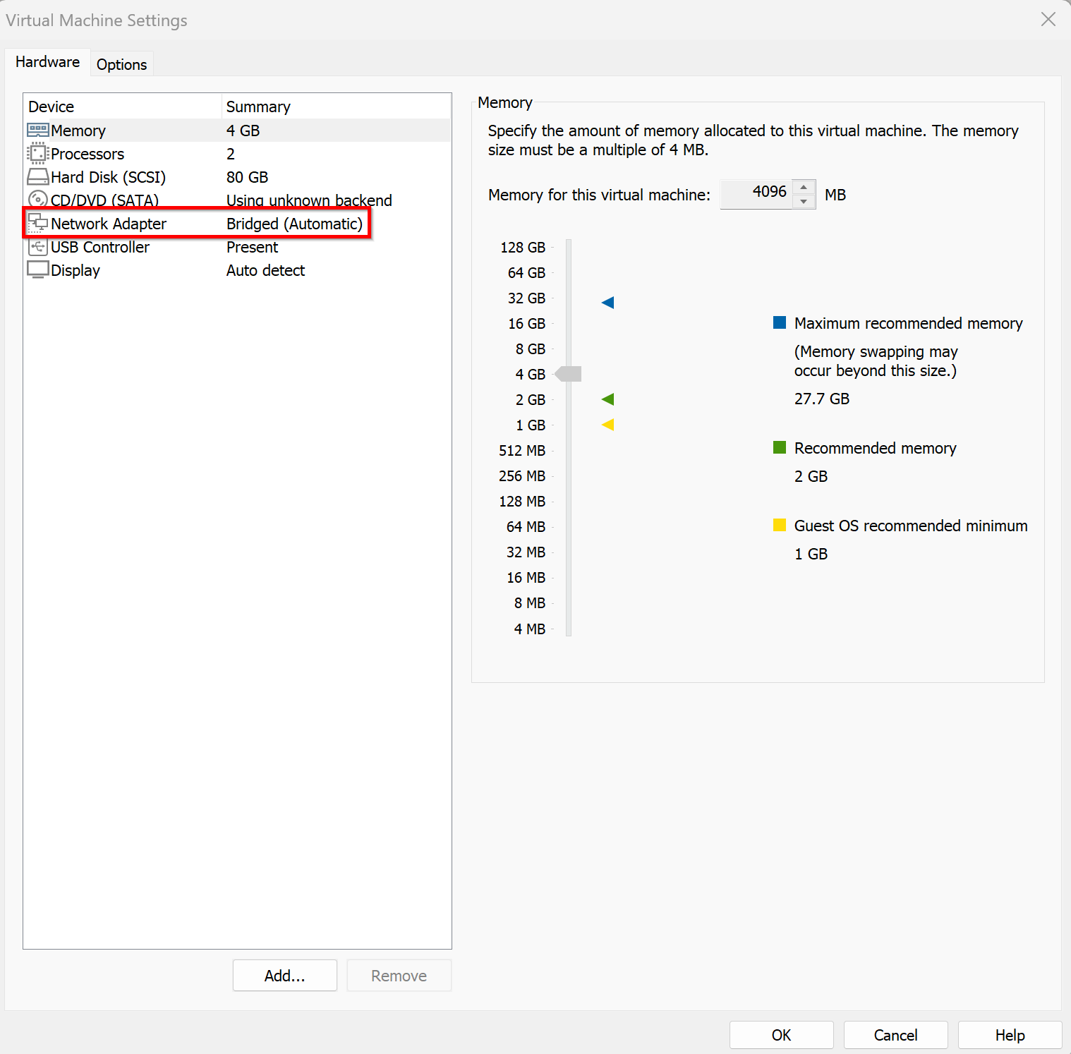

Set Debain to obtain IPv4 via DHCP
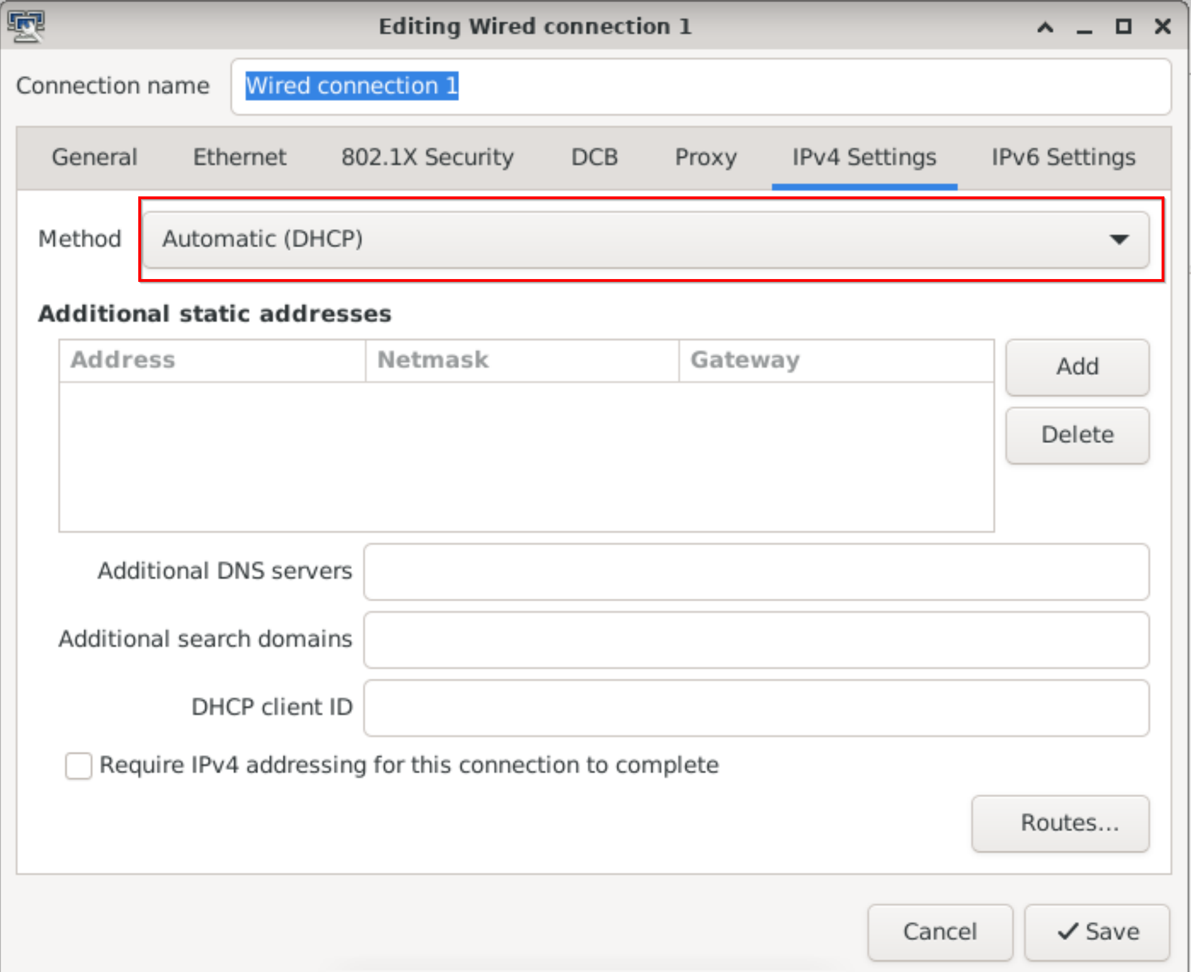

Task 4 – Connecting to Web Interface of pfSense
You’ll be using a Debian VM to access the pfSense’s WebGUI for further configurations.

Step 1: Start your Debian and connect it to LAN 1 Port of Netgate.

Step 2: Connect to pfSense WebGUI
The WebGUI for pfSense is accessed via entering the IP address of the LAN interface in your web browser.
Open your browser and navigate to:
https://192.168.1.1

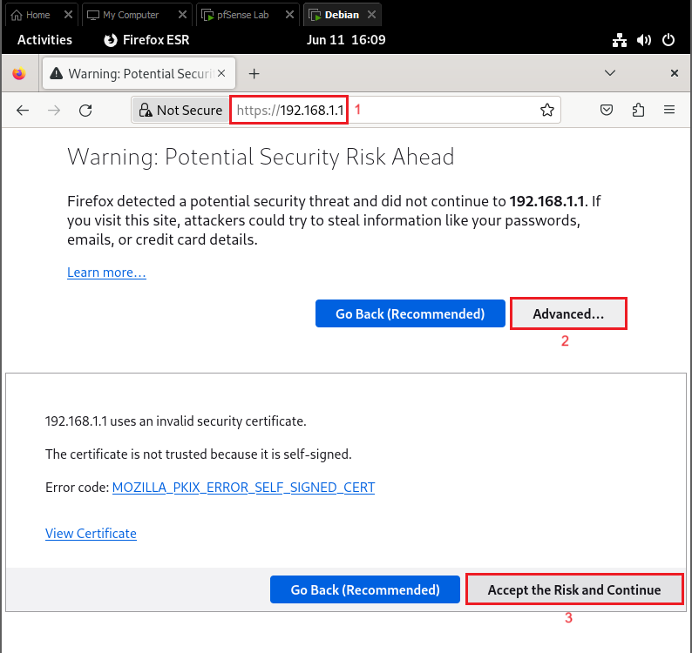
- The default login information for pfSense WebGUI is as follows:
Username: admin
Password: pfsense

Step 3 – pfSense Configuration Wizard
The first time you log into the WebGUI after installing pfSense, you will be greeted by the pfSense Setup Wizard. The Setup Wizard will guide you through the required first-time configuration.
- This is the welcome screen for the Setup Wizard. Click Next when ready to begin the configuration.
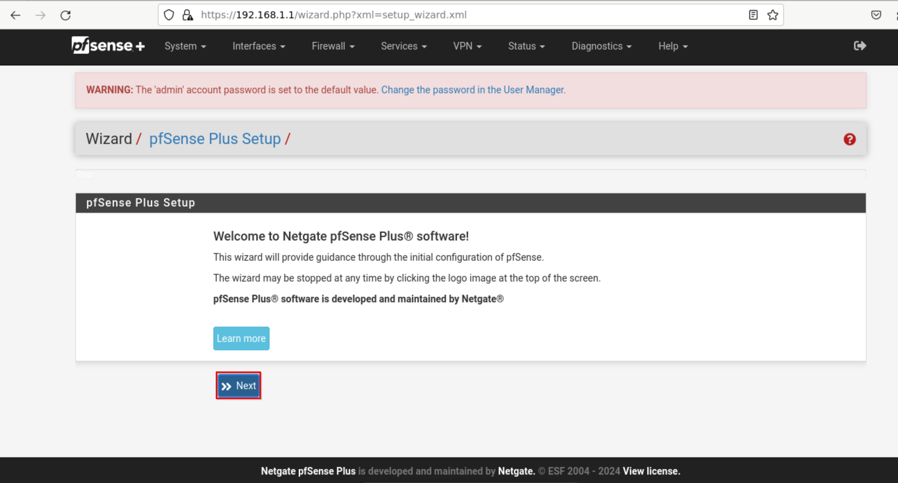
- Learn about Netgate support if needed.

- Set the General information for your pfSense instance as follows:
Hostname (1): GxPF – Example for Group 1 G1PF
Domain (2): cybertech.lan
Primary DNS (3): 8.8.8.8
Secondary DNS (4) 8.8.4.4
Click Next (5) to proceed.
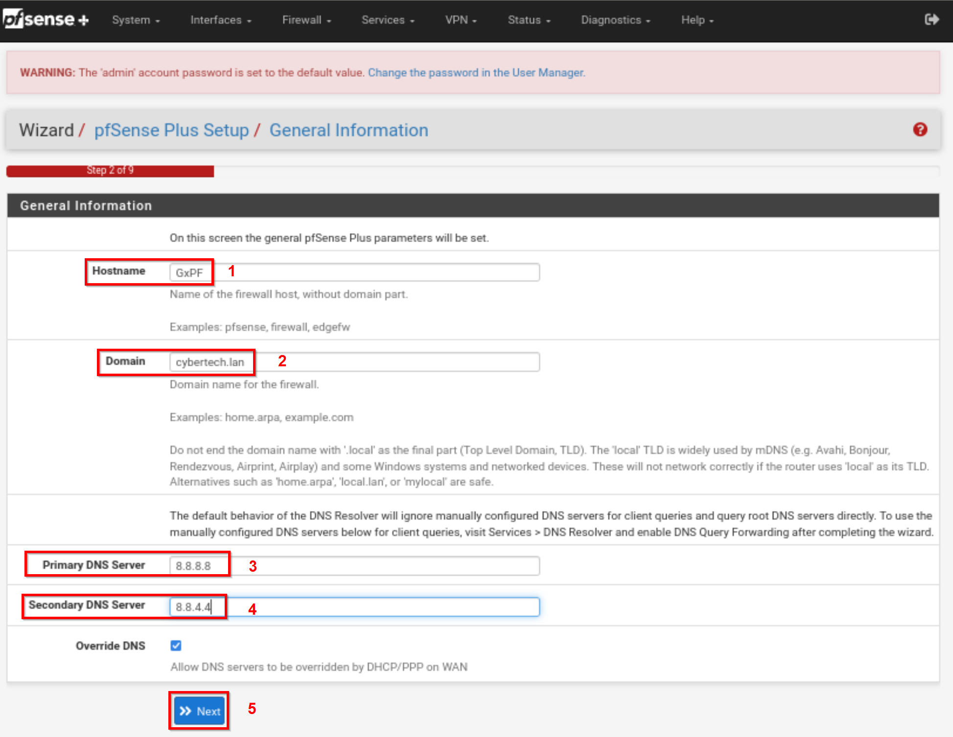
- The next page is Time Server Information
Select appropriate time zone and click next.
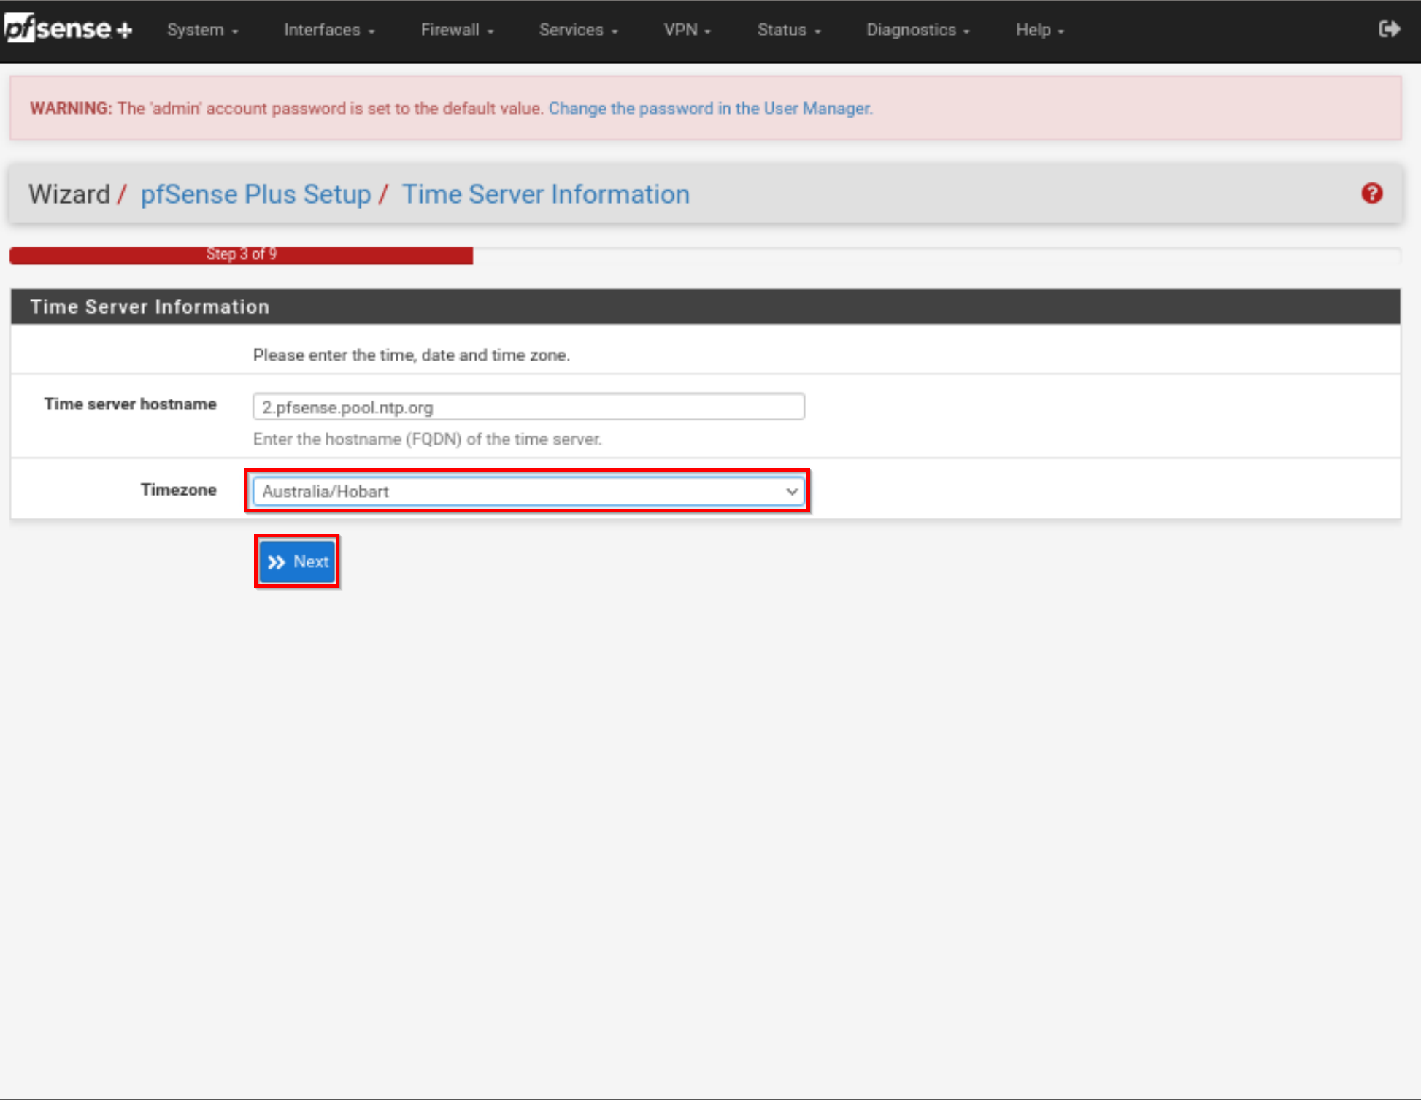
- The next page is the WAN Configuration. These settings can be left on their default. Click Next.
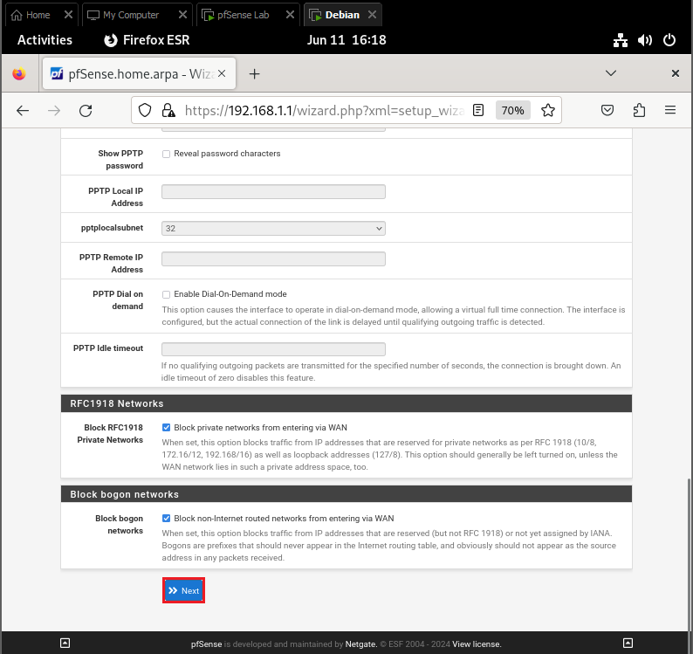
- Configure the LAN Interface with the following information relevant to your group:
LAN IP Address: Group network

Example: For Group 1 network should be 10.1.1.0

Refer to addressing scheme below:
 | Network ID
GROUP1 | 10.1.1.0/24
GROUP2 | 10.1.2.0/24
GROUP3 | 10.1.3.0/24
GROUP4 | 10.1.4.0/24
GROUP5 | 10.1.5.0/24
GROUP6 | 10.1.6.0/24

POD A

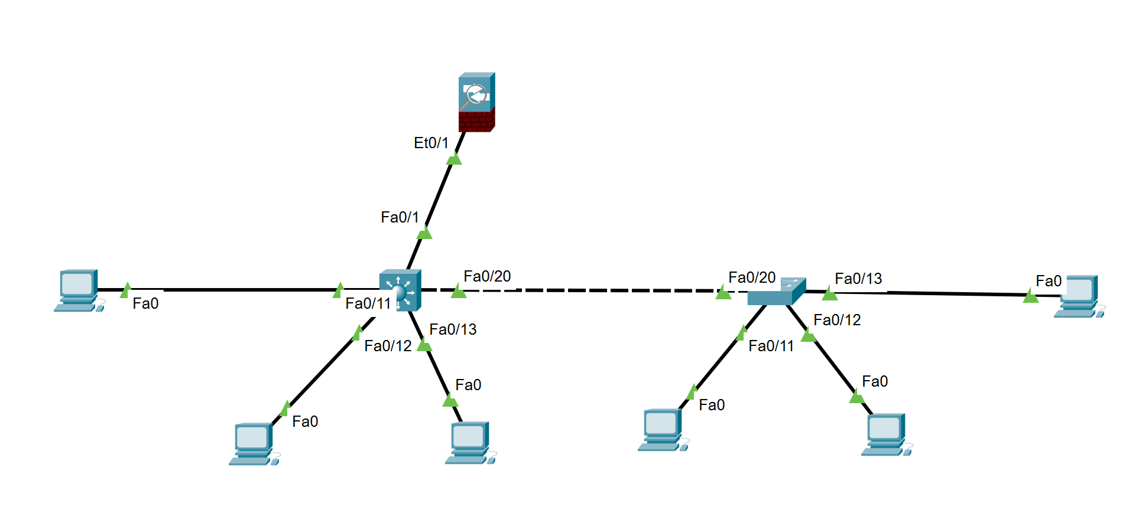

POD B

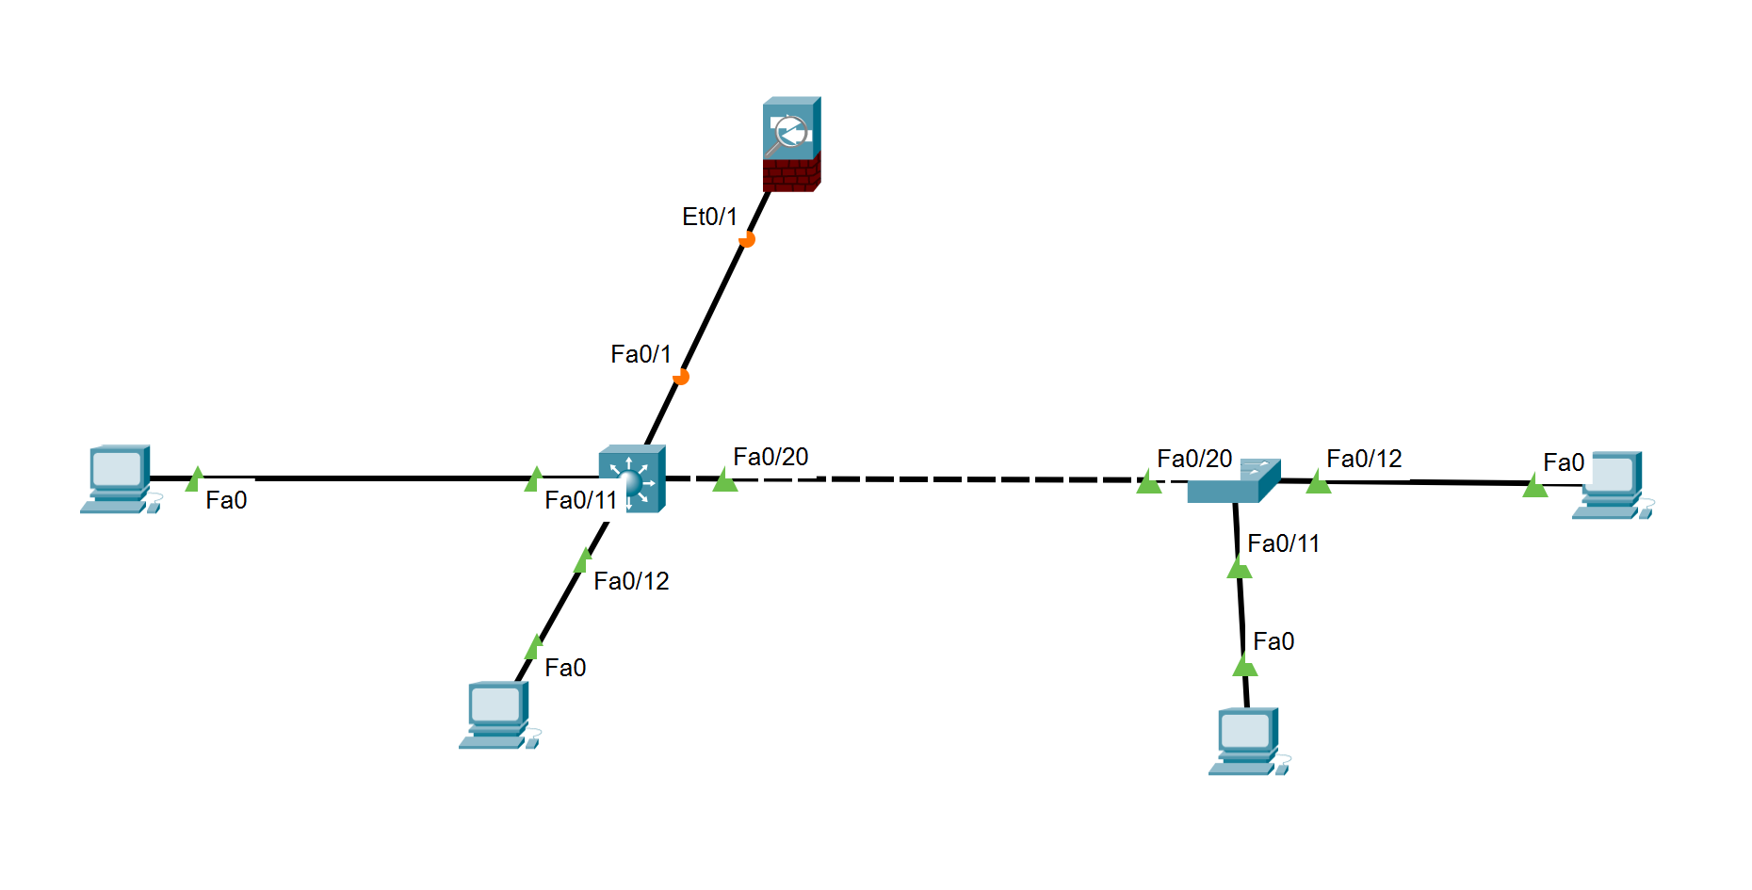

Subnet Mask: 24
Click Next.

- Set a new password for the WebGUI. Change the password to:
student
Click Next.
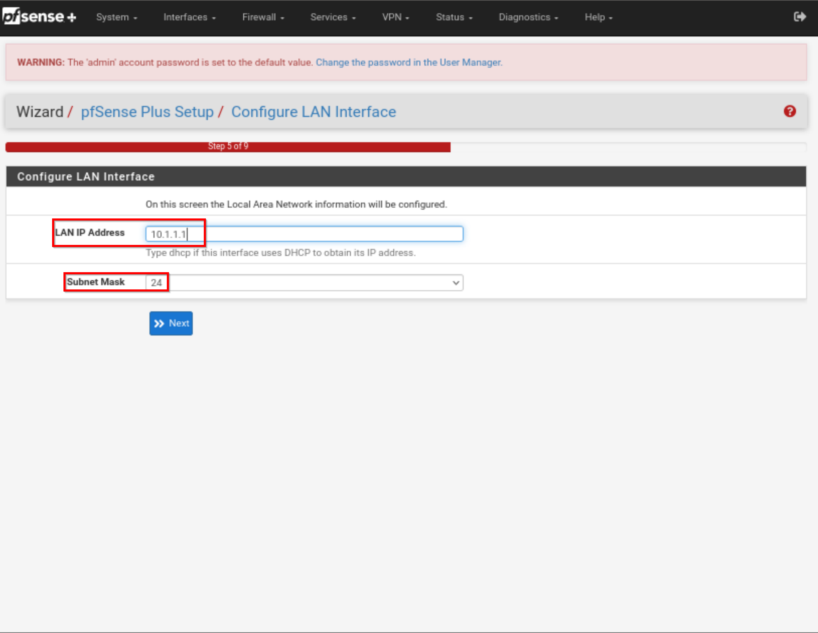

- Set Admin WebGUI password.
Password: student
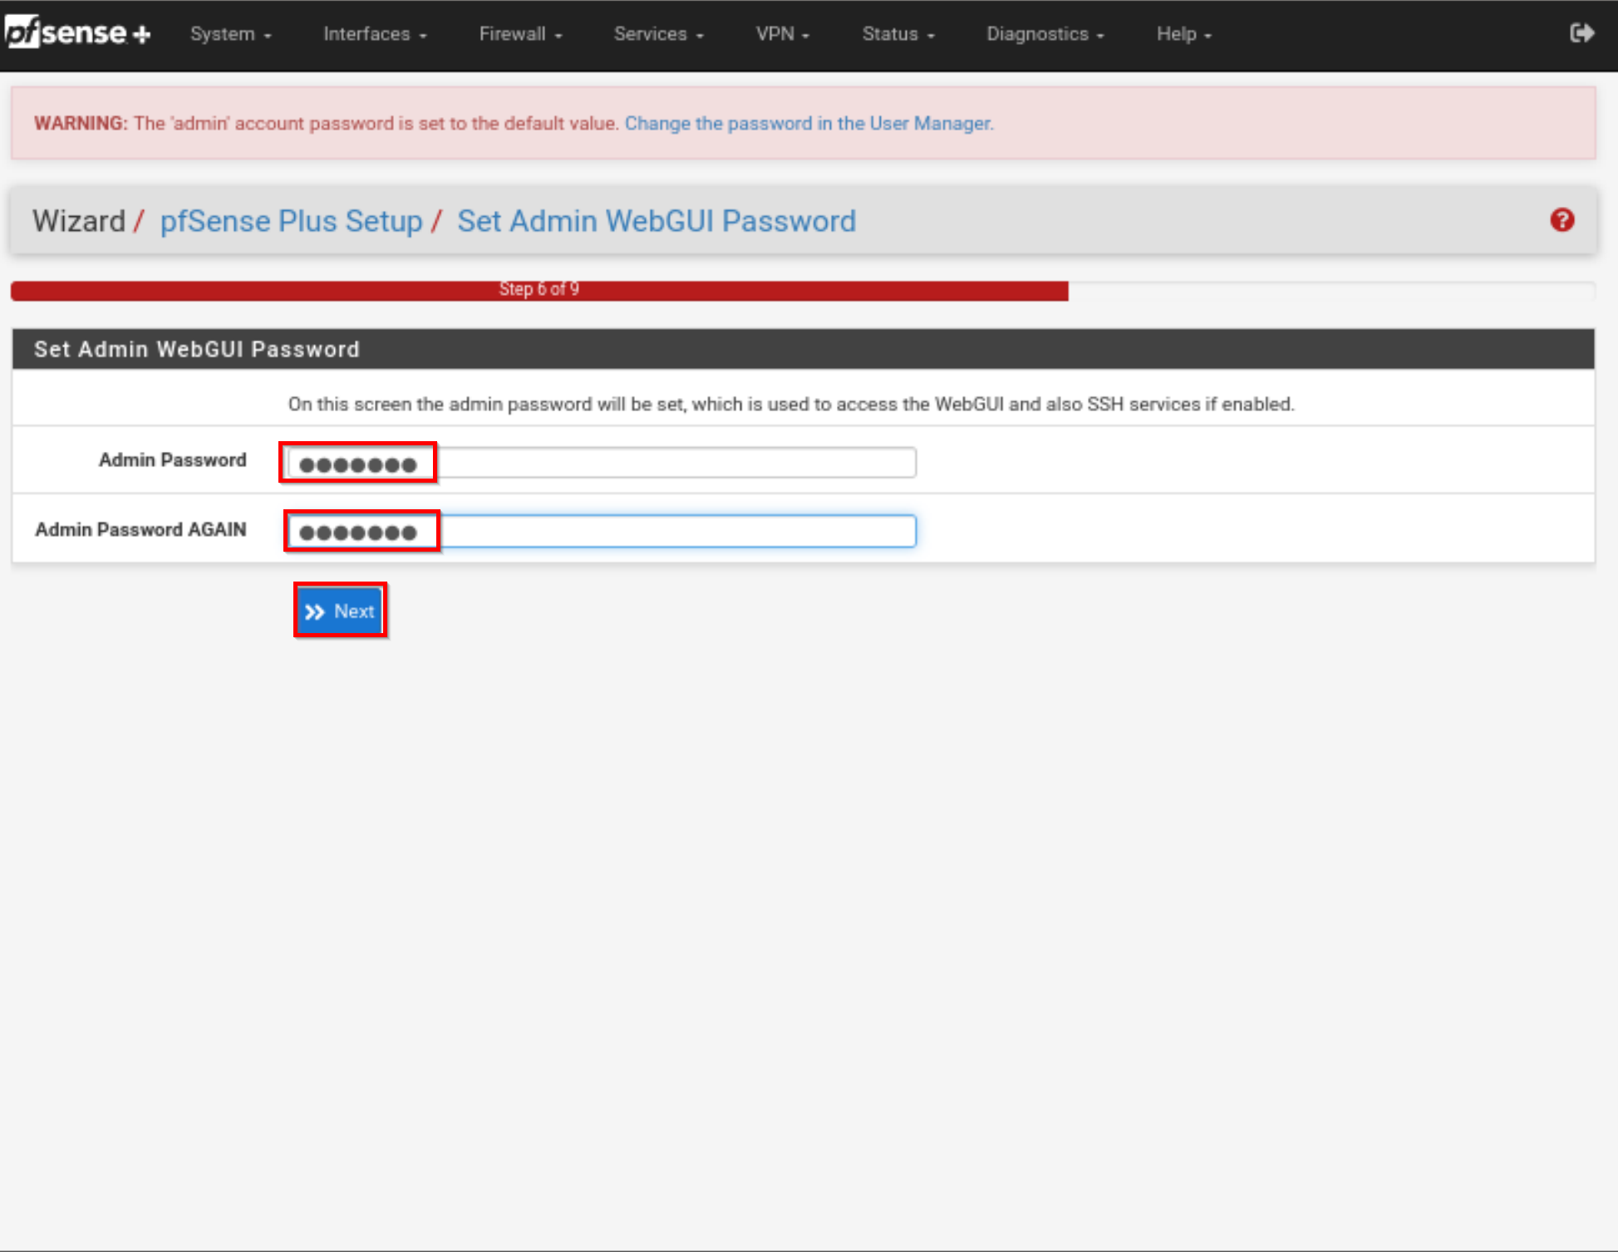
- To apply these settings, the WebGUI needs to be reloaded. Click Reload.
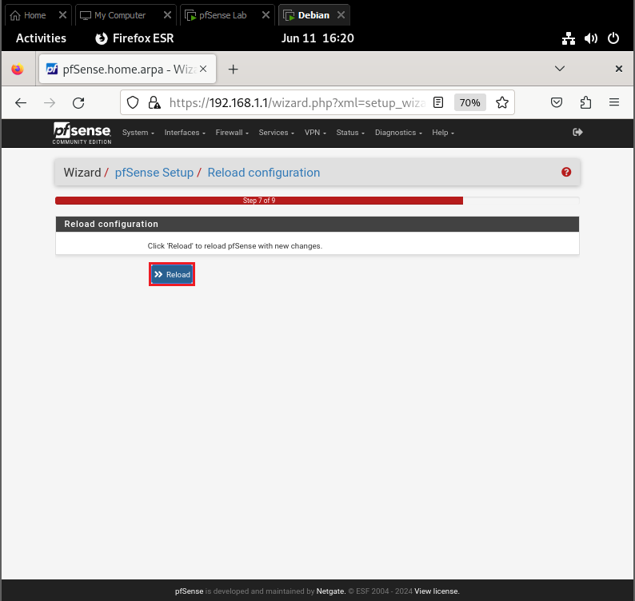
- Next thing we need to do is to release and renew our IPv4 address on Debian as we have changed our DHCP scope and be sure that we have new IP address

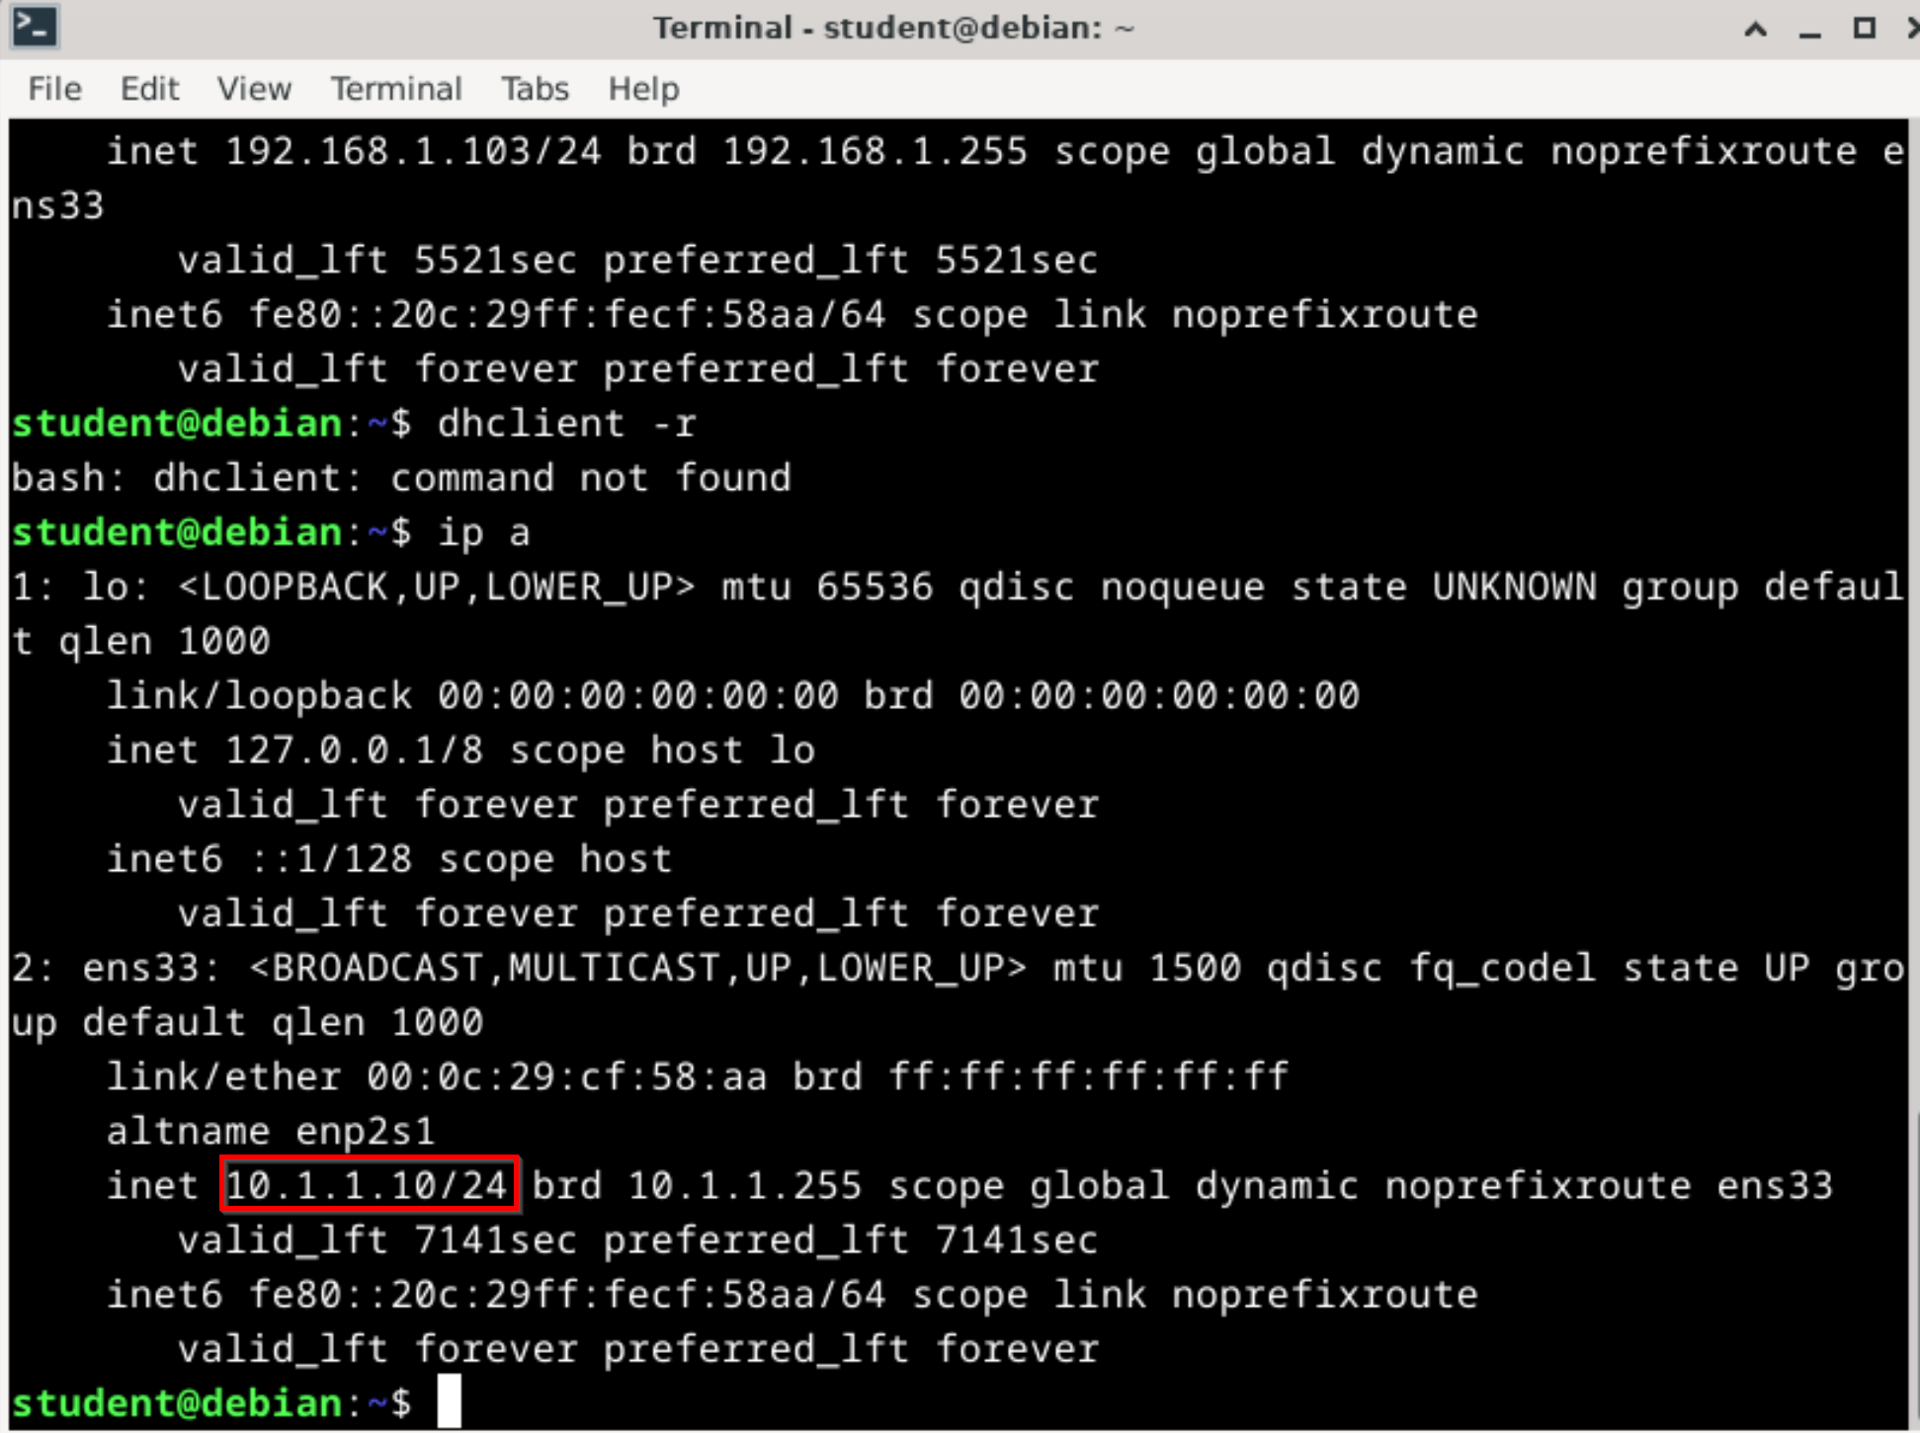
- Let’s connect to our pfSense running on new IP.
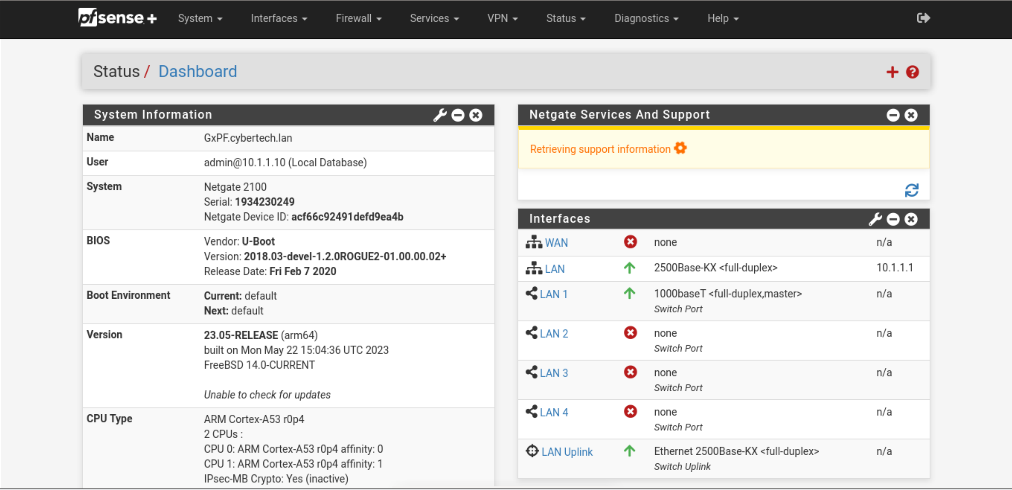

Task 5 – Create a new user
It is recommended to create a new Administrator account and disable the built-in Admin account.

Step 1: Create a new Administrator account.
- Open User Management by opening the System tab and clicking User Management.
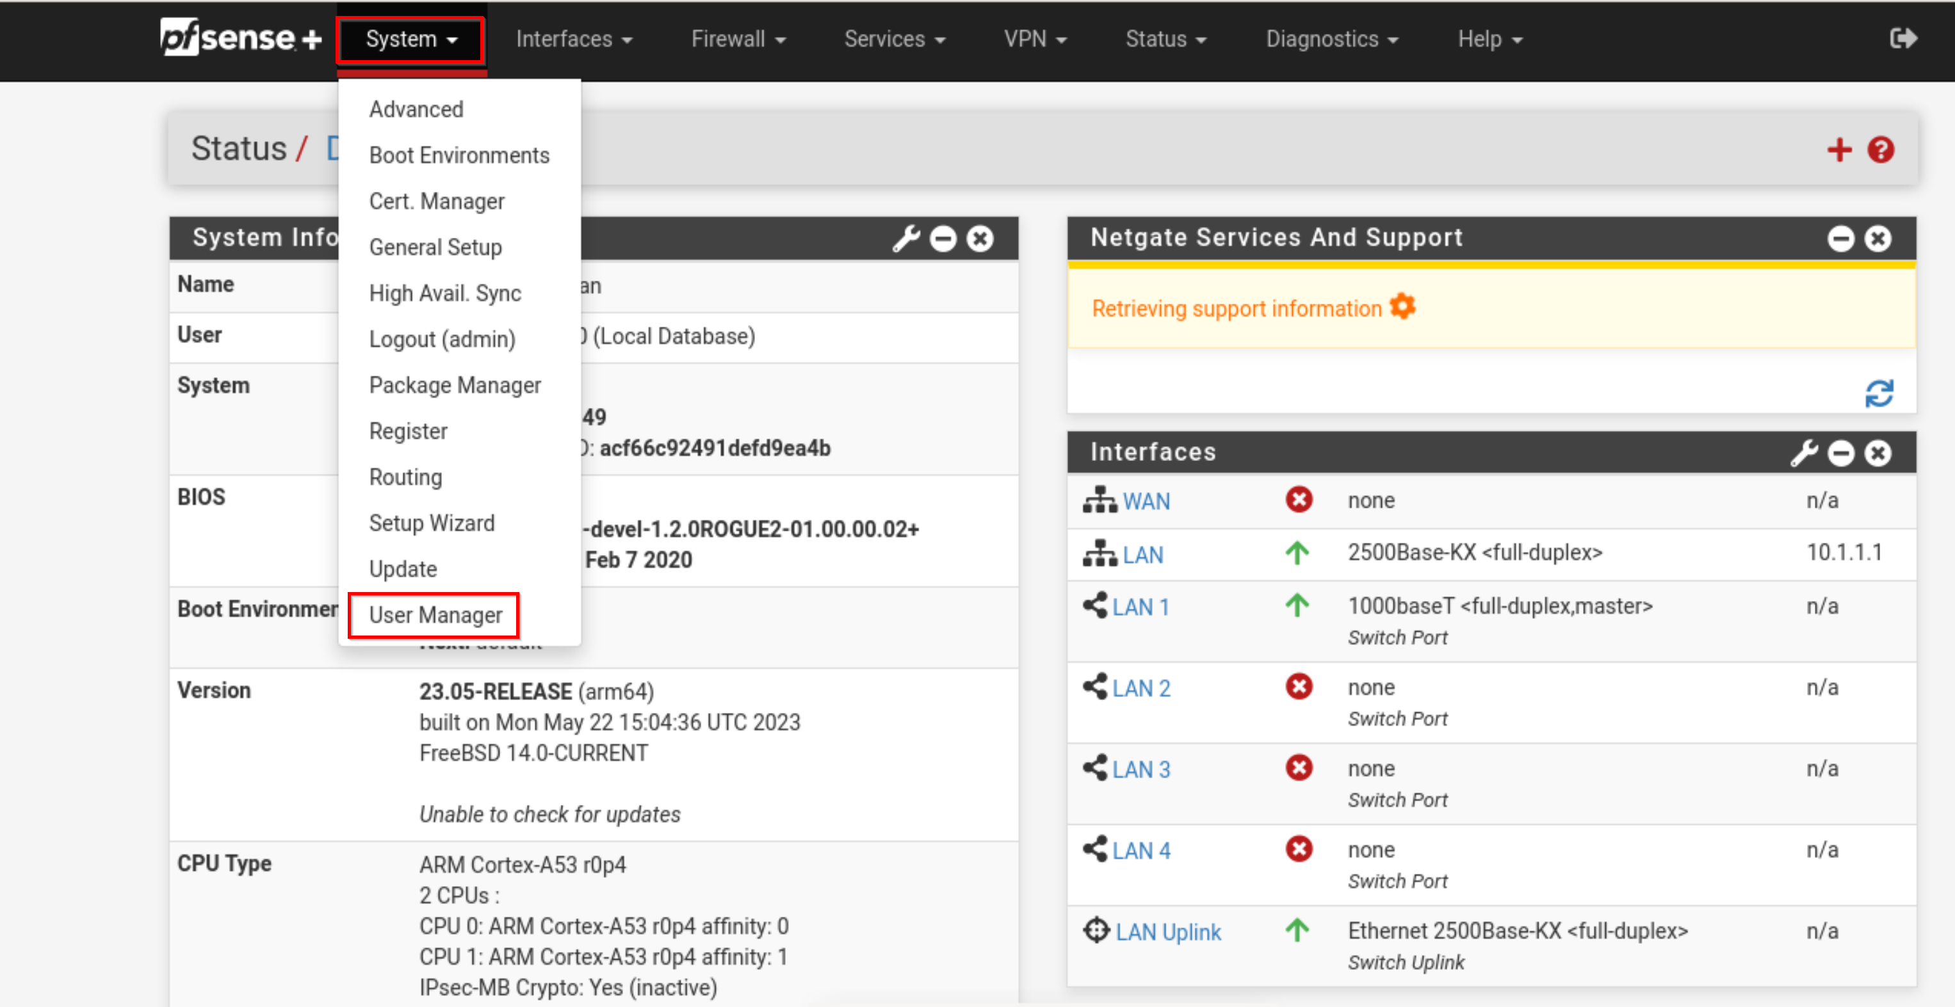
- To adda new user, click Add.
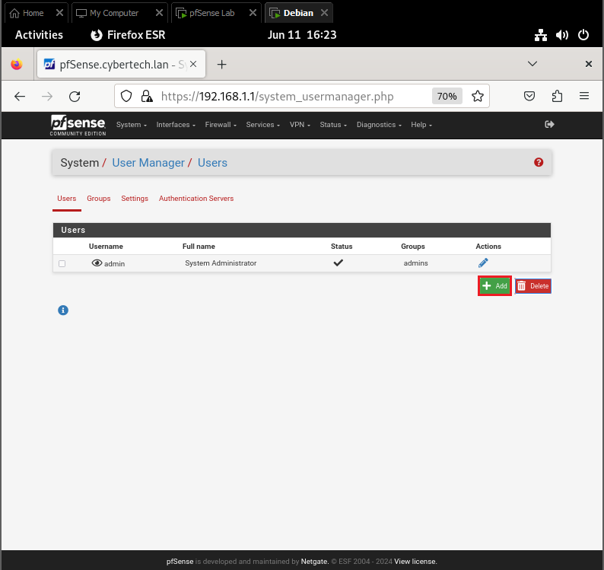
- Set Username and Password as follows:
Username: student
Password: student
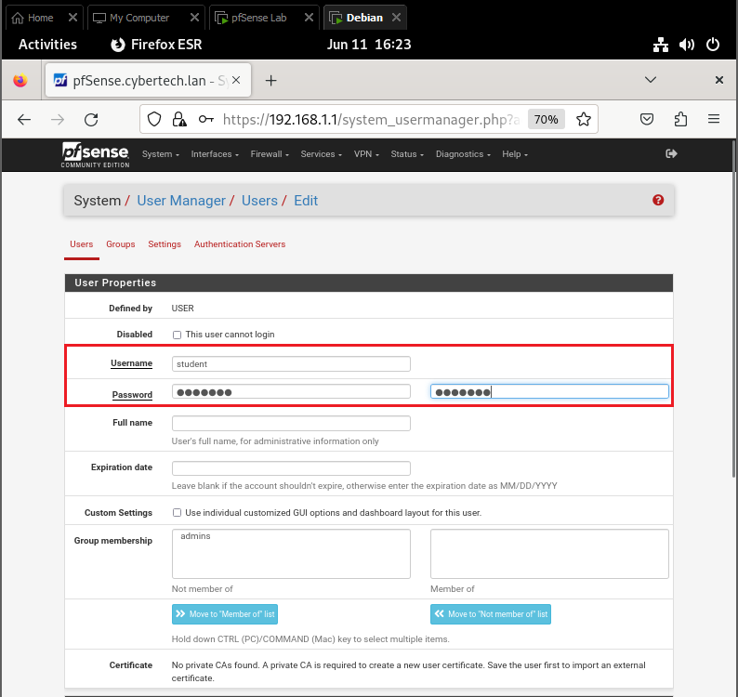
- Add the new user to the admins group. Under Group membership, select the admins group (1), and click Move to members of list (2).
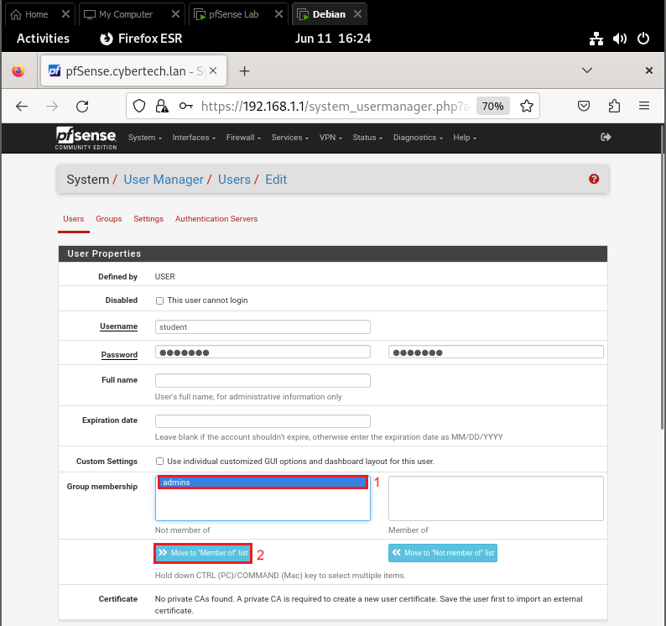
- Admins will have been added to the “Member of” column as seen below:
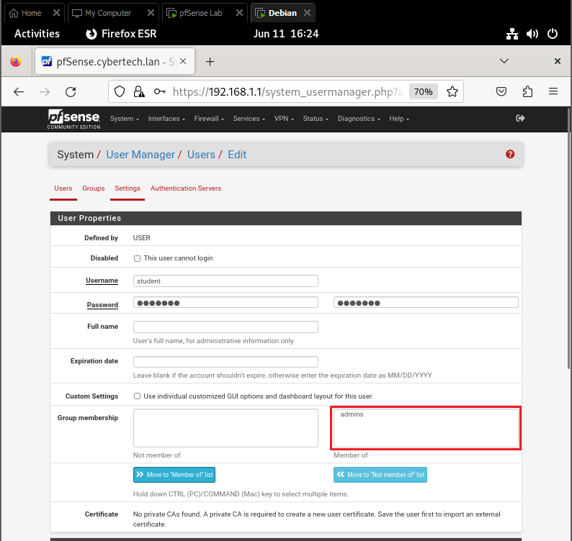
- Save the new user by clicking Save on the bottom of the page.
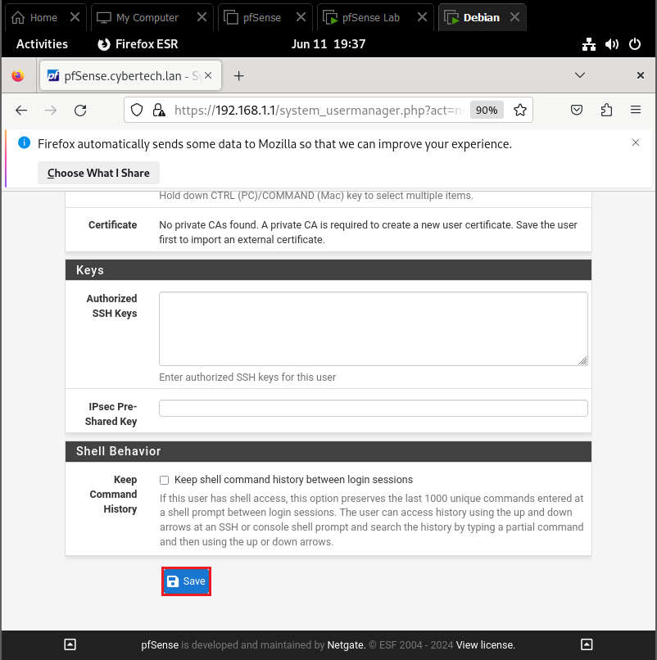
- You should be returned to the Users page, and should see the newly created account, as below:
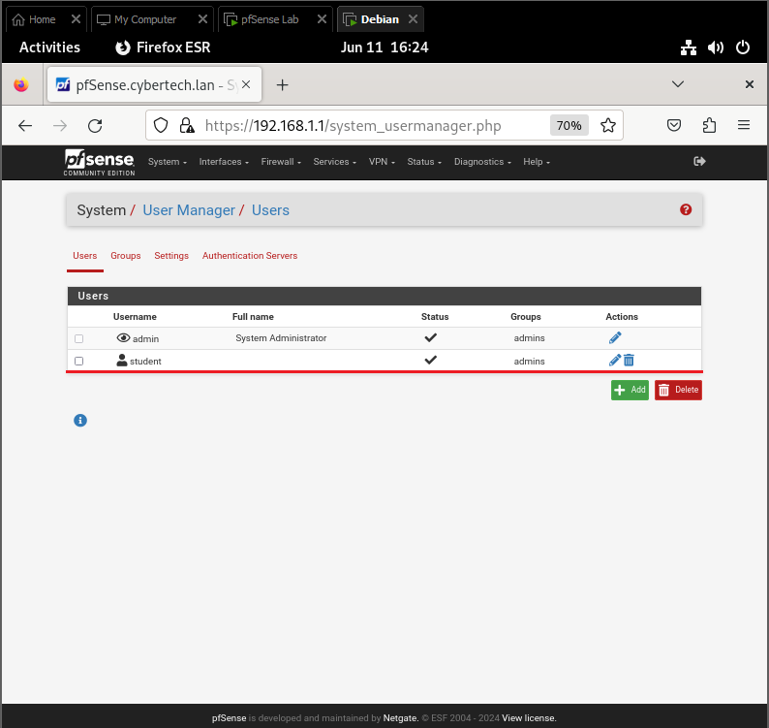

Step 2: Disable Admin login.
Now that there is a new admin account, disable the default admin account.
- Edit the admin account by clicking the pencil.
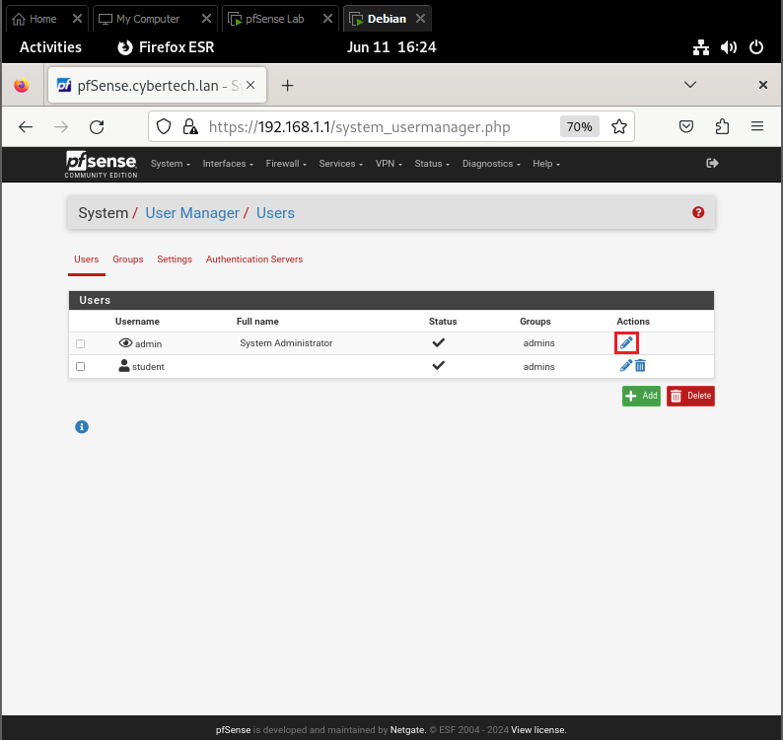
- Select the checkbox to disable login
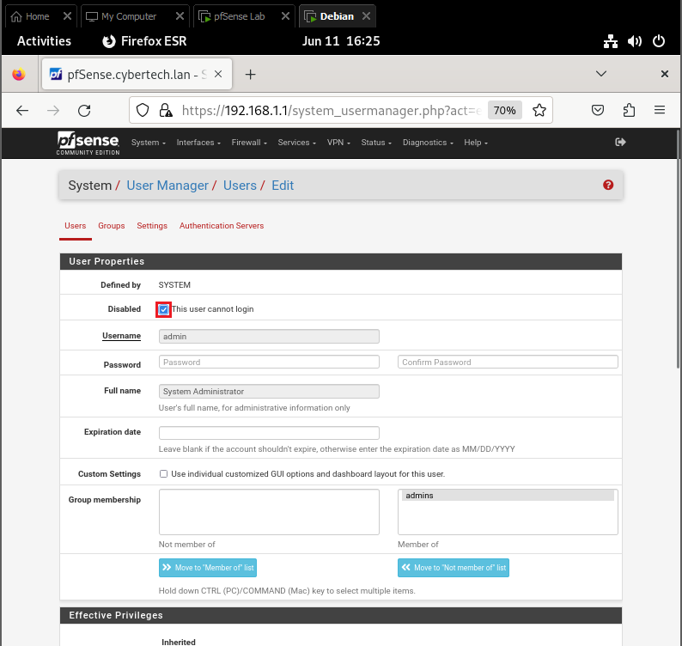
- Save changes.
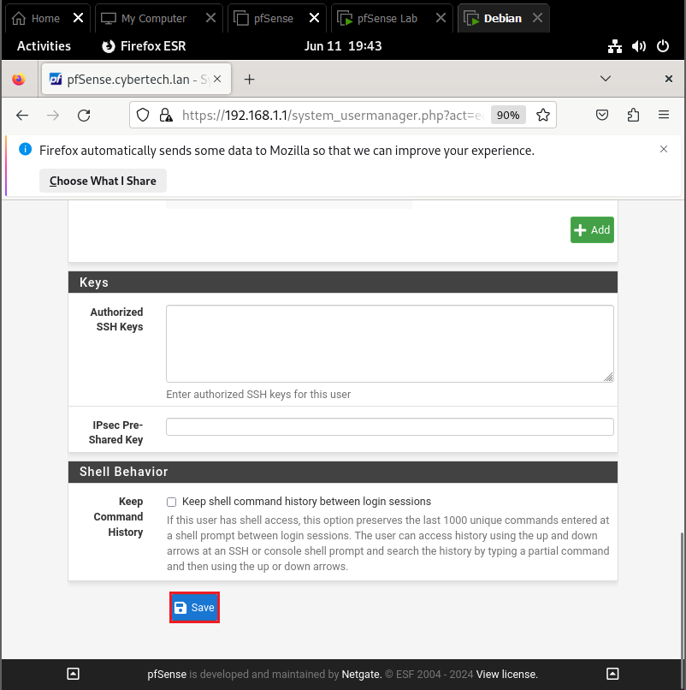
- You should be returned to the Users page again. That status of the default account will have changed, as seen below:
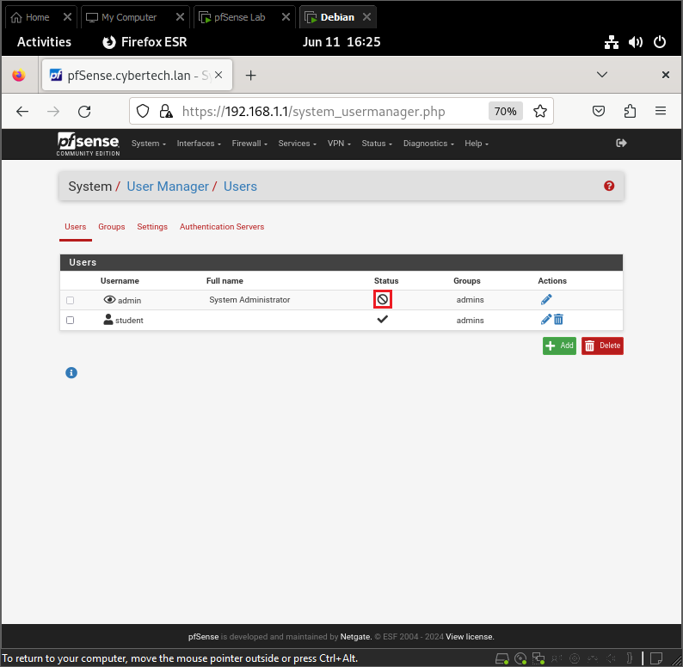
- Let’s create new junior admin account.
Username: jradmin
Password: student
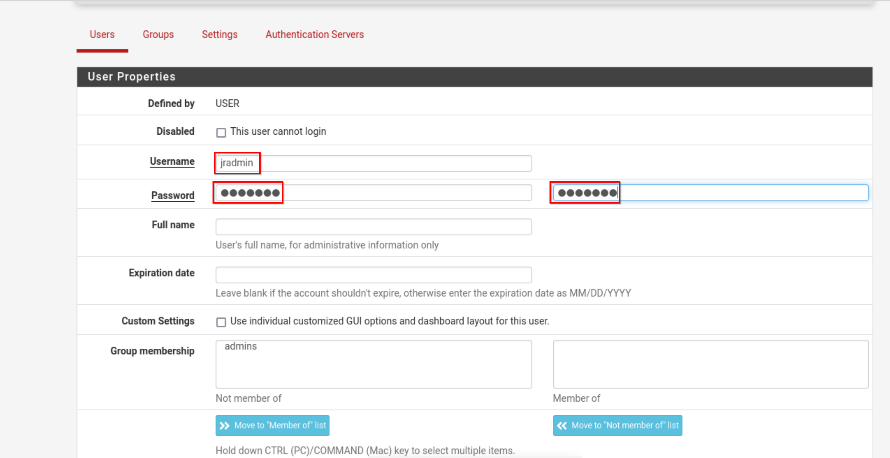

Task 6 – Create a new Group

Step 1: Create DHCP Group

In this Task we will create new group called DHCP admin Group and assign jradmin to it.
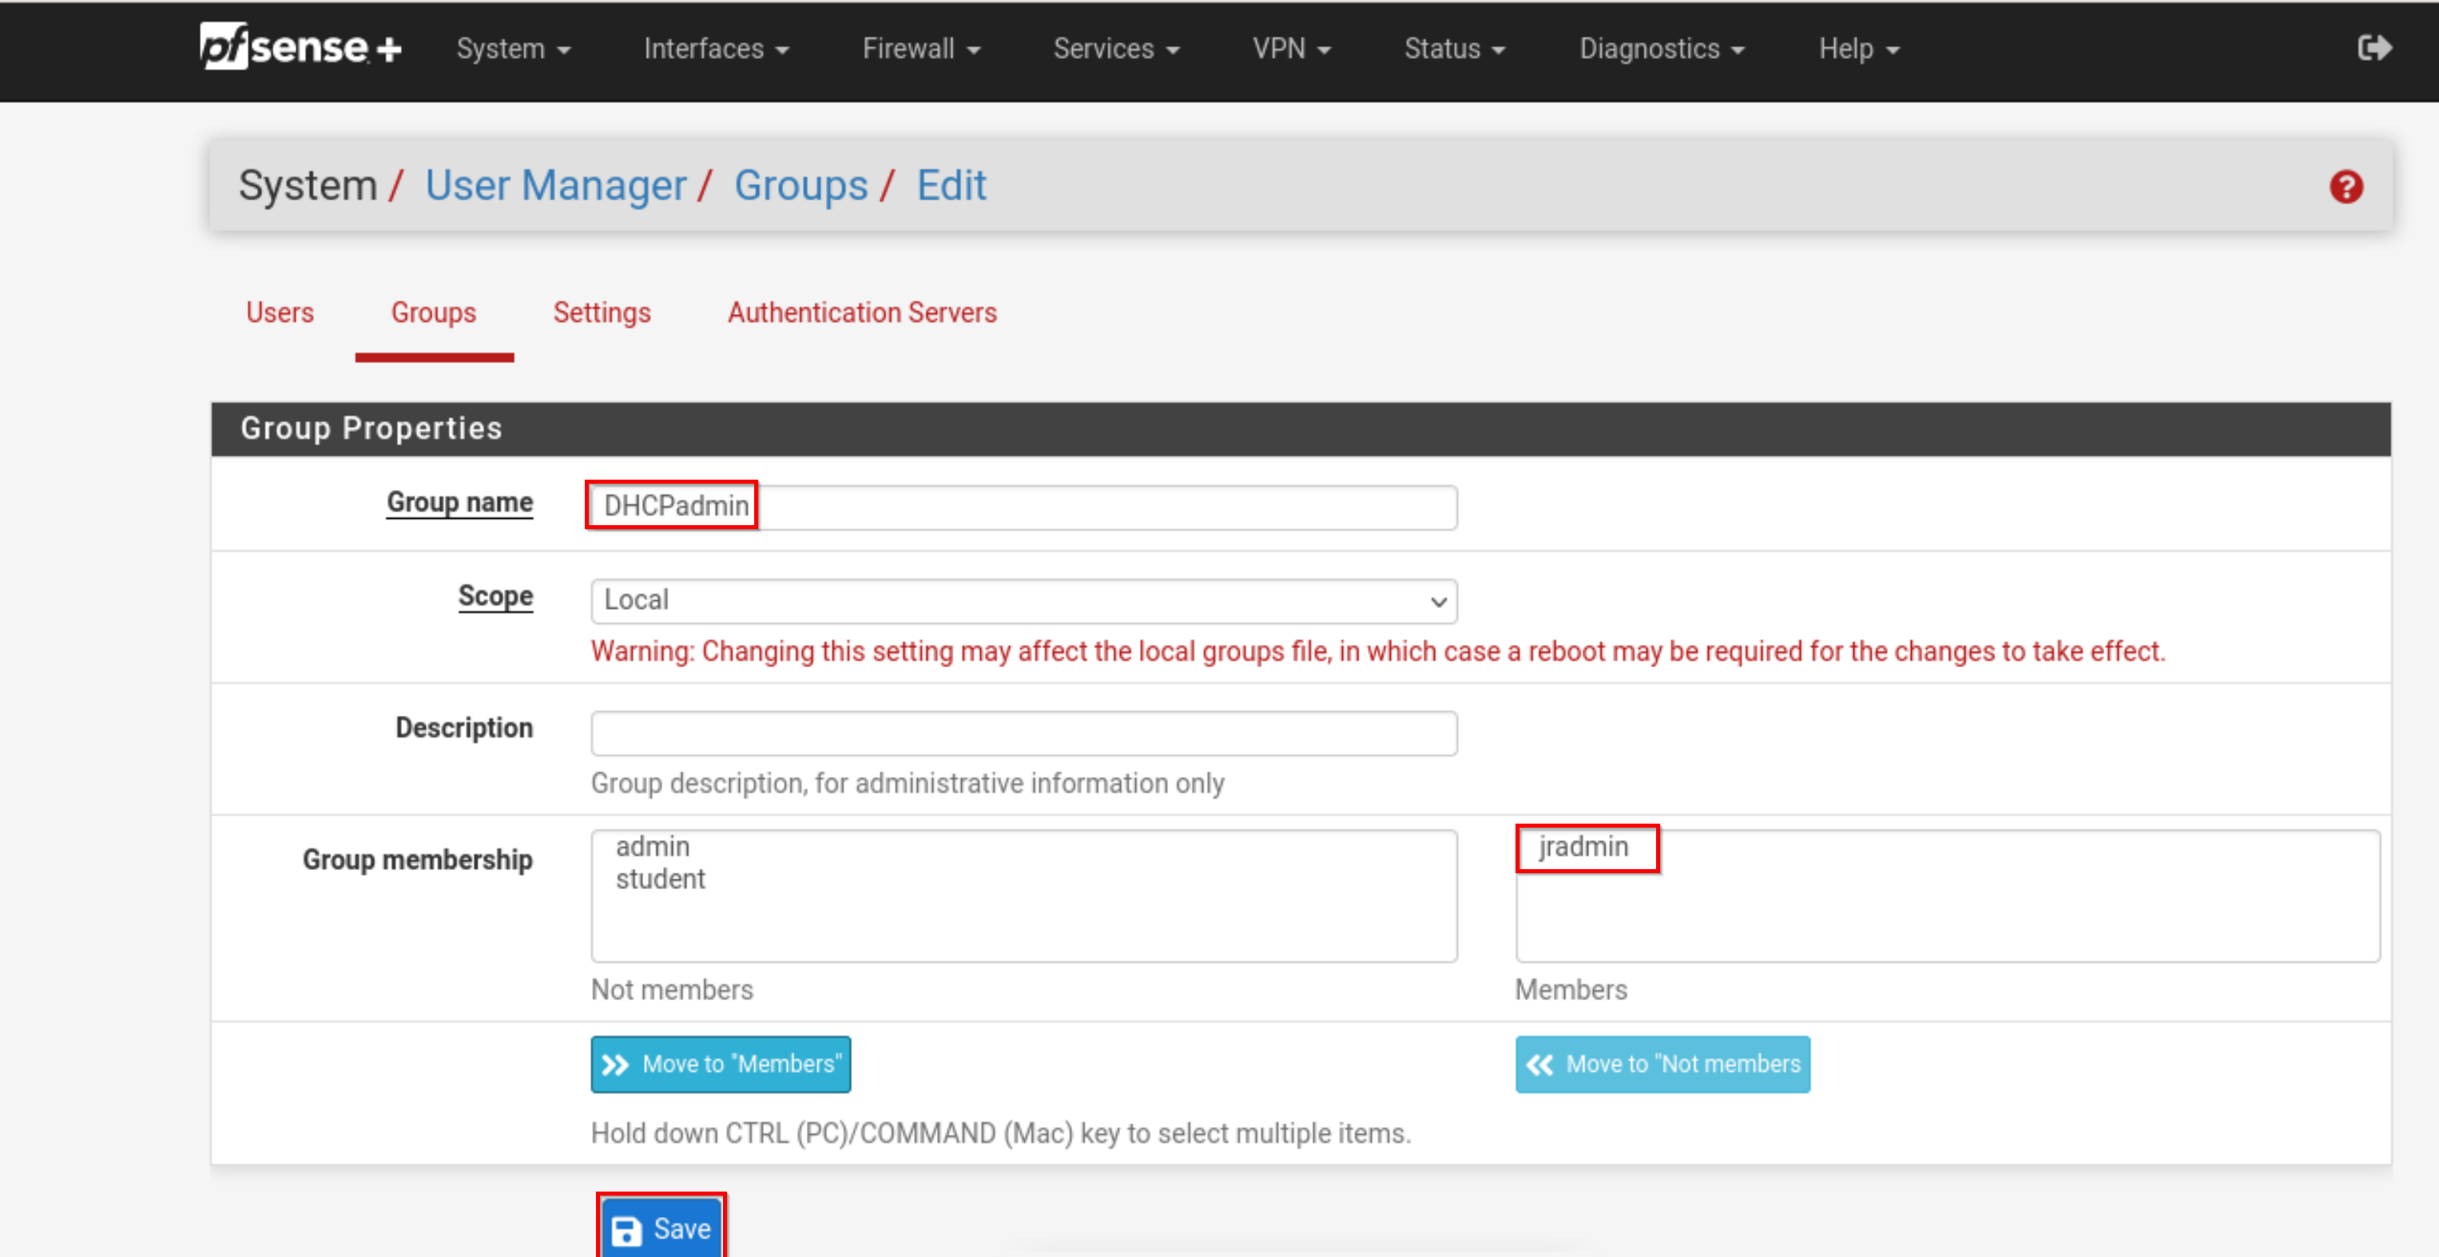

Step 2: Add correct permissions to group.
- Edit group.
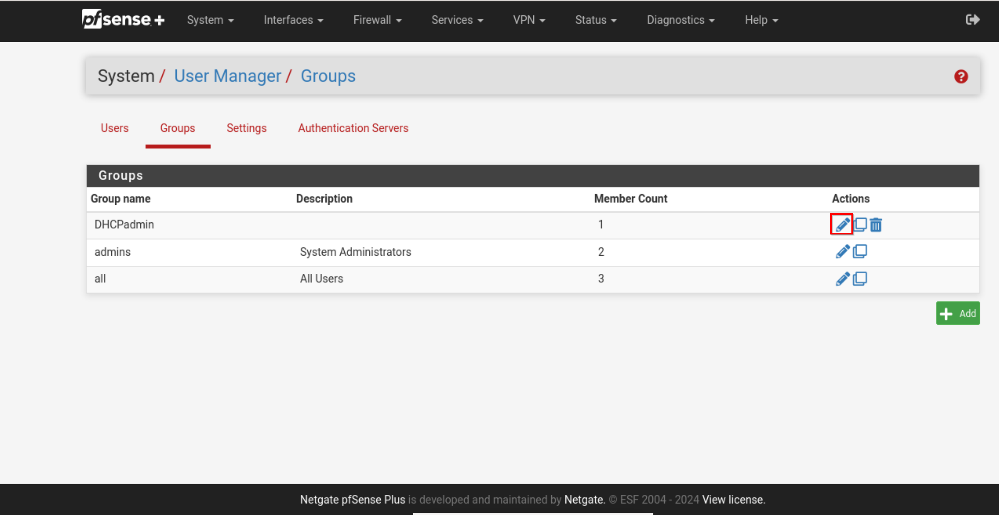
- Assign Privileges
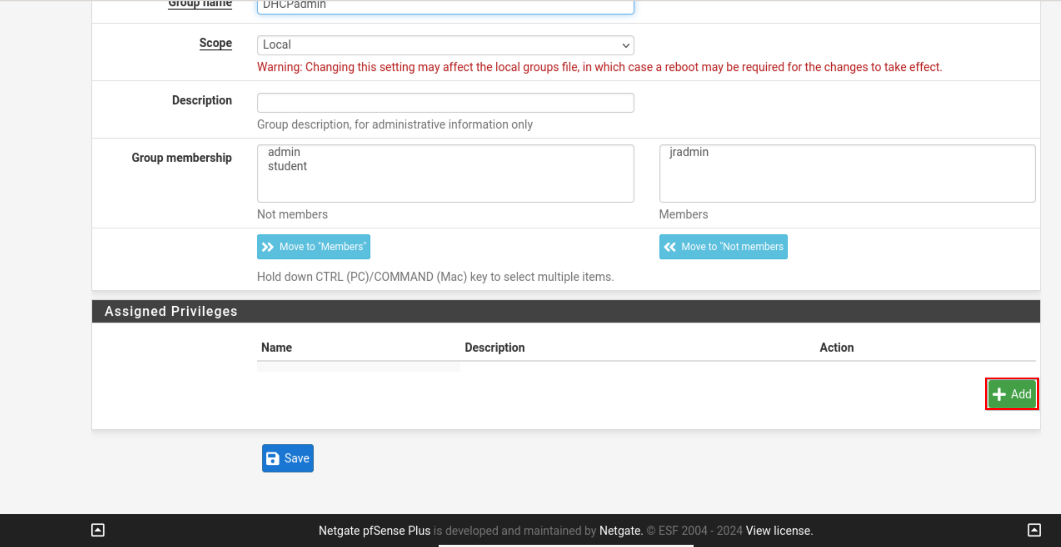
- Filter by dhcp and select WebCfg- Services: DHCP Server
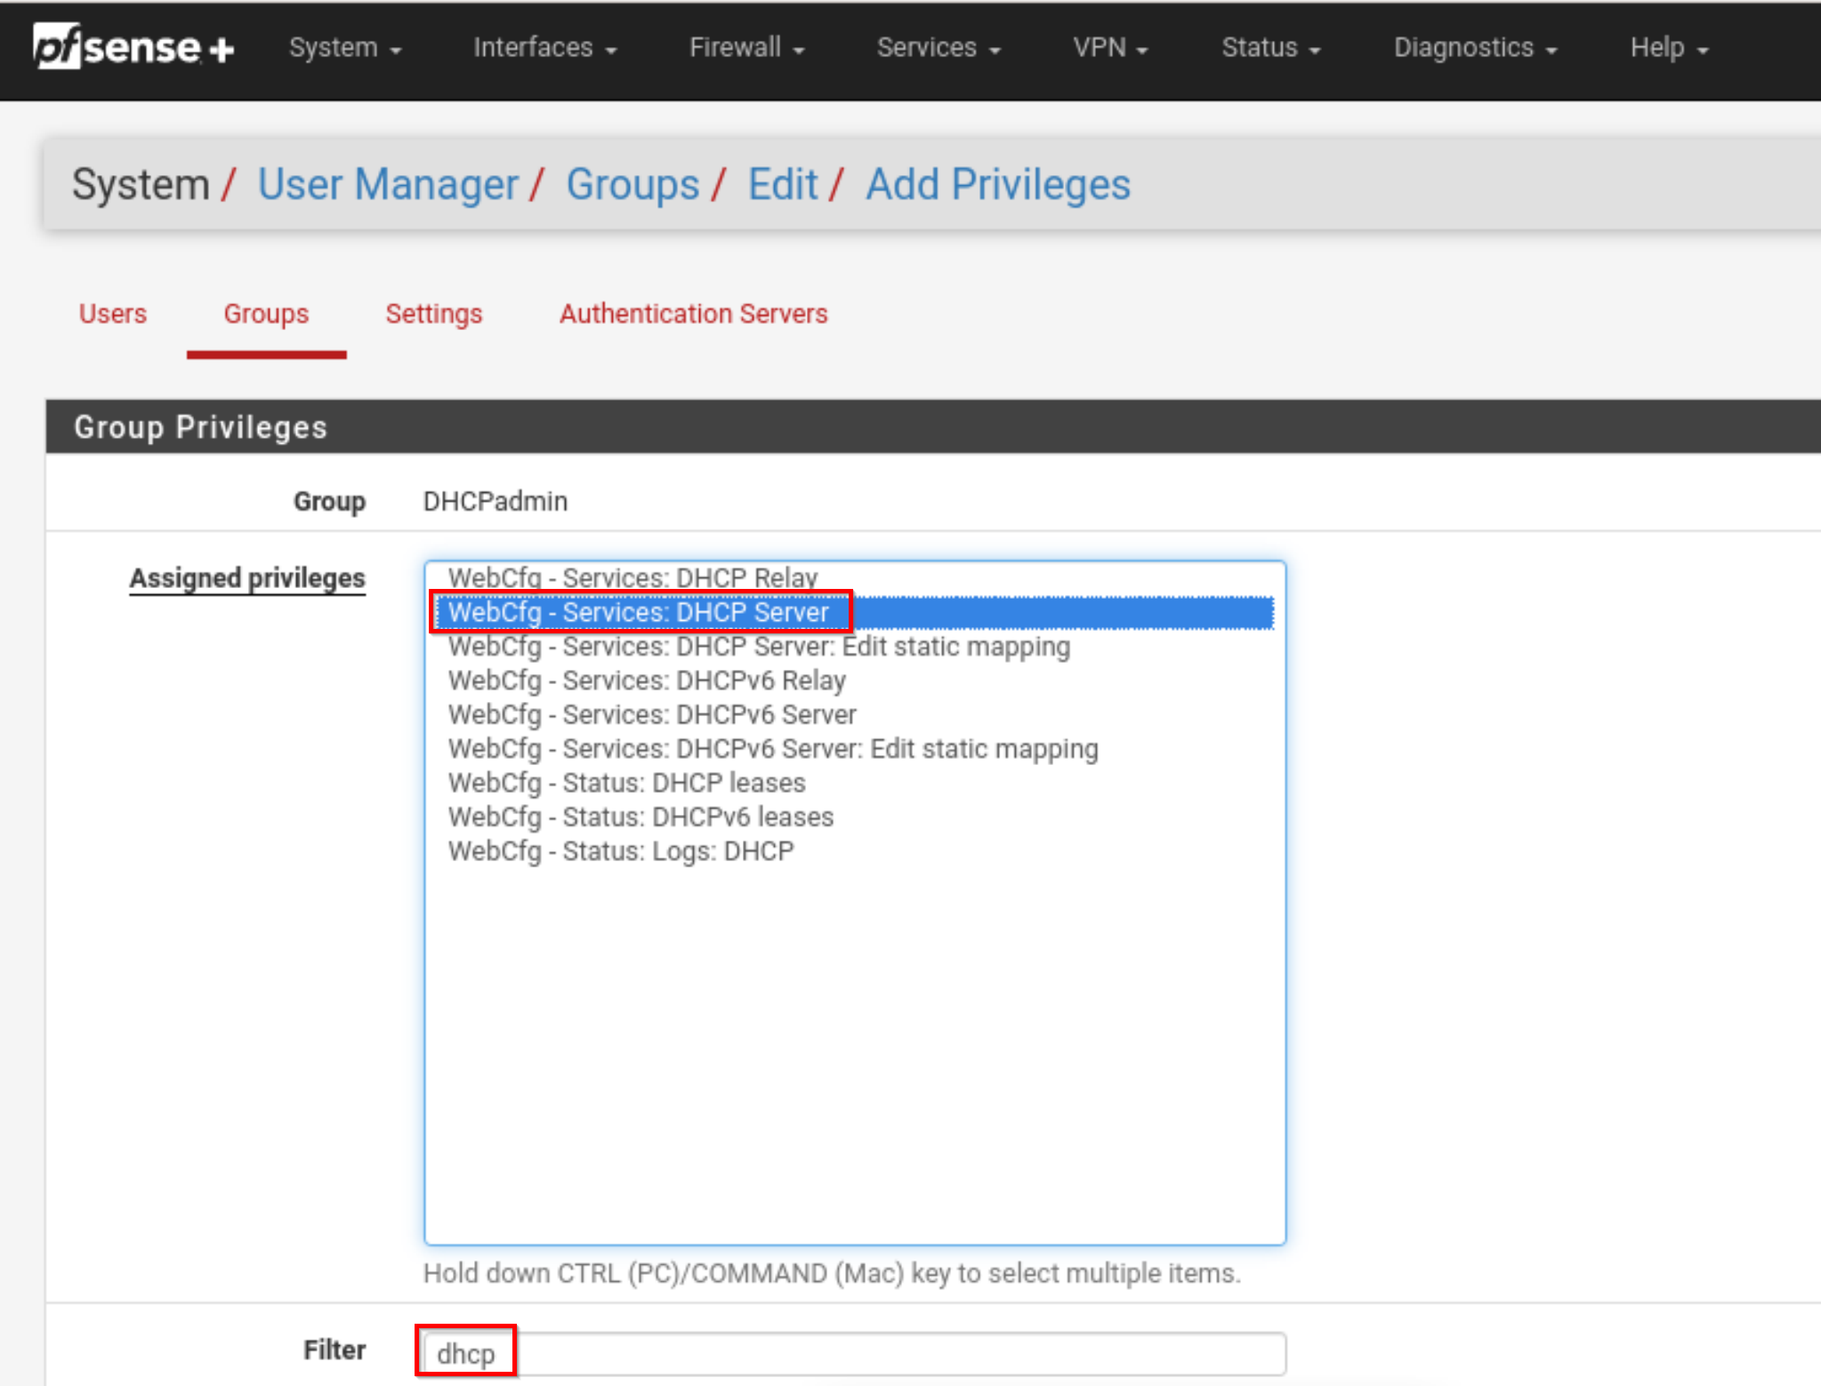
- Save changes.
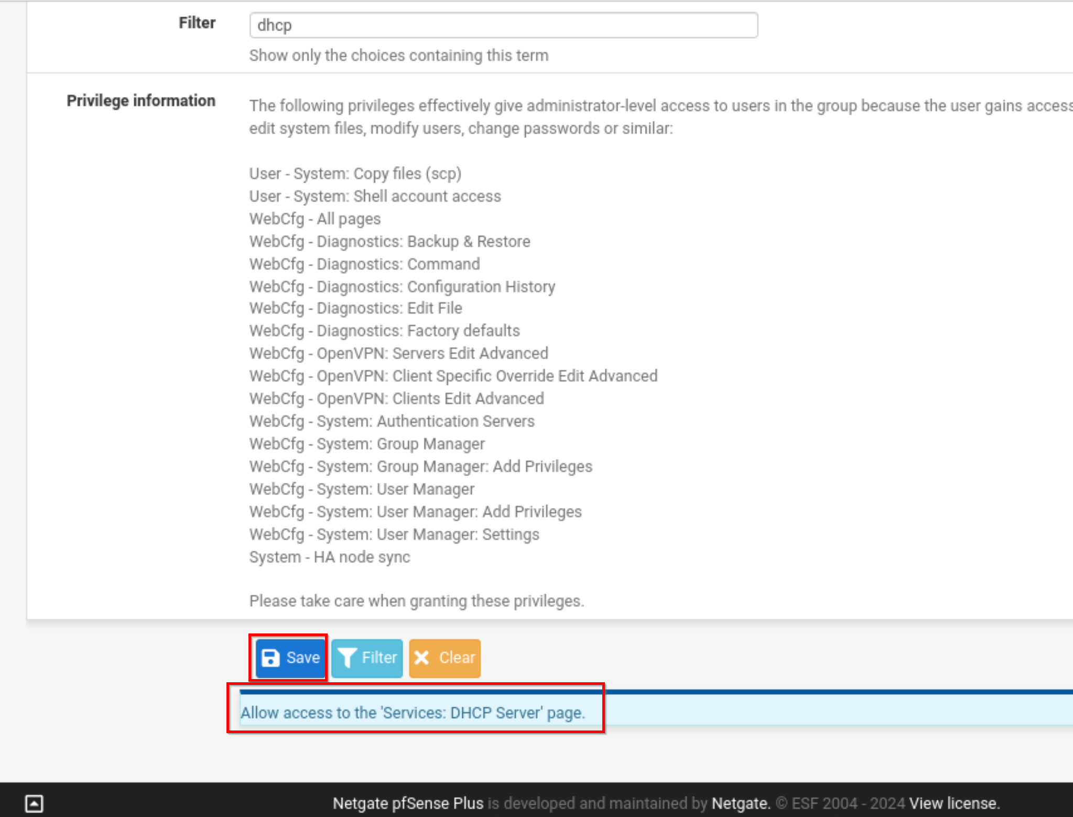
- Save changes again.

- Log Out and Log in as jradmin
- Analyse web interface and observe differences.
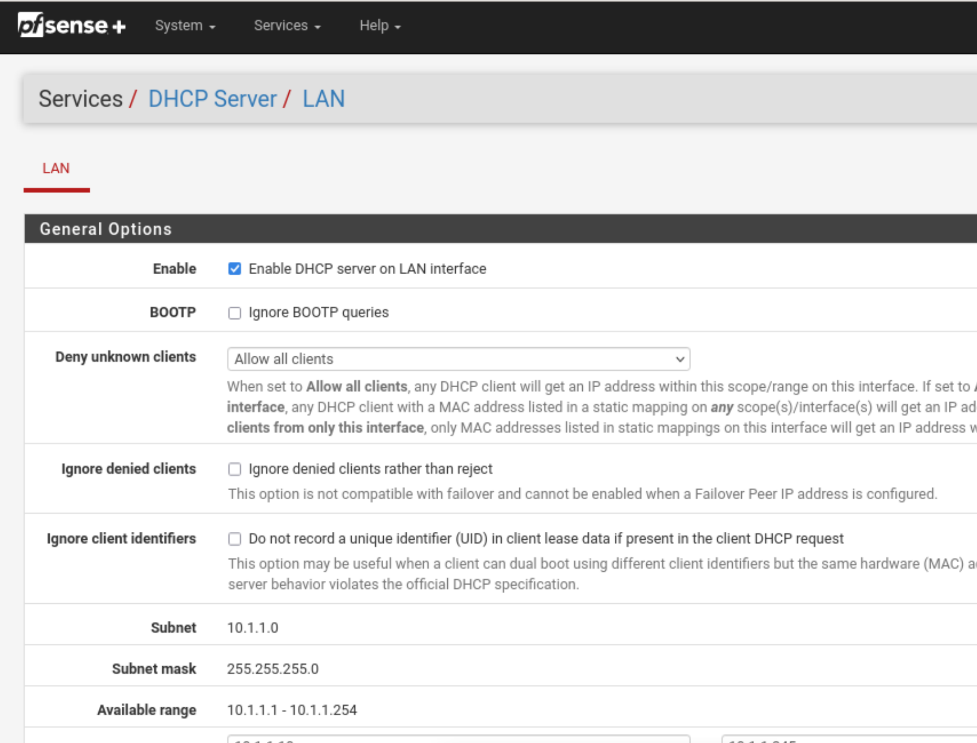

Task 6 – Create a new Group
In this step we will need to modify our DHCP setting as there is known issue.
Sometimes System default setting are not pushed to clients so we will have to assign them manually.
- Navigate to Service > DHCP Server > LAN
- Add DNS Servers
- Add Default Gateway
- Save Changes
- Release and renew DHCP lease in Debian.
- Verify that new setup is working. Ping google.com
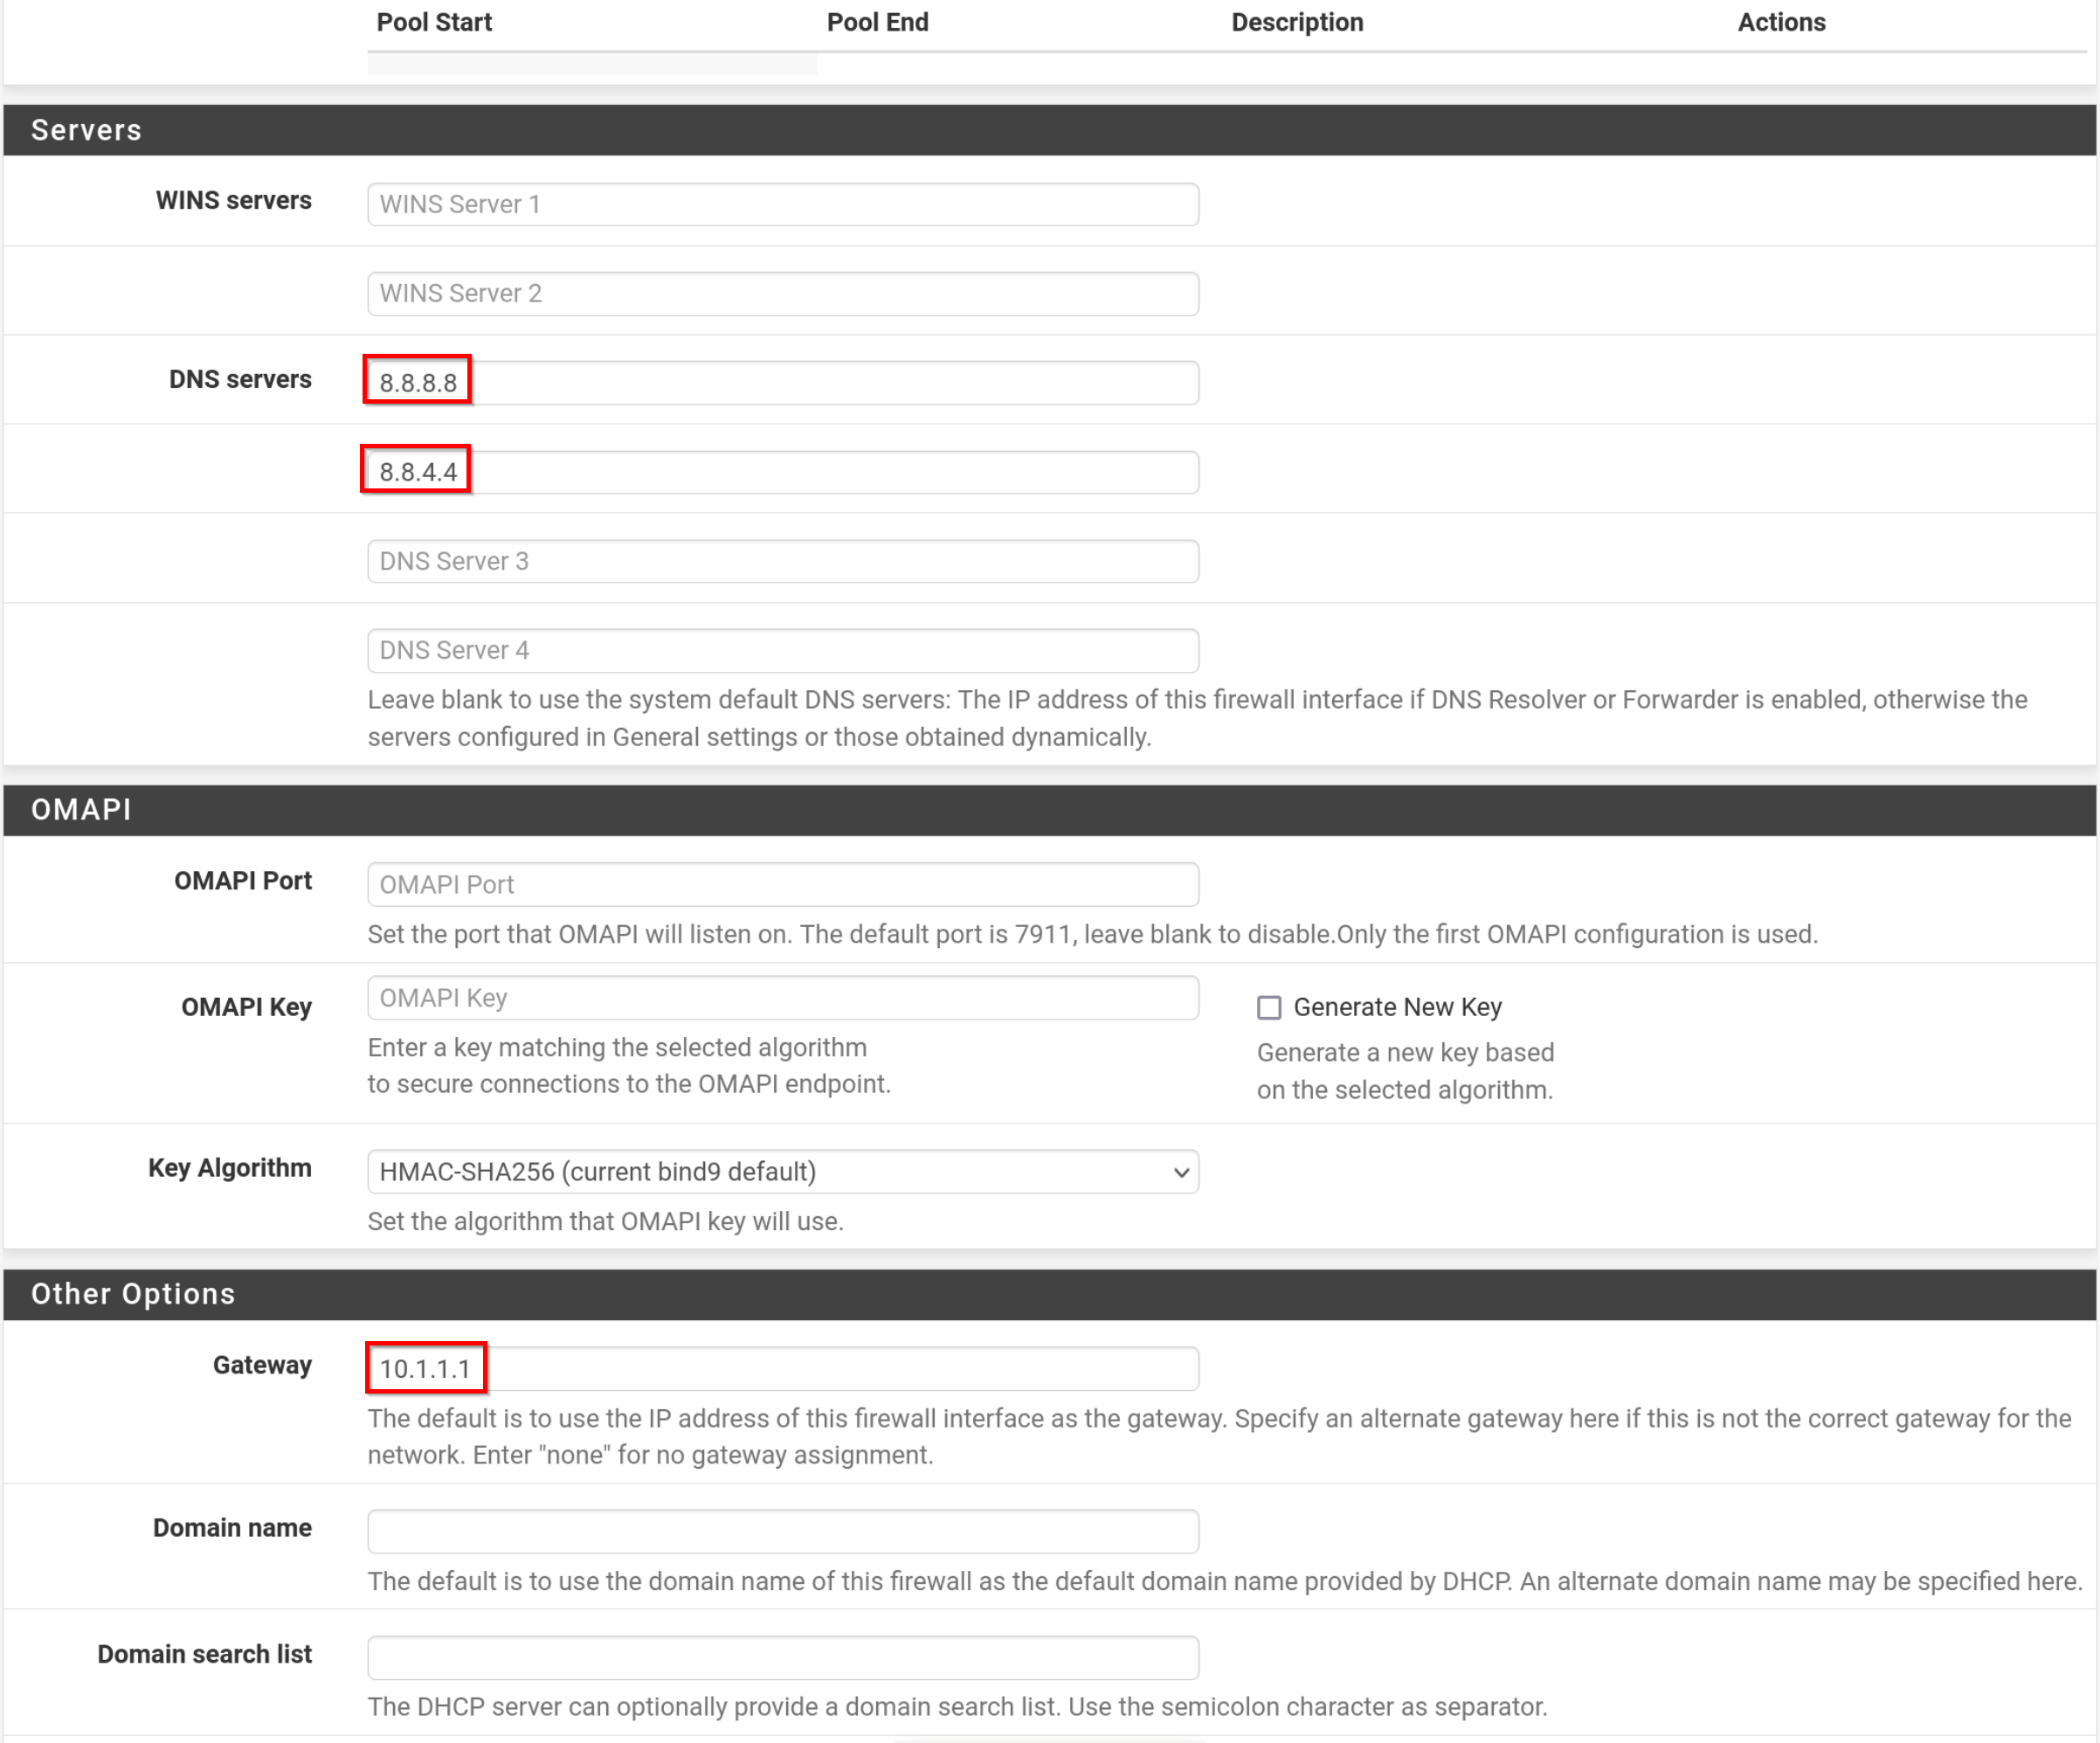

Lab Challenges.

Challange 1: Changing DHCP Server settings.

- DHCP exclusion
- Edit your DHCP setting:
- Change your DHCP scope to only distribute addresses from 100-150.
Those addressed will be used for non admin PC’s.

Screenshots:

a.

b.

- DHCP Static Mapping for clients (DHCP Reservation) for Student Debian clients including:
- Appropriate IP (Use IP range from 90-99)
- Description: Add student name that owns VM as description
Those addresses will be used for administrator PC’s
- Can you change these settings as jradmin user?

Screenshots:
a.

b.

- Answer:
Reflection:

Challange 2: Changing user permissions.

Change privileges assigned to the junior admin to include:
- Status: DHCP leases
- Services: DHCP Server: Edit static mapping
- Status: DHCP: Logs

Screenshots showing appropriate modifications.

a.

b.

c.

Users
Each pf Sense need to have:

Room admin account:
Right room Groups 1.2 and 3:
Username: rradmin (right room admin)
Password: student

Left Room Groups 4,5 and 6.
Username: lradmin (left room admin)
Password: student

Global admin account:
Username: gadmin
Password: student

