pfSense IPSEC VPN Client Configuration
Lab Goal:
- pfSense IPSEC VPN Client Configuration
- Connecting Windows client to network using VPN

Lab Requirements:
- pfSense VM
- Windows 10 VM






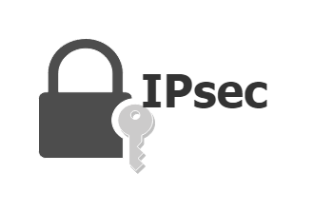



Table of Contents
pfSense IPSEC VPN Client Configuration 1
Table of Contents 2
Virtual Private Networks (VPNs) 4
Remote Access VPN 4
Site-to-Site VPN 4
• Intranet VPN: 5
• Extranet VPN: 5
SSL/TLS VPN 5
IPsec VPN 5
MPLS VPN 6
Hybrid VPN 6
OpenVPN 7
WireGuard 7
Summary 8
CA – Certificate Authority 8
1. Digital Certificates 8
2. Public Key Infrastructure (PKI): 8
3. Certificate Issuance 8
4. Trust Hierarchy 8
5. Revocation 8
6. Chain of Trust 8
IPSEC 9
Key Components of IPsec 9
1. Protocols: 9
Authentication Header (AH): 9
Encapsulating Security Payload (ESP): 10
ESP vs AH 10
2. Security Associations (SA): 10
3. Key Management: 11
Internet Key Exchange (IKE) Phases in IPsec 11
IKE Phase 1 11
1. Negotiation of Parameters: 11
2. Diffie-Hellman Key Exchange: 11
3. Authentication: 12
4. Establishment of the ISAKMP (Internet Security Association and Key Management Protocol) Security Association (SA): 12
Modes of Operation in Phase 1: 12
1. Main Mode: 12
2. Aggressive Mode: 12
IKE Phase 2 12
1. Negotiation of IPsec SAs: 12
2. Establishment of the IPsec SA: 12
3. Quick Mode: 12
Summary of Key Differences Between Phase 1 and Phase 2 13
Lab Prerequisites 14
Task 1 – Creating a Certificate Authority 14
Step 1: Navigate to System > Certificates. 14
Step 2 – Export CA Certificate 16
Task 2 – Create a Certificate Authority 17
Step 1: Navigate to System > Certificates, Certificates tab 17
Task 3 – Mobile Client Settings 18
Step 1: Navigate to VPN > IPsec 18
Step 2: Configure IKE Phase 1 21
Step 3: Configure IKE Phase 2 23
Task 4 – Mobile IPsec User Creation 26
Step 1: • Navigate to VPN > IPsec, Pre-Shared Keys tab 26
Task 5 – Configure WAN Interface 27
Step 1: Go to Interfaces >WAN 27
Step 2 – Find IPv4 WAN address 27
Task 5 – Configuring Windows 10 Client 28
Step 1: Change Windows registry 28
Step 2: Import the CA to the Client 31
Step 3: Verify that Certificate has been imported 34
Step 3: Configure VPN client connection 35
References: 39

Virtual Private Networks (VPNs)

Virtual Private Networks (VPNs) are essential for establishing secure, encrypted connections over less secure networks, such as the internet. Various types of VPNs exist to cater to different requirements and use cases. Below is a comprehensive overview of the primary VPN types, including popular implementations like OpenVPN and WireGuard, along with their operation within the OSI model.

Remote Access VPN

Description:
- Provides individual users with secure access to a remote network, commonly used by employees connecting to their company’s network from outside the office.

Mechanism:
- Users connect to the VPN server using client software.
- The VPN client encrypts data before transmission over the internet to the VPN server.
- The VPN server decrypts the data and forwards it to the corporate network.

OSI Layer:
- Operates primarily at Layer 3 (Network) and Layer 4 (Transport).

Use Cases:
- Telecommuting employees accessing corporate resources.
- Secure connection from public Wi-Fi hotspots.

Advantages:
- Enhances security for remote users.
- Ensures data privacy and integrity.

Site-to-Site VPN

Description:
- Connects entire networks over the internet, often used to link branch offices to a central office network.

Types:
- Intranet VPN: Connects different networks within the same organization.
- Extranet VPN: Connects networks from different organizations, such as a business and its partners or clients.

Mechanism:
- VPN gateways (routers or firewalls) in each location encrypt and decrypt traffic between sites.
- VPN gateways establish a secure tunnel over the internet, allowing inter-network communication as if on the same local network.

OSI Layer:
- Operates primarily at Layer 3 (Network).

Use Cases:
- Connecting branch offices to the main office.
- Secure collaboration with partner organizations.

Advantages:
- Facilitates secure inter-office communication.
- Reduces costs compared to dedicated leased lines.

SSL/TLS VPN

Description:
- Utilizes Secure Sockets Layer (SSL) or Transport Layer Security (TLS) protocols to create secure, encrypted connections over the internet, commonly for web access.

Mechanism:
- Users access the VPN through a web browser without needing specific client software.
- SSL/TLS VPN encrypts data between the user's browser and the VPN server.

OSI Layer:
- Operates at Layer 4 (Transport) and Layer 7 (Application).

Use Cases:
- Securely accessing web-based applications and services.
- Remote users requiring secure, browser-based access to internal applications.

Advantages:
- Easy to deploy and manage.
- No need for special client software.

IPsec VPN

Description:
- Employs the IPsec protocol suite to provide secure communications over IP networks, suitable for both remote access and site-to-site VPNs.

Mechanism:
- Establishes a secure tunnel using IKE phases.
- Encrypts and authenticates each IP packet within the data stream.

OSI Layer:
- Operates at Layer 3 (Network).

Use Cases:
- Remote access for employees.
- Secure site-to-site connections between offices.

Advantages:
- High level of security.
- Versatile and widely supported.

MPLS VPN

Description:
- Uses Multi-Protocol Label Switching (MPLS) technology to create private networks over a shared infrastructure provided by an ISP, often for large organizations requiring reliable and scalable connectivity.

Mechanism:
- MPLS routes data based on labels rather than network addresses, ensuring efficient data transfer.
- The ISP manages the MPLS network, providing high quality of service (QoS).

OSI Layer:
- Operates at Layer 2 (Data Link) and Layer 3 (Network).

Use Cases:
- Connecting multiple sites of a large enterprise.
- Ensuring high performance for critical applications.

Advantages:
- High performance and reliability.
- Scalable to large networks.

Hybrid VPN

Description:
- Combines different types of VPN technologies to meet specific needs. For example, an organization might use both MPLS and IPsec VPNs.

Mechanism:
- Integrates multiple VPN types to leverage the strengths of each.
- Ensures flexible, scalable, and robust connectivity solutions.

OSI Layer:
- Operates at multiple layers, depending on the integrated technologies.

Use Cases:
- Large enterprises with diverse networking requirements.
- Organizations requiring both remote access and site-to-site connectivity.

Advantages:
- Tailored to specific needs.
- Maximizes strengths of different VPN technologies.

OpenVPN

Description:
- Open-source VPN protocol known for its flexibility and robust security, suitable for both remote access and site-to-site VPNs.

Mechanism:
- Uses SSL/TLS for key exchange, creating a secure channel.
- Supports multiple encryption algorithms, providing strong security.

OSI Layer:
- Operates at Layer 4 (Transport) and Layer 7 (Application).

Use Cases:
- Secure remote access for individuals.
- Site-to-site VPN connections in various network configurations.

Advantages:
- Highly configurable and compatible with various platforms.
- Strong security features and widely trusted in the open-source community.

WireGuard

Description:
- A modern, high-performance VPN protocol designed for simplicity and efficiency, providing a streamlined alternative to older protocols like IPsec and OpenVPN.

Mechanism:
- Utilizes state-of-the-art cryptography (e.g., Curve25519 for key exchange, ChaCha20 for encryption).
- Designed for ease of use and rapid setup, with a lean codebase and low overhead.

OSI Layer:
- Operates at Layer 3 (Network).

Use Cases:
- Remote access VPNs requiring high performance and low latency.
- Site-to-site VPNs with a focus on speed and simplicity.

Advantages:
- Faster and more efficient than traditional VPN protocols.
- Easier to audit and maintain due to its smaller codebase.

Summary

Remote Access VPN: Provides secure connections for individual users to a remote network, operating primarily at Layer 3 and Layer 4.
Site-to-Site VPN: Securely connects entire networks over the internet, operating primarily at Layer 3.
SSL/TLS VPN: Enables browser-based secure access using SSL/TLS protocols, operating at Layer 4 and Layer 7.
IPsec VPN: Ensures secure IP communications using the IPsec protocol suite, operating at Layer 3.
MPLS VPN: Creates private networks over shared infrastructure using MPLS technology, operating at Layer 2 and Layer 3.
Hybrid VPN: Integrates multiple VPN technologies for tailored solutions, operating at multiple layers.
OpenVPN: Flexible, open-source VPN protocol suitable for various configurations, operating at Layer 4 and Layer 7.
WireGuard: Modern, efficient VPN protocol known for high performance and simplicity, operating at Layer 3.
Each type of VPN, including implementations like OpenVPN and WireGuard, serves specific needs and use cases, providing flexibility and security for various network configurations and requirements.

CA – Certificate Authority

A Certificate Authority (CA) is a trusted entity that issues digital certificates used to verify the identity of organizations and individuals in the digital world.
- Digital Certificates: These are electronic credentials that associate the identity of the certificate holder with a public key. They are used to establish secure communications over networks, particularly the Internet.
- Public Key Infrastructure (PKI): CAs are a critical component of the PKI, a framework that uses cryptographic techniques to secure communications and verify identities. PKI enables secure data transmission and authentication.
- Certificate Issuance: When an entity requests a digital certificate, the CA verifies the identity of the requester through a series of checks. Once verified, the CA issues a certificate that includes the entity’s public key and their verified identity details.
- Trust Hierarchy: CAs are at the top of a trust hierarchy. Certificates issued by a trusted CA are inherently trusted by operating systems, browsers, and other software. This trust is foundational for activities like secure web browsing (HTTPS), email security, and secure software distribution.
- Revocation: CAs also manage the revocation of certificates. If a certificate is compromised or the holder's information changes, the CA can revoke the certificate and add it to a Certificate Revocation List (CRL), ensuring that it is no longer trusted.
- Chain of Trust: CAs may issue certificates to intermediate authorities, which in turn can issue certificates to end users. This creates a chain of trust, where each link in the chain is verified by the one above it.
In essence, CAs enable secure digital interactions by ensuring that the entities we communicate with online are who they.

IPSEC
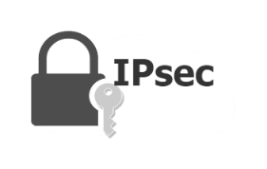

IPsec (Internet Protocol Security) is a framework of open standards for ensuring private, secure communications over Internet Protocol (IP) networks through cryptographic security services. It is widely used in virtual private networks (VPNs) to provide a secure path between two or more devices over a public network like the internet. Here’s a brief explanation of its key components and functionalities: IPsec (Internet Protocol Security) is a framework of open standards for ensuring private, secure communications over Internet Protocol (IP) networks through cryptographic security services.
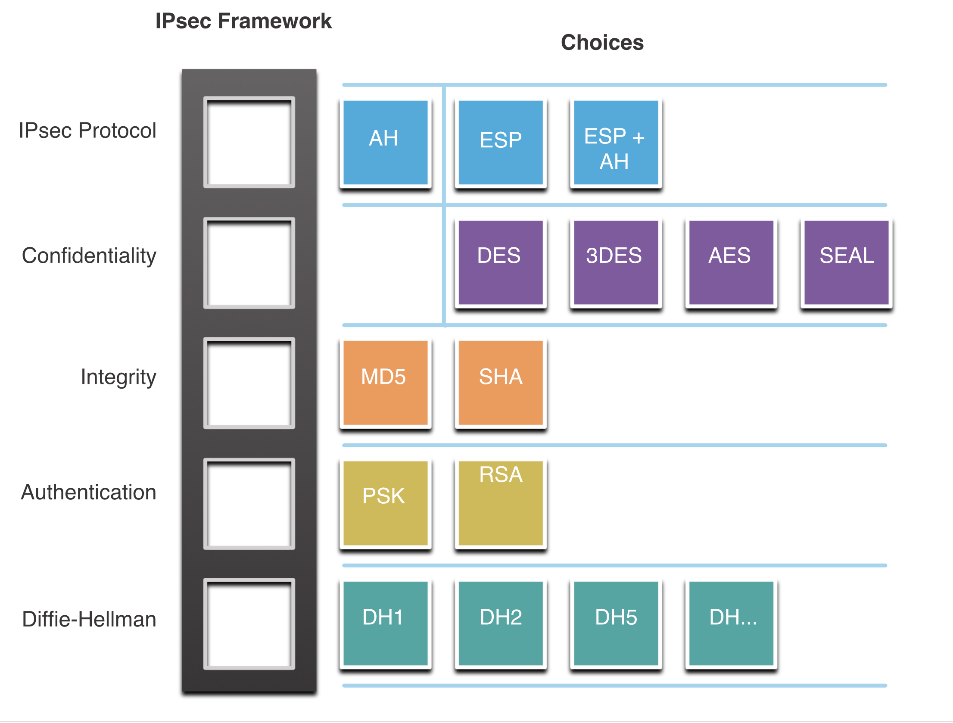
It is widely used in virtual private networks (VPNs) to provide a secure path between two or more devices over a public network like the internet. Here’s a brief explanation of its key components and functionalities:

Key Components of IPsec

Protocols:
Authentication Header (AH): Provides data integrity, authentication, and anti-replay protection. It ensures that the data has not been tampered with and verifies the identity of the sender.
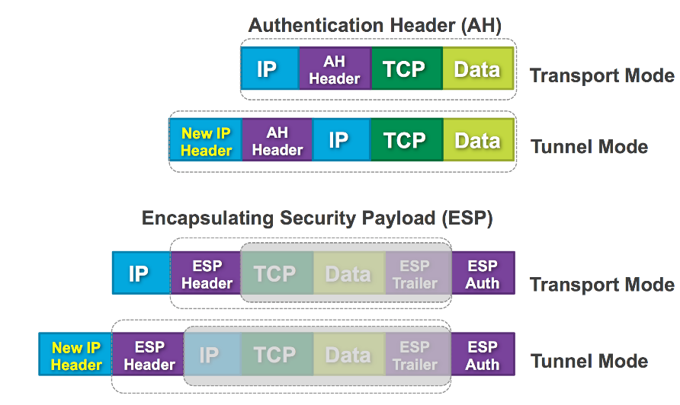

Encapsulating Security Payload (ESP): Provides data encryption, data integrity, authentication, and anti-replay protection. ESP ensures confidentiality by encrypting the payload of IP packets.
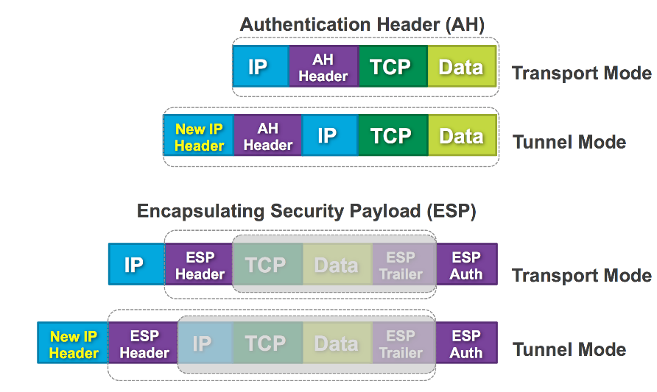

ESP vs AH

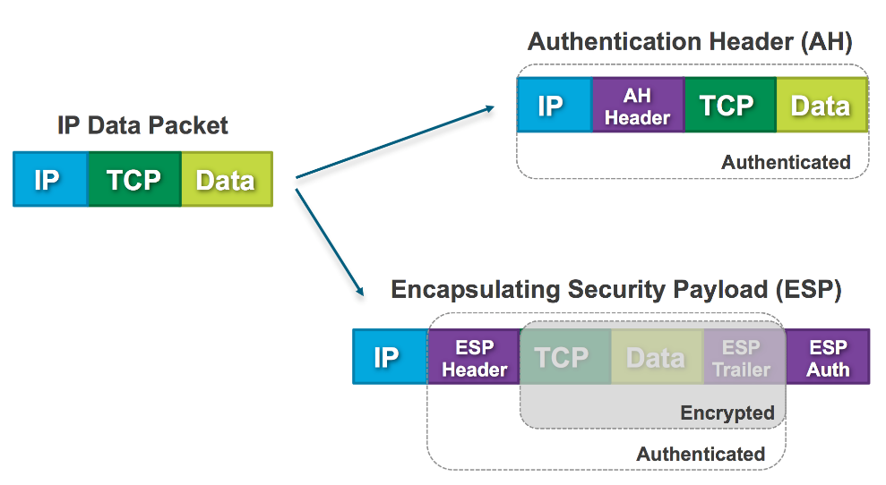

Security Associations (SA):
An SA is a relationship between two or more entities that describes how they will use security services to communicate securely. Each SA is identified by a unique identifier called the Security Parameter Index (SPI).

Key Management:
IPsec uses the Internet Key Exchange (IKE) protocol to set up a secure, authenticated communication channel and negotiate the security associations.
IKE has two phases:
- IKE Phase 1 establishes the initial secure channel
- IKE Phase 2 negotiates the IPsec SAs for actual data transmission.

Internet Key Exchange (IKE) Phases in IPsec

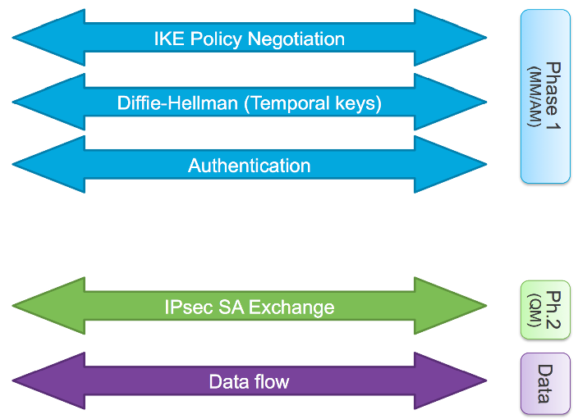

IKE (Internet Key Exchange) is a protocol used to set up a secure, authenticated communication channel and negotiate the security parameters for IPsec. It operates in two main phases: IKE Phase 1 and IKE Phase 2. Here’s a detailed but simple explanation of each phase:

IKE Phase 1

Objective:

Establish a secure and authenticated channel between two devices (peers) so they can communicate securely.

Steps:

Negotiation of Parameters:

The peers negotiate and agree on a set of cryptographic algorithms and parameters to use. This includes deciding on encryption algorithms (like AES or 3DES), hash functions (like SHA-256), and key exchange methods (like Diffie-Hellman).

Diffie-Hellman Key Exchange:

The peers use the Diffie-Hellman algorithm to generate a shared secret key over an insecure channel. This shared secret is used to encrypt subsequent communication.

Authentication:

The peers authenticate each other using methods such as pre-shared keys (a secret key known by both parties), digital certificates (issued by a trusted authority), or public key encryption.

Establishment of the ISAKMP (Internet Security Association and Key Management Protocol) Security Association (SA):

An ISAKMP SA is created, which establishes a secure channel for the two peers to communicate. This SA includes the negotiated parameters and the shared secret.

Modes of Operation in Phase 1:

Main Mode:

Provides greater security by separating the process into six distinct messages: three exchanges each way. It hides the identities of the peers and is more secure but slower.

Aggressive Mode:

Completes the exchange in three messages: one exchange each way. It is faster but less secure because it exposes the identities of the peers.

IKE Phase 2

Objective:

Negotiate the IPsec Security Associations (SAs) for the actual data transfer and establish the secure communication channel.

Steps:

Negotiation of IPsec SAs:

The peers negotiate and agree on the parameters for the IPsec tunnel, including the encryption and authentication algorithms to use for securing the data.

Establishment of the IPsec SA:

Using the secure channel established in Phase 1, the peers create one or more IPsec SAs. These SAs define the parameters and keys to be used for securing the data traffic.

Quick Mode:

IKE Phase 2 typically uses Quick Mode to negotiate the IPsec SAs. This involves three exchanges (or messages) between the peers. Quick Mode also refreshes the keying material by performing another Diffie-Hellman exchange if required, ensuring that the session keys are fresh and secure.

Functionality in Phase 2:

IPsec SAs are used to secure the actual data packets that are transmitted between the peers. The data is encrypted and authenticated according to the agreed-upon parameters.

Summary of Key Differences Between Phase 1 and Phase 2

Phase 1:
Establishes a secure and authenticated channel (ISAKMP SA).
Focuses on secure key exchange and peer authentication.

Phase 2:
Negotiates the IPsec SAs for securing data packets.

Uses the secure channel from Phase 1 to negotiate parameters and keys for data encryption and authentication.
`
Functionalities of IPsec
- Data Confidentiality:
Ensures that the data cannot be read by unauthorized parties by encrypting the payload of IP packets using algorithms like AES, 3DES, etc.
- Data Integrity:
Guarantees that the data has not been tampered with during transit by using hash functions like SHA-2.
- Authentication:
Verifies the identity of the communicating parties, ensuring that the data is being sent and received by legitimate users. This is achieved using mechanisms like digital signatures and shared secret keys.
- Anti-Replay:
Protects against replay attacks by ensuring that each packet is unique and cannot be maliciously resent. This is done using sequence numbers.
Modes of Operation
- Transport Mode:
Encrypts only the payload of the IP packet, leaving the header intact. This mode is typically used for end-to-end communication between two devices.
- Tunnel Mode:
Encrypts both the payload and the original IP header, encapsulating the entire packet within a new IP packet with a new header. This mode is commonly used in VPNs to connect two networks securely over the internet.
Use Cases
- VPNs (Virtual Private Networks):
Provides secure remote access to a network over the internet, allowing users to connect to their organization's network securely.
- Site-to-Site VPNs:
Connects entire networks securely, often used between branch offices and the main office.
- Secure Communication:
Ensures secure data exchange between devices, such as between a client and a server in sensitive applications.

In summary, IPsec is a comprehensive suite of protocols and standards designed to ensure secure communication over IP networks through encryption, authentication, and integrity verification.

Lab Prerequisites

For this lab, you will need to:
- Import pfSense OVA. It can be found on Teams.
- Change name of pfSense host to PF1

Task 1 – Creating a Certificate Authority

Step 1: Navigate to System > Certificates.

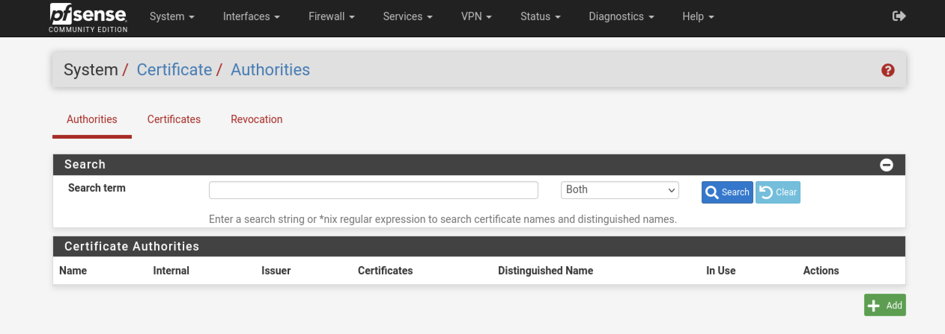

Click + Add to create a new certificate authority
Configure CA as per specification:
  - Descriptive Name: CybertechCA
  - Method: Create an internal Certificate Authority
  - Randomize Serial: Checked
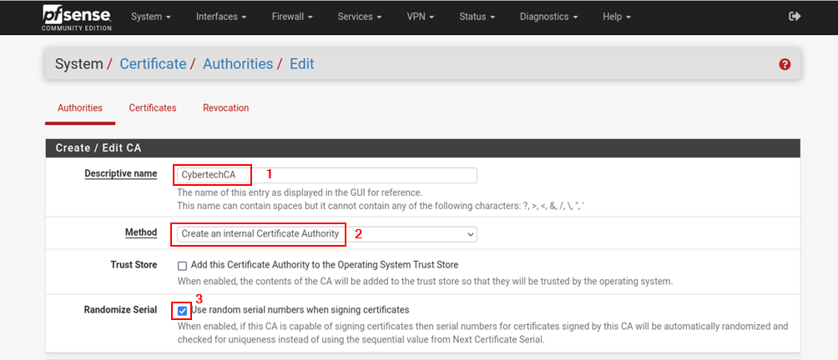
  - Country Code: AU
  - State or Province: Tasmania
  - City: Hobart
  - Organization: Cybertech
  - Organizational Unit: SOC
  - Click on save.

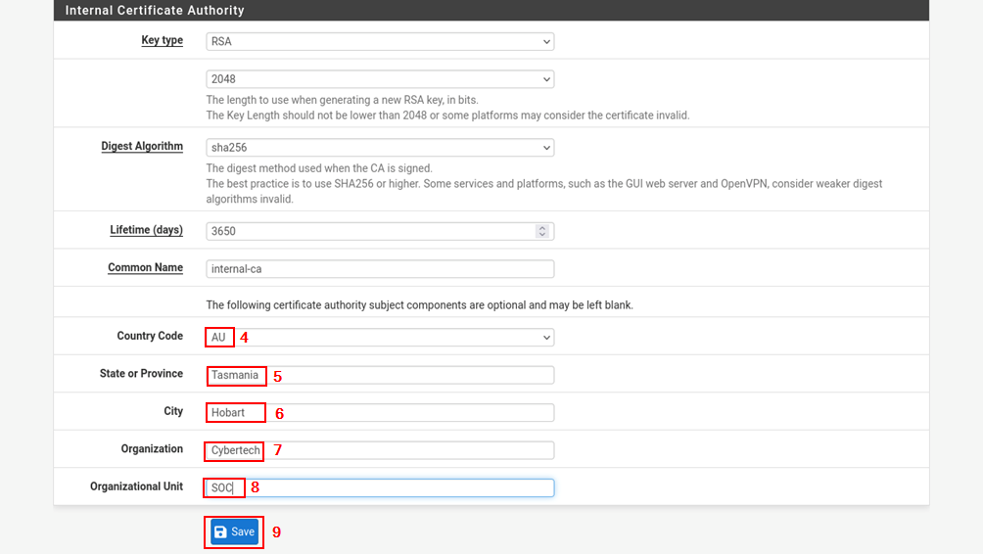
Expected screenshot:

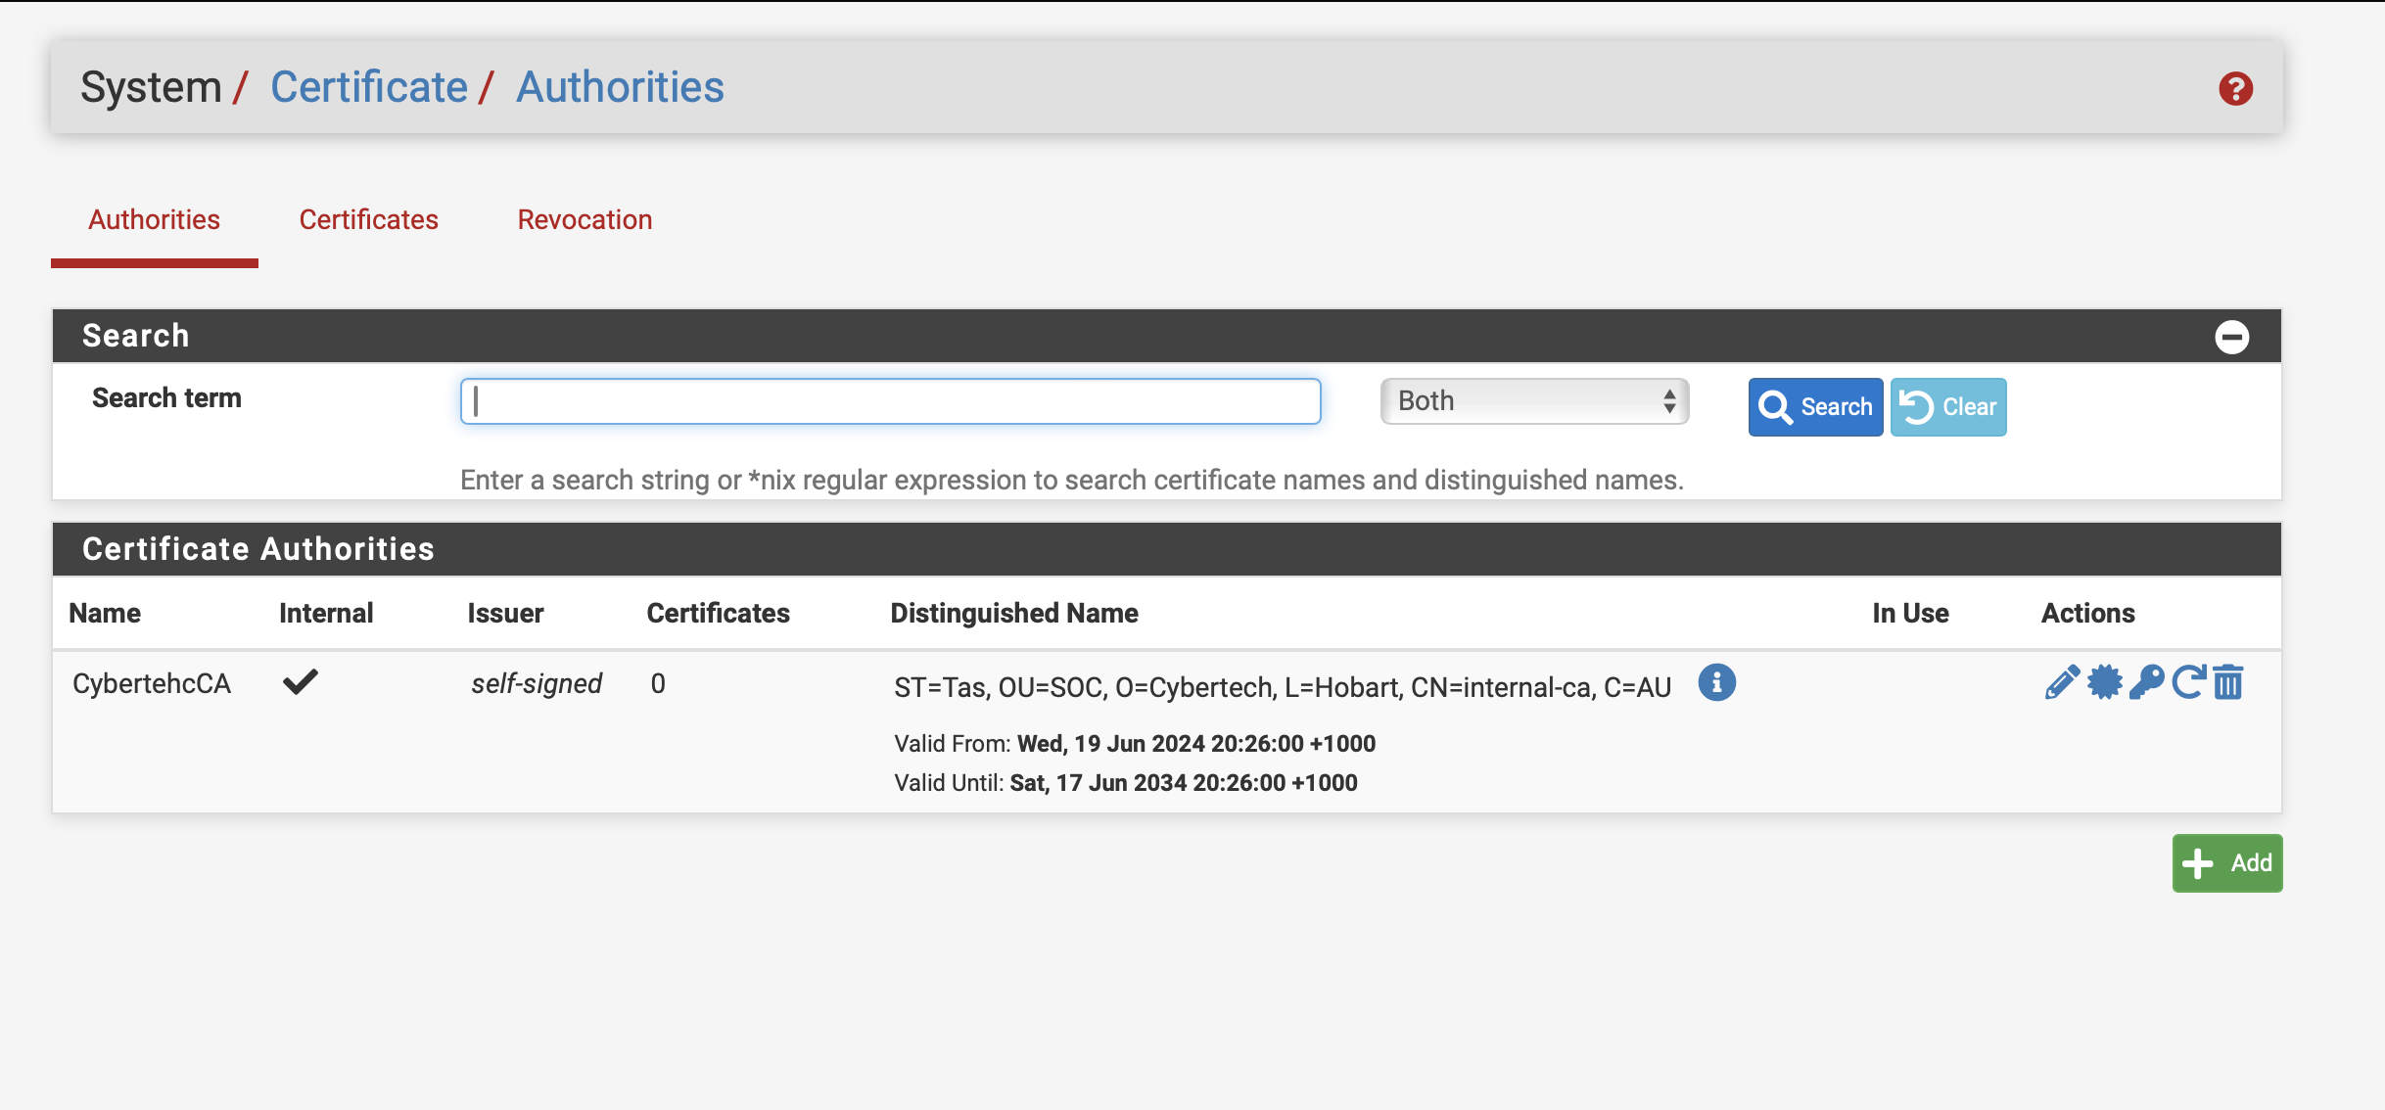

Step 2 – Export CA Certificate

Click on 
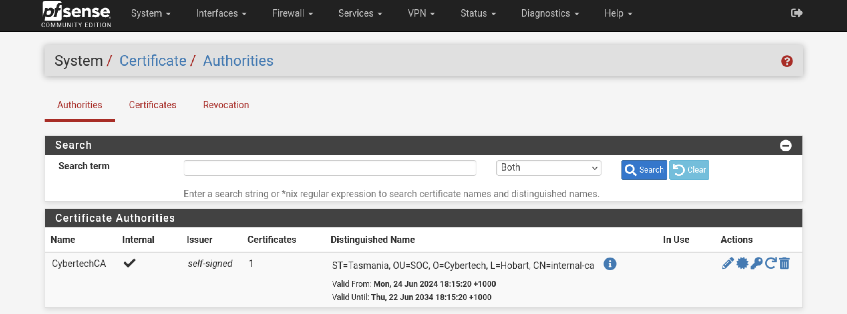
Go to Downloads folder and transfer CA Certificate to Host PC

Task 2 – Create a Certificate Authority

Step 1: Navigate to System > Certificates, Certificates tab

Click fa-plus Add to create a new certificate.
Set the options as follows:

Method: Create an internal Certificate
Descriptive Name: IKEv2 Server
Certificate Authority: CybertechCA
Common Name: ike.cybertech.lab

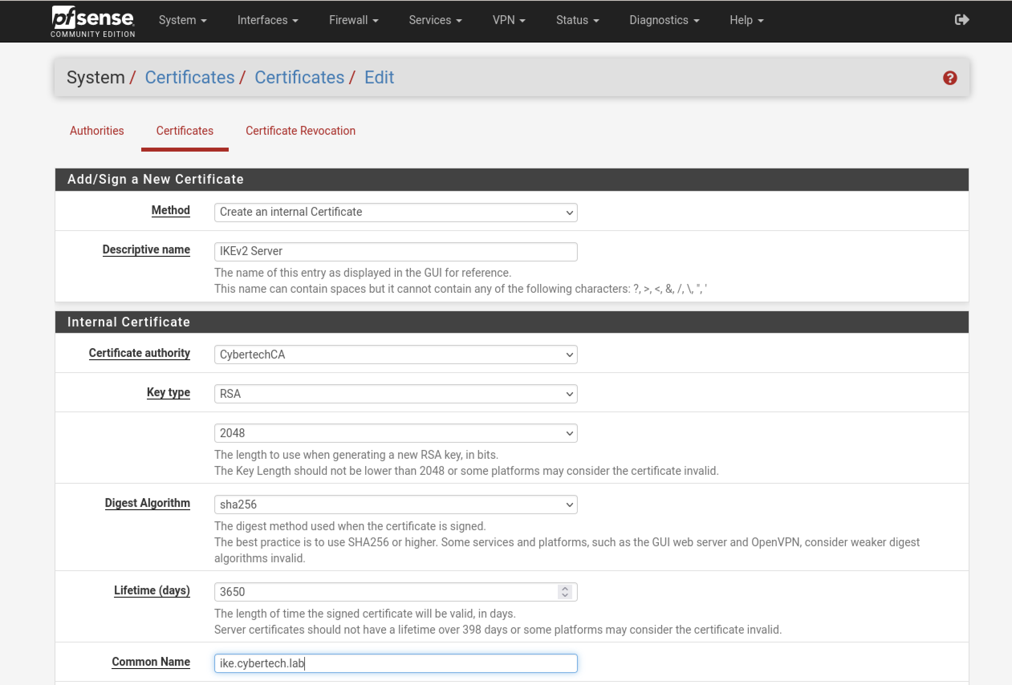
Certificate Type: Server Certificate
Save
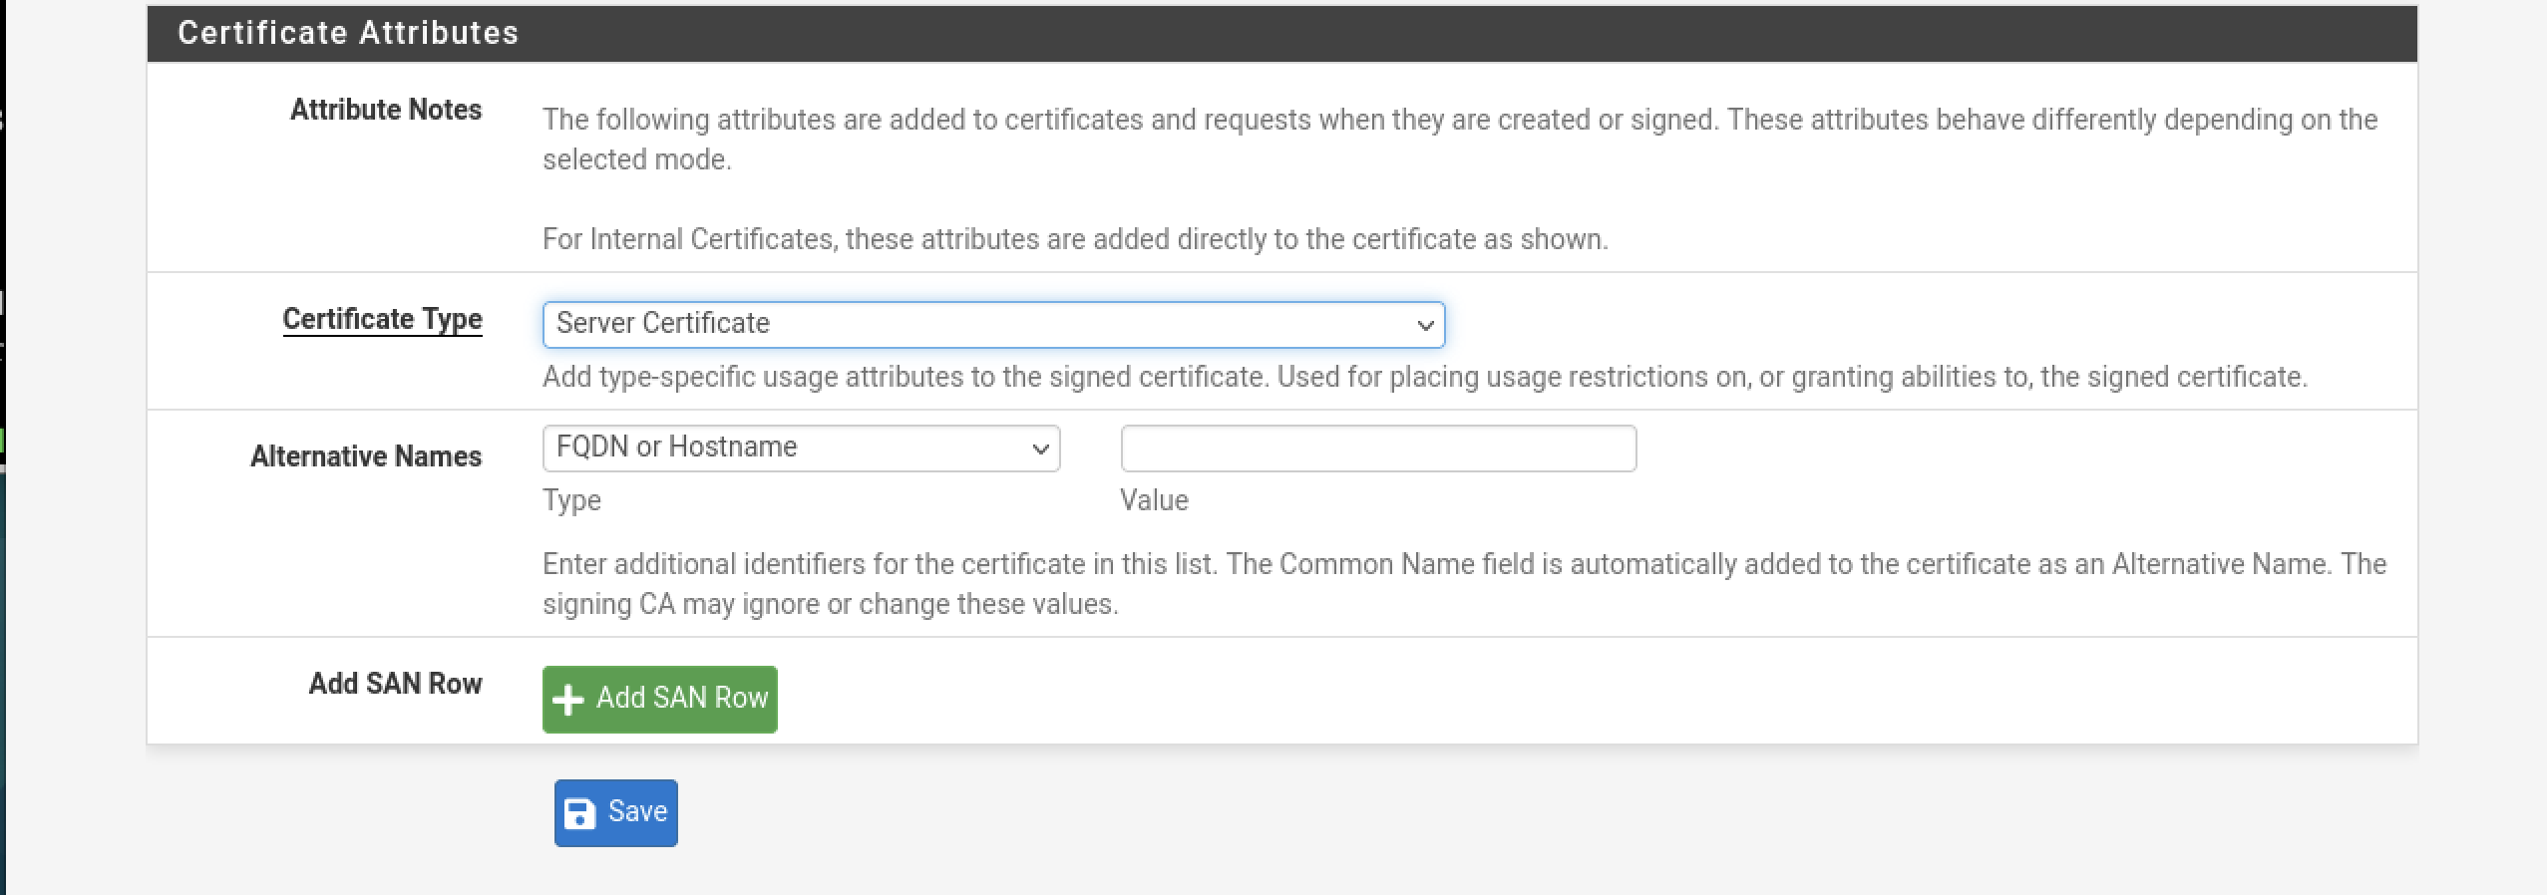
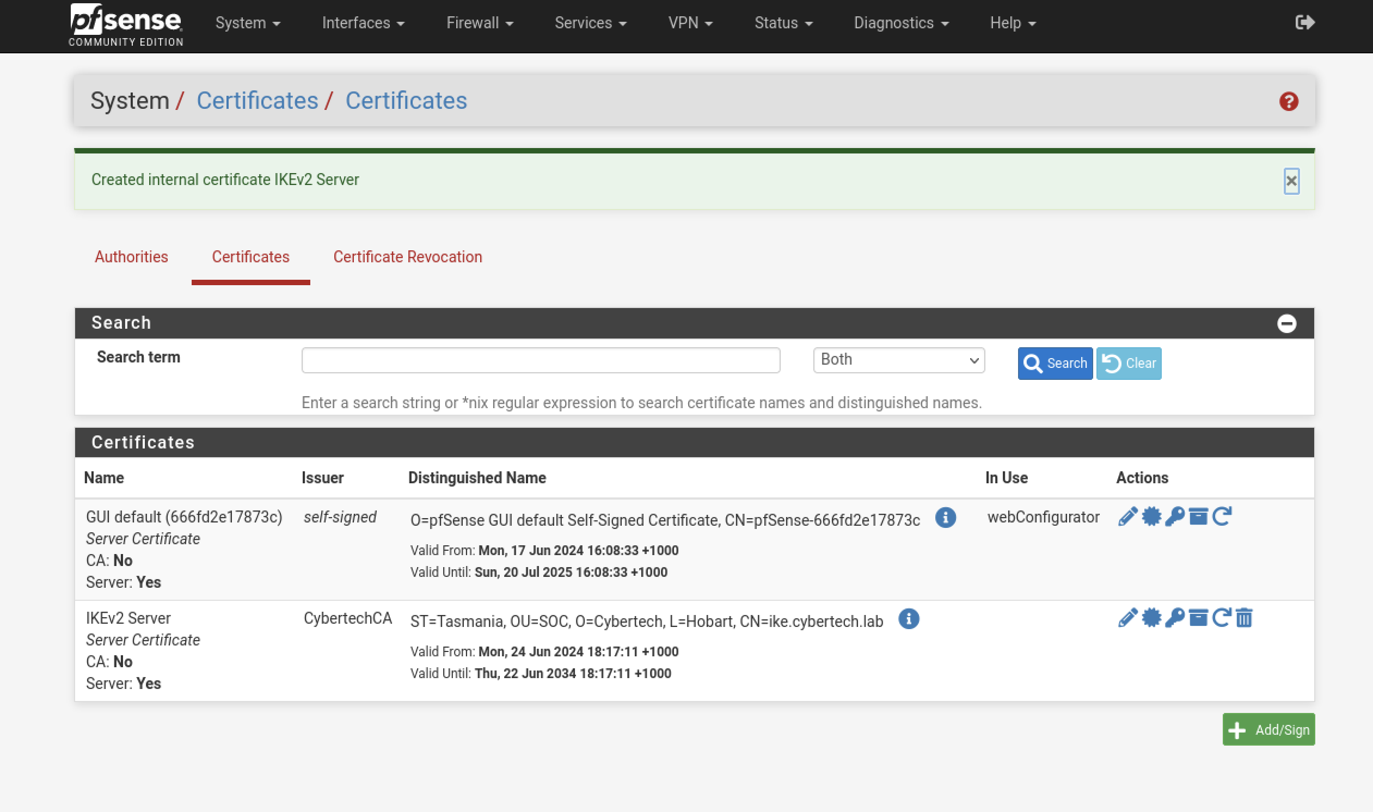

Task 3 – Mobile Client Settings

Step 1: Navigate to VPN > IPsec

Click on Mobile Clients tab
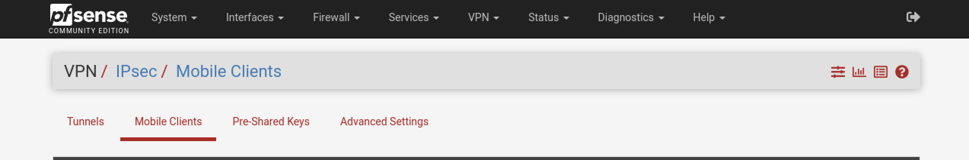
Enable IPsec Mobile Client Support: Checked
User Authentication: Local Database - Click on it, refer to screenshot.
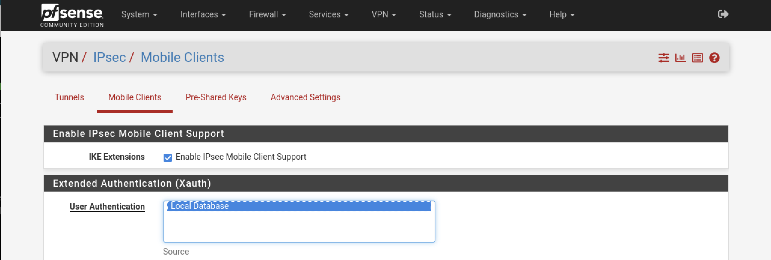
Virtual Address Pool: Checked, 10.10.10.0/24
DNS Default Domain: Checked, cybyertech.lab
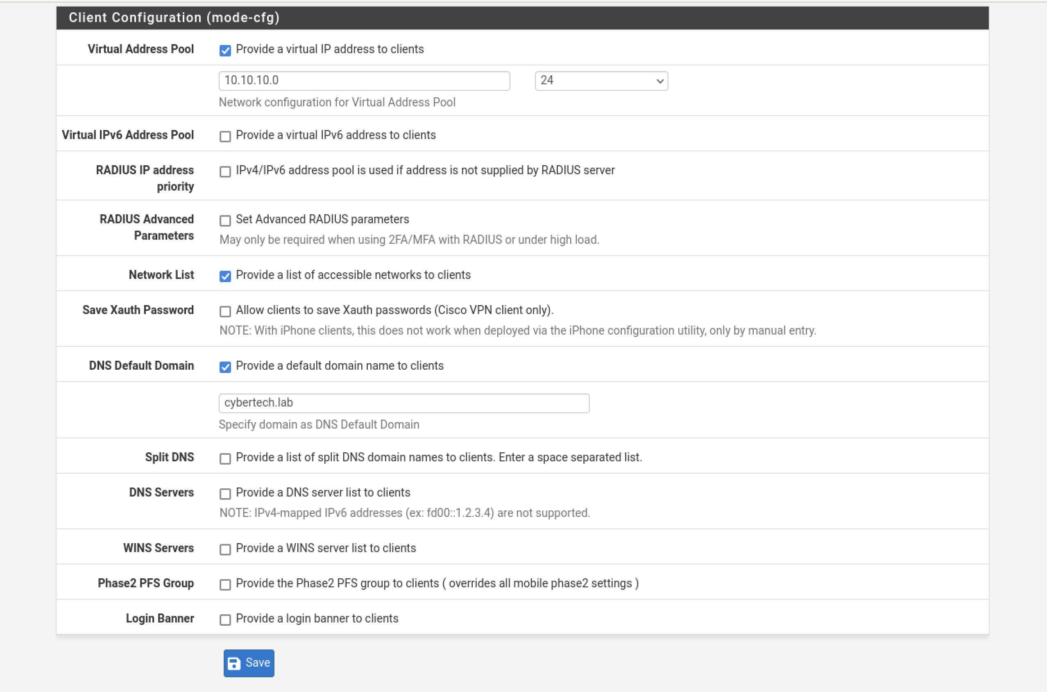
Save
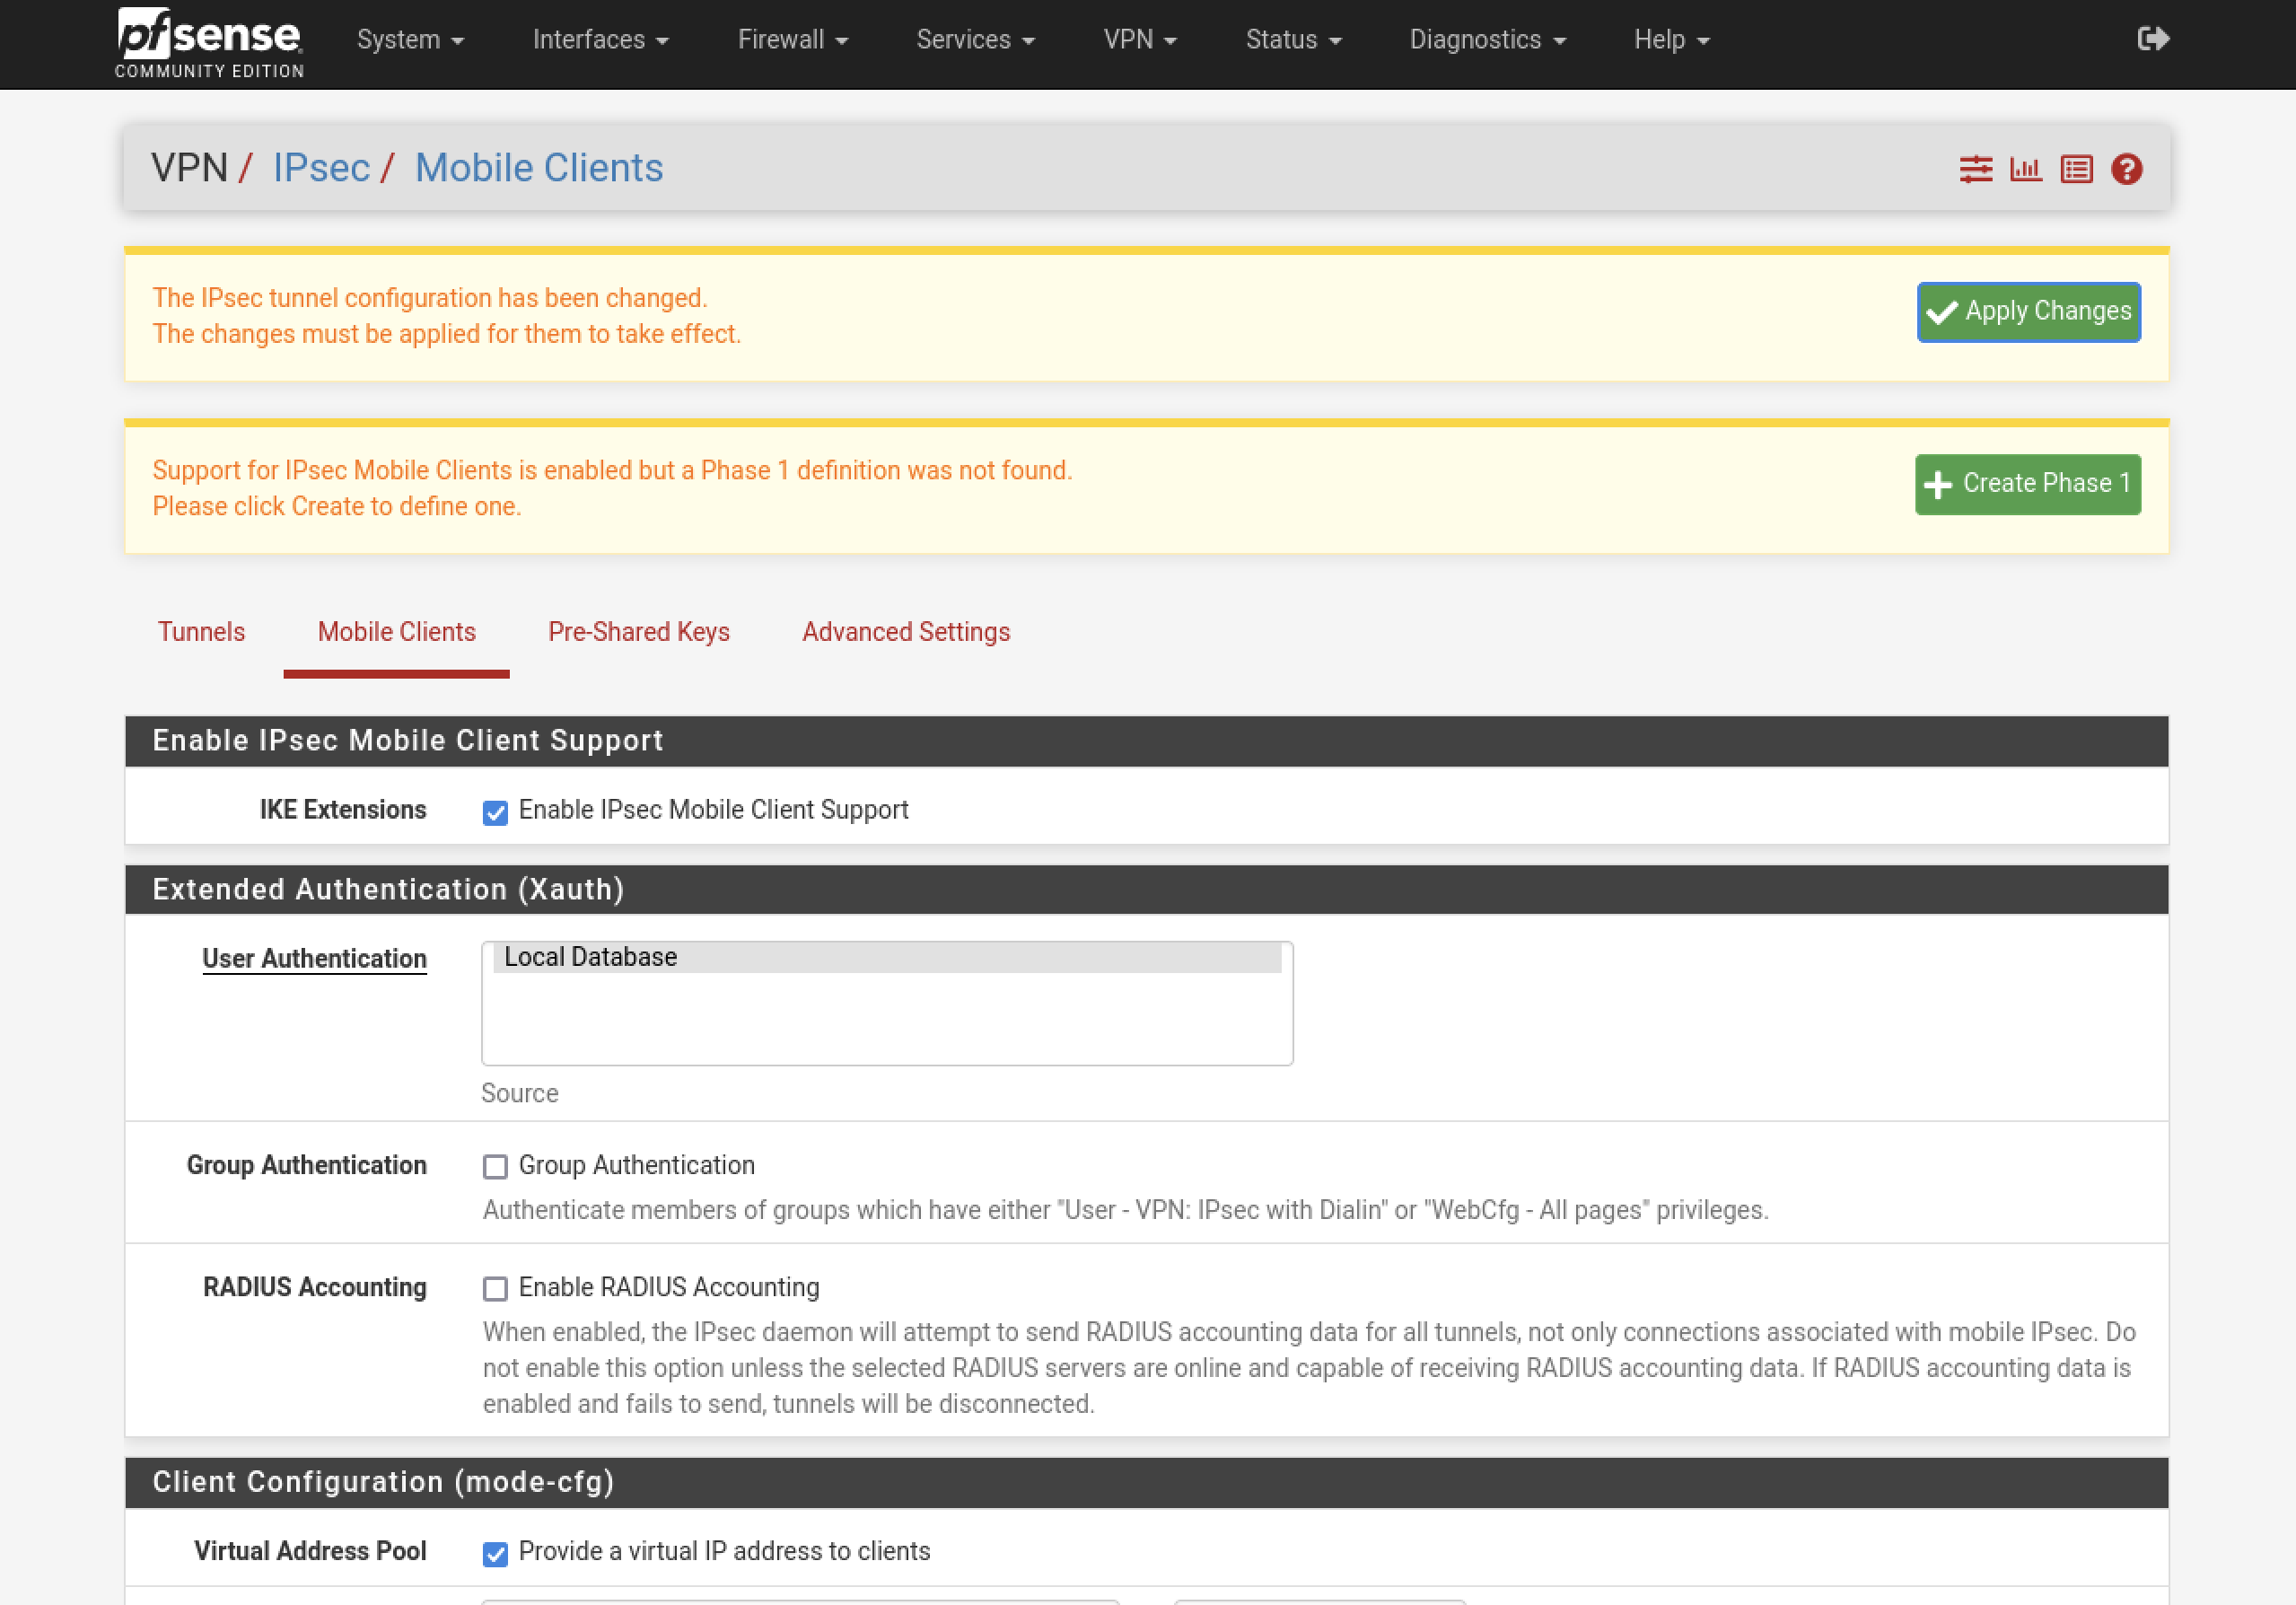

Step 2: Configure IKE Phase 1
Click on:


Description: Mobile IPsec
Key Exchange Version: IKEv2
Internet Protocol: IPv4
Interface: WAN
Authentication Method: EAP-MSCHAPv2
My identifier: Automatic based on content
Peer Identifier: Any
My Certificate: IKEv2 Server
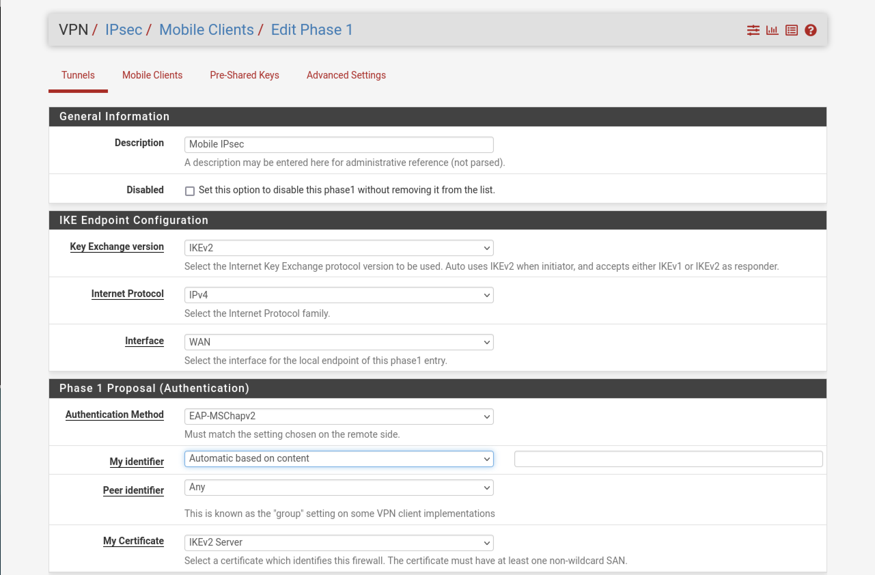
- Encryption Algorithm:
Add following:
Algorithm AES256-GCM, Hash SHA256, DH Group 16
Algorithm AES256-GCM, Hash SHA256, DH Group 2
- Life time: 28800
- Click Save

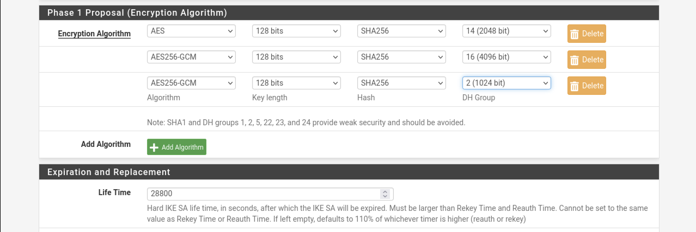
Expected screenshot:
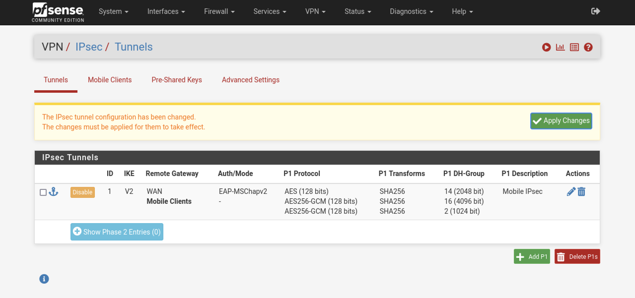

Step 3: Configure IKE Phase 2
Click  Show Phase 2 Entries to expand the list of mobile phase 2 entries

Click Add P2 to add a new mobile phase 2.

- Description: Mobile IPv4
- Mode: Tunnel IPv4
- Local Network: LAN subnet
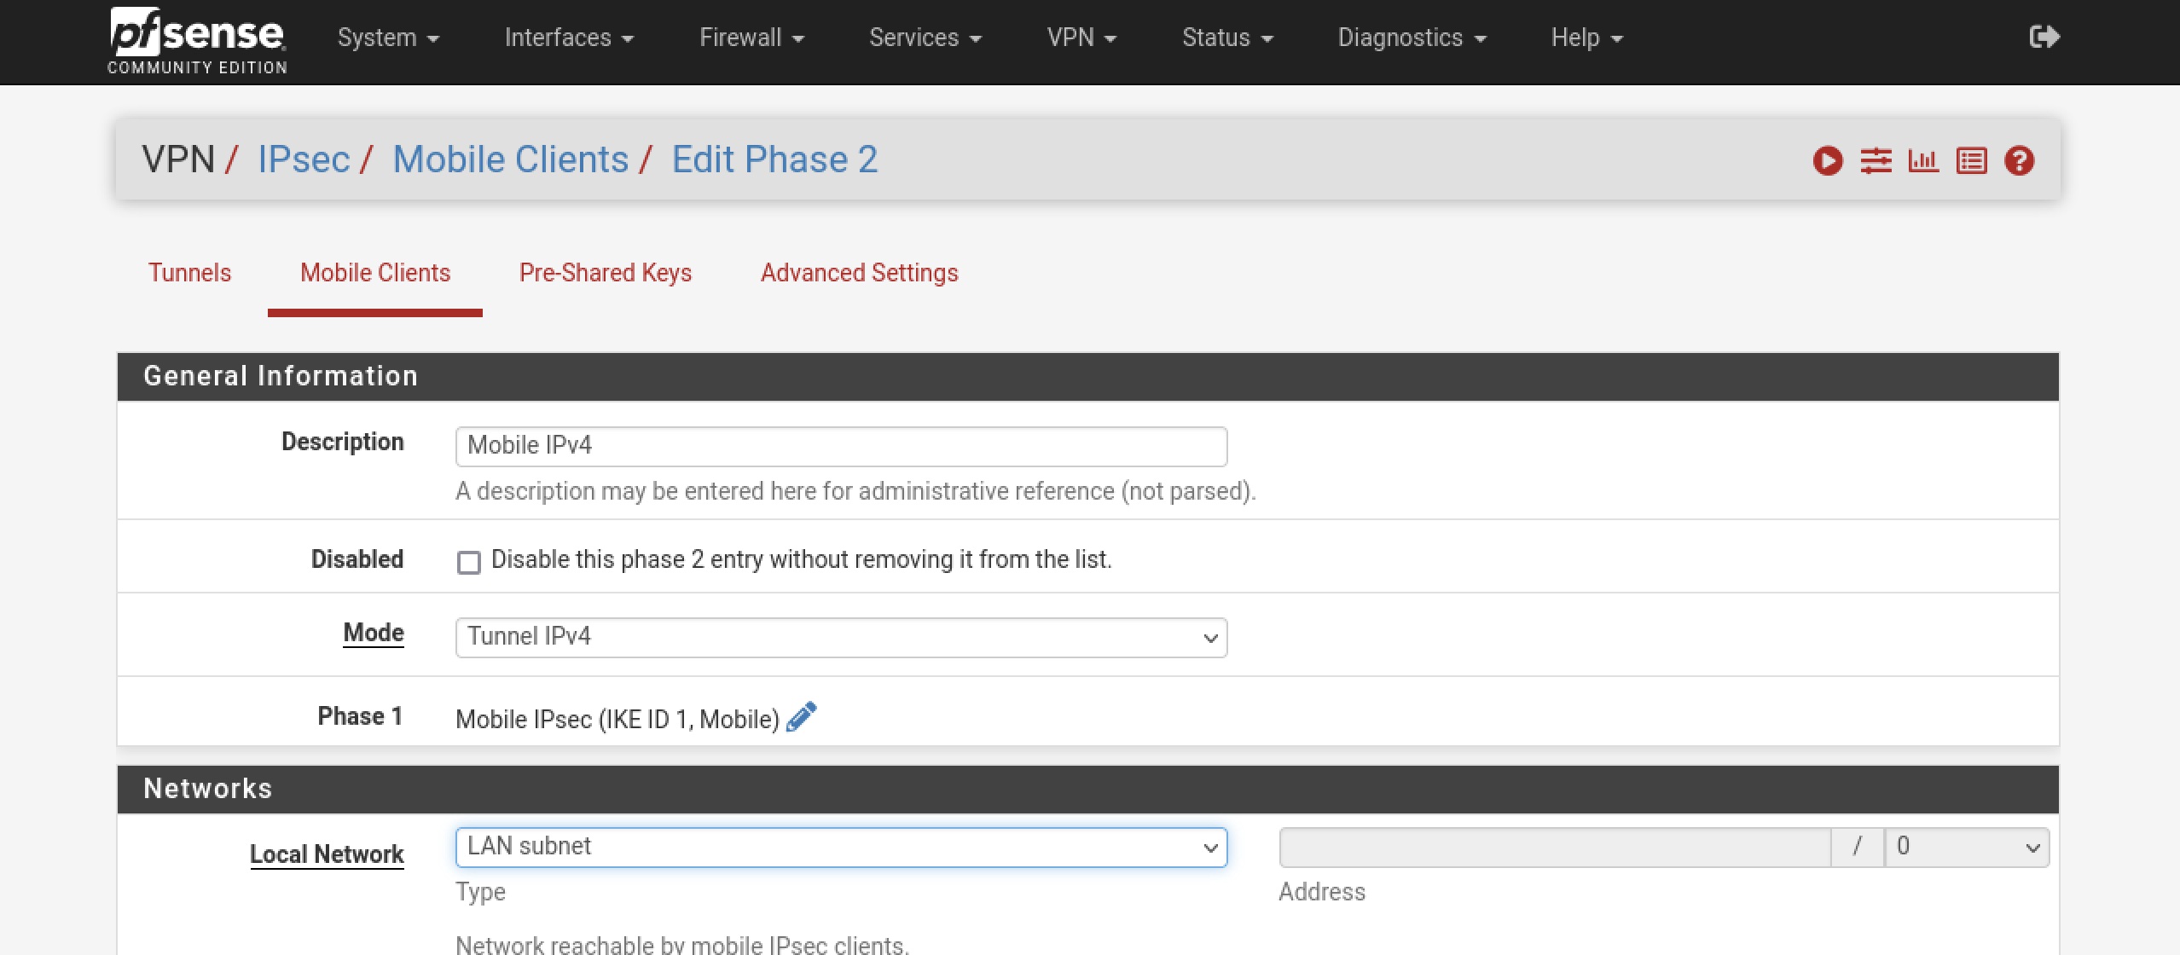
- Protocol: ESP
- Encryption algorithms:
- AES, 128
- AES128-GCM, 128
- AES256-GCM, 128
- Hash algorithms:
- SHA1
- SHA256
- SHA384
- SHA512
- PFS Key Group:14 (2048 bit)
- Save
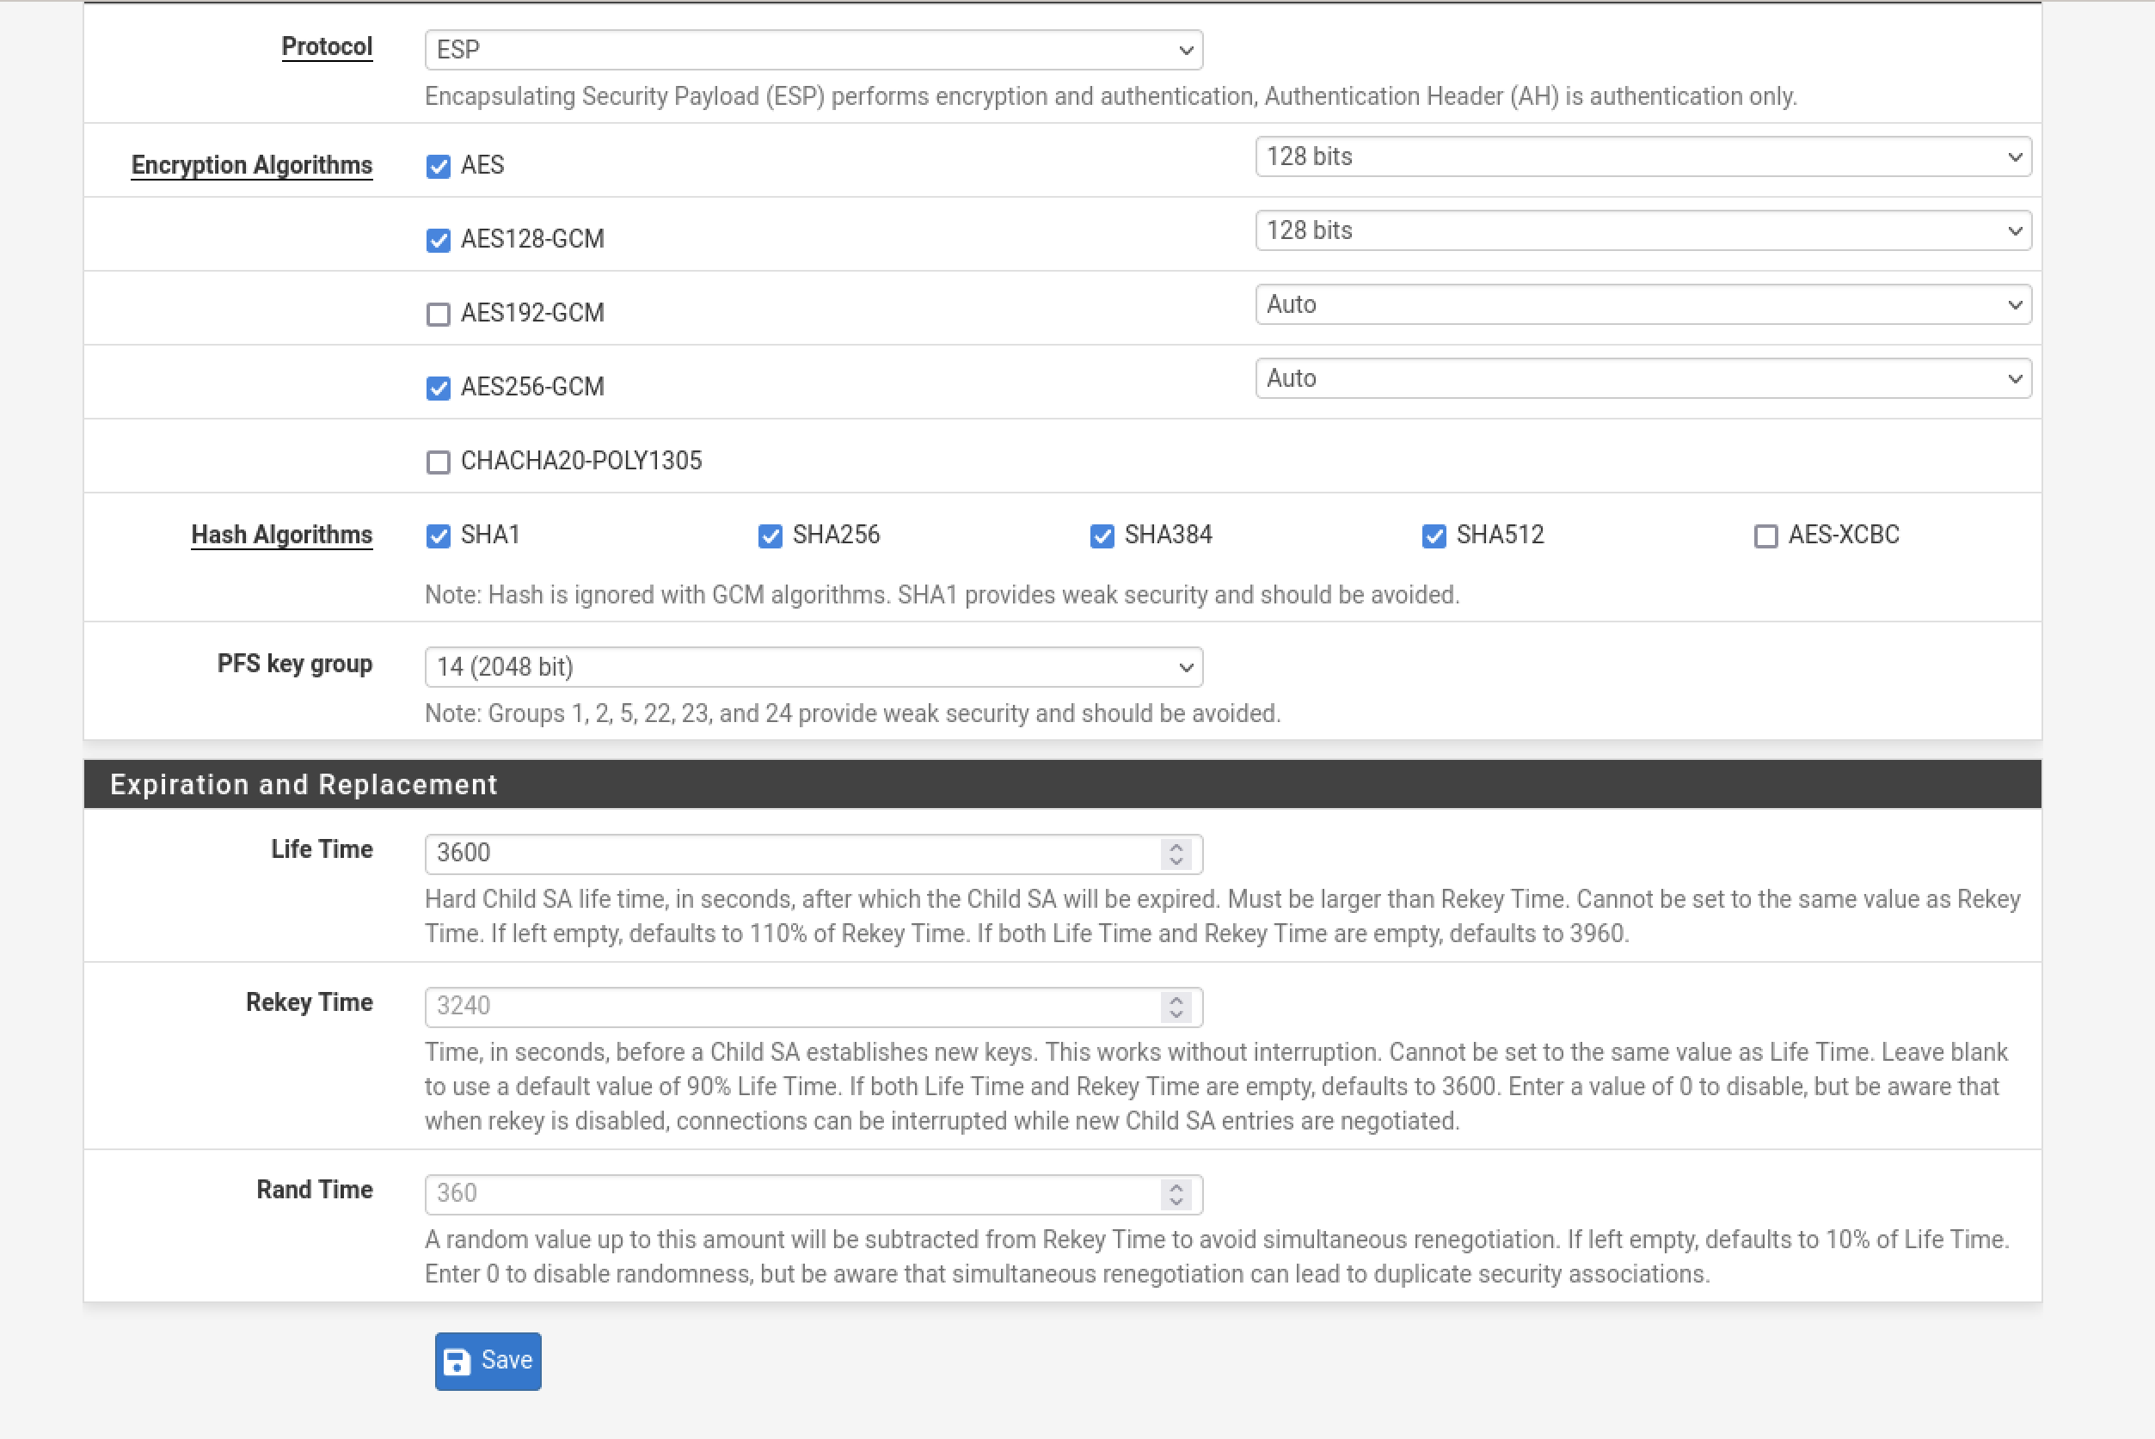
Expand Phase 2
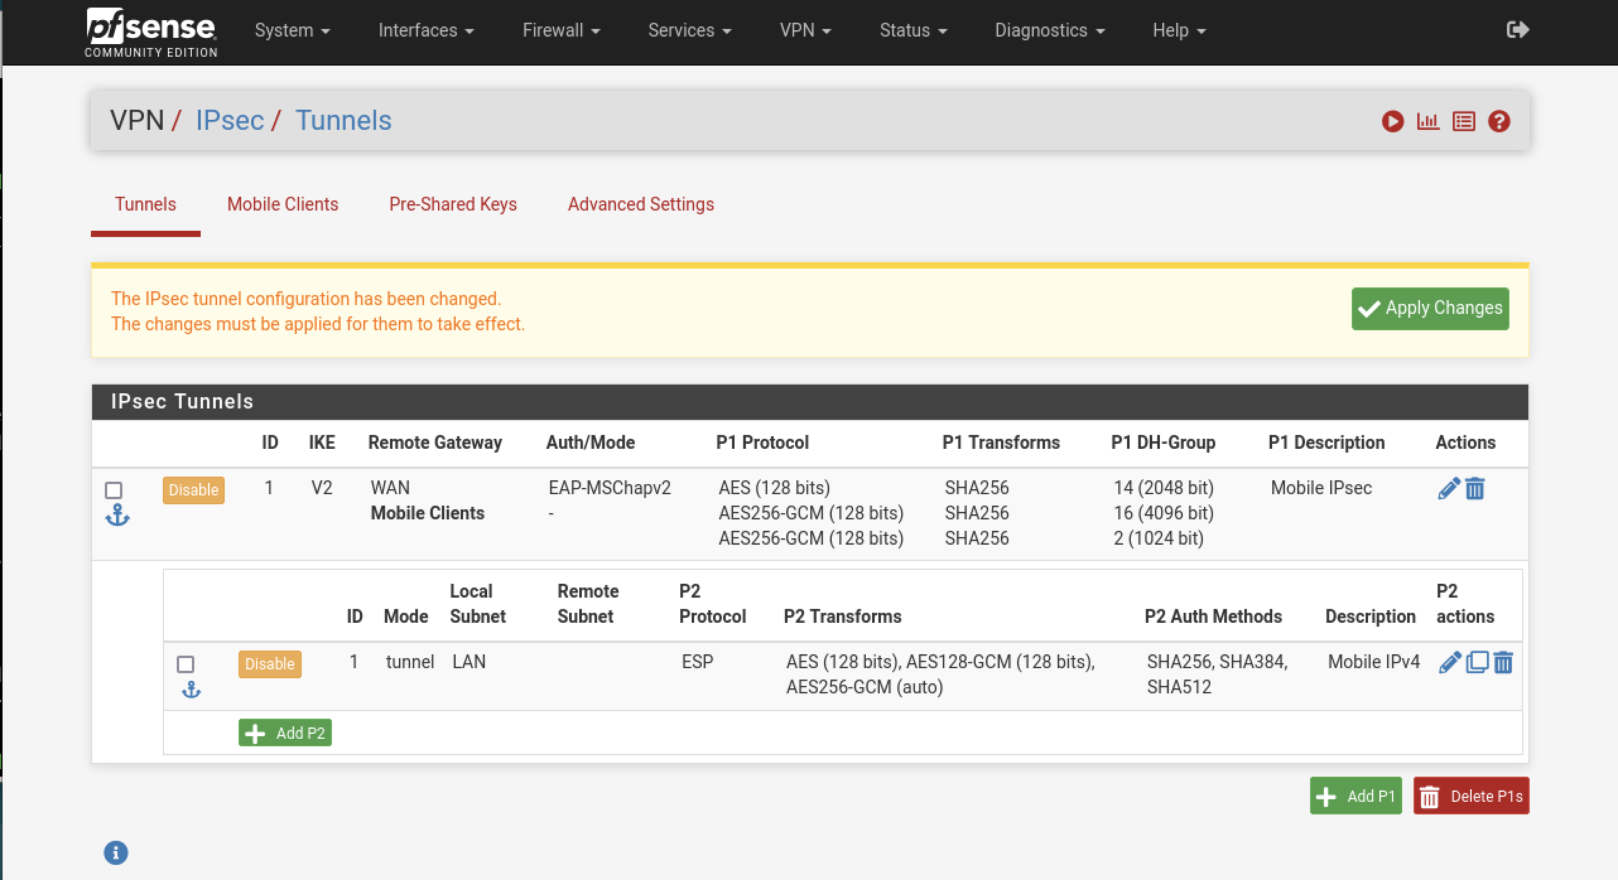
Apply Changes

Task 4 – Mobile IPsec User Creation

Step 1: • Navigate to VPN > IPsec, Pre-Shared Keys tab

Click Add to add a new key
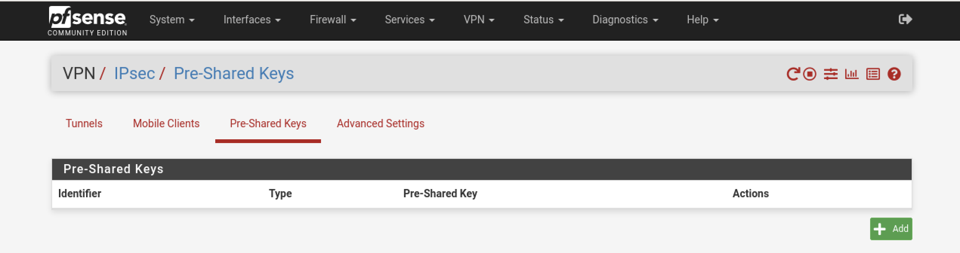
Configure the options as follows:
- Identifier: vpnuser - The username for the client.
- Secret Type: EAP
- Pre-Shared Key: vpnpassword
- Save
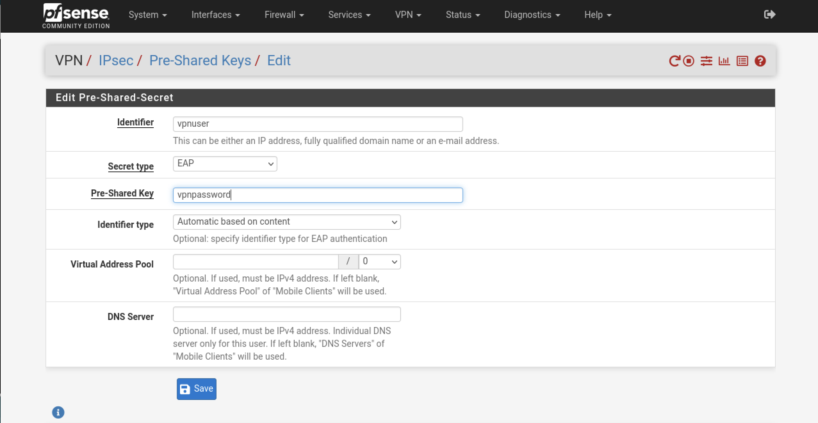

Apply Changes.
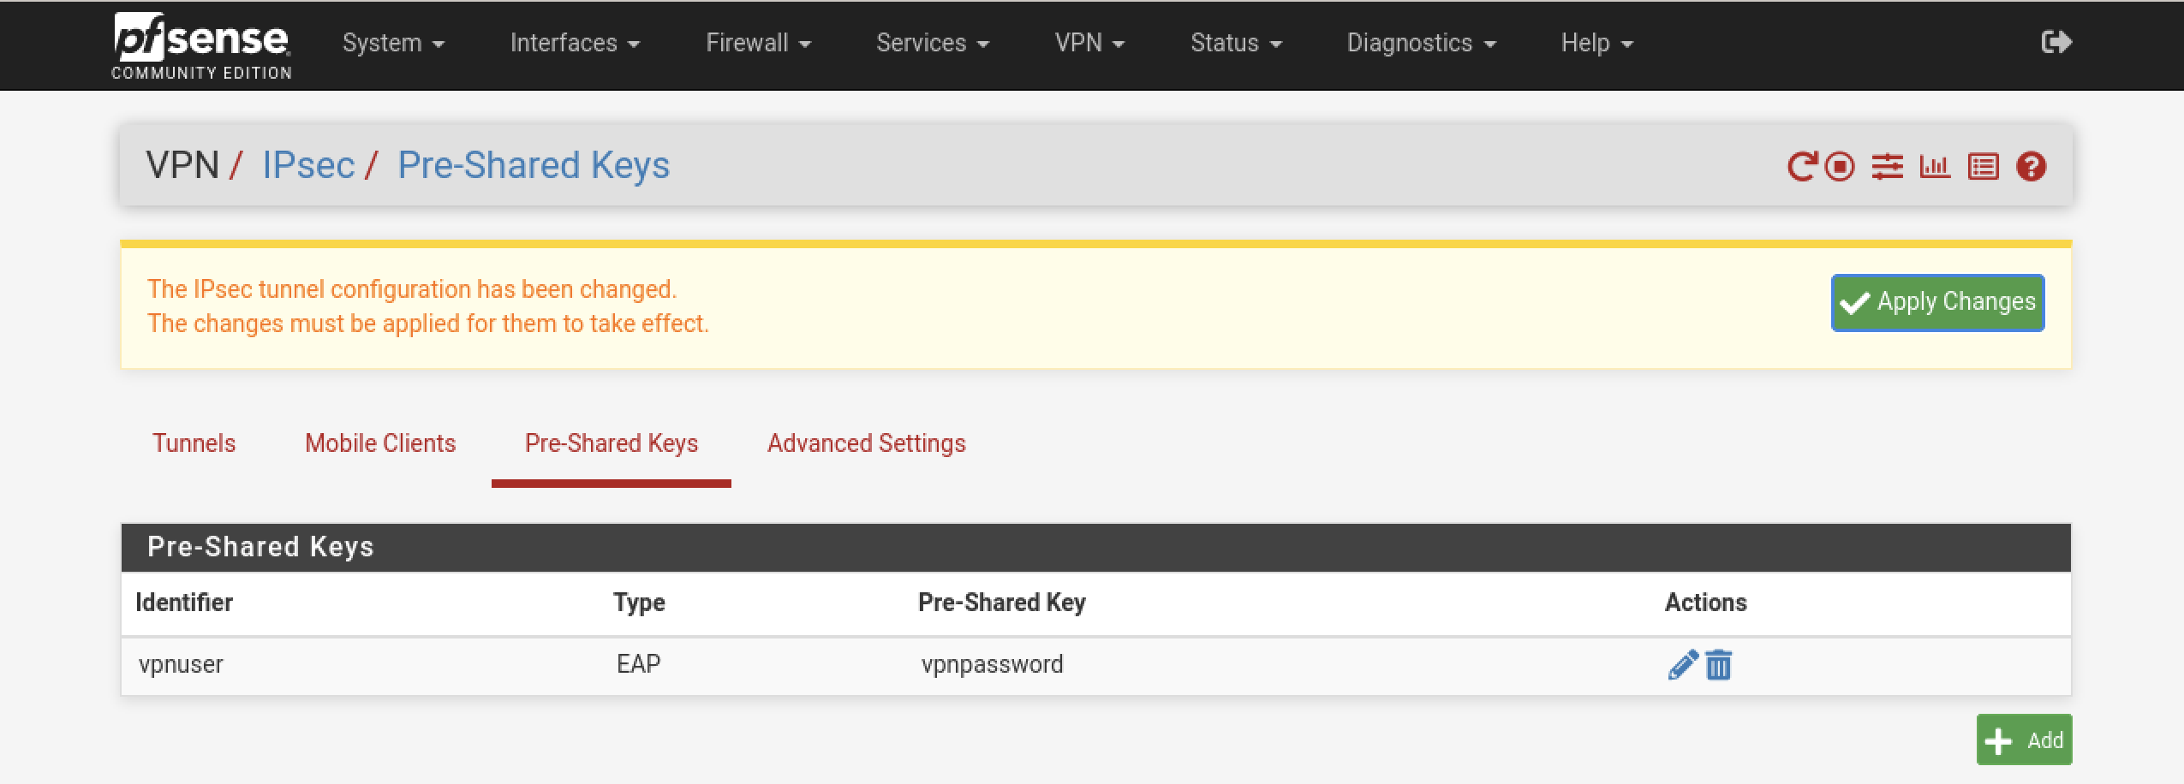

Task 5 – Configure WAN Interface

Step 1: Go to Interfaces >WAN

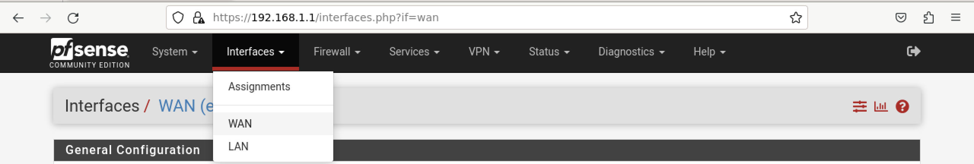
Block private networks and loopback addresses: Unchecked
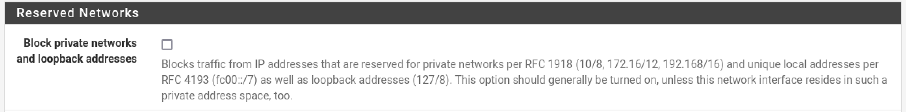
Note: This is for Lab purposes only. Please read description.
Save
Apply Changes

Step 2 – Find IPv4 WAN address

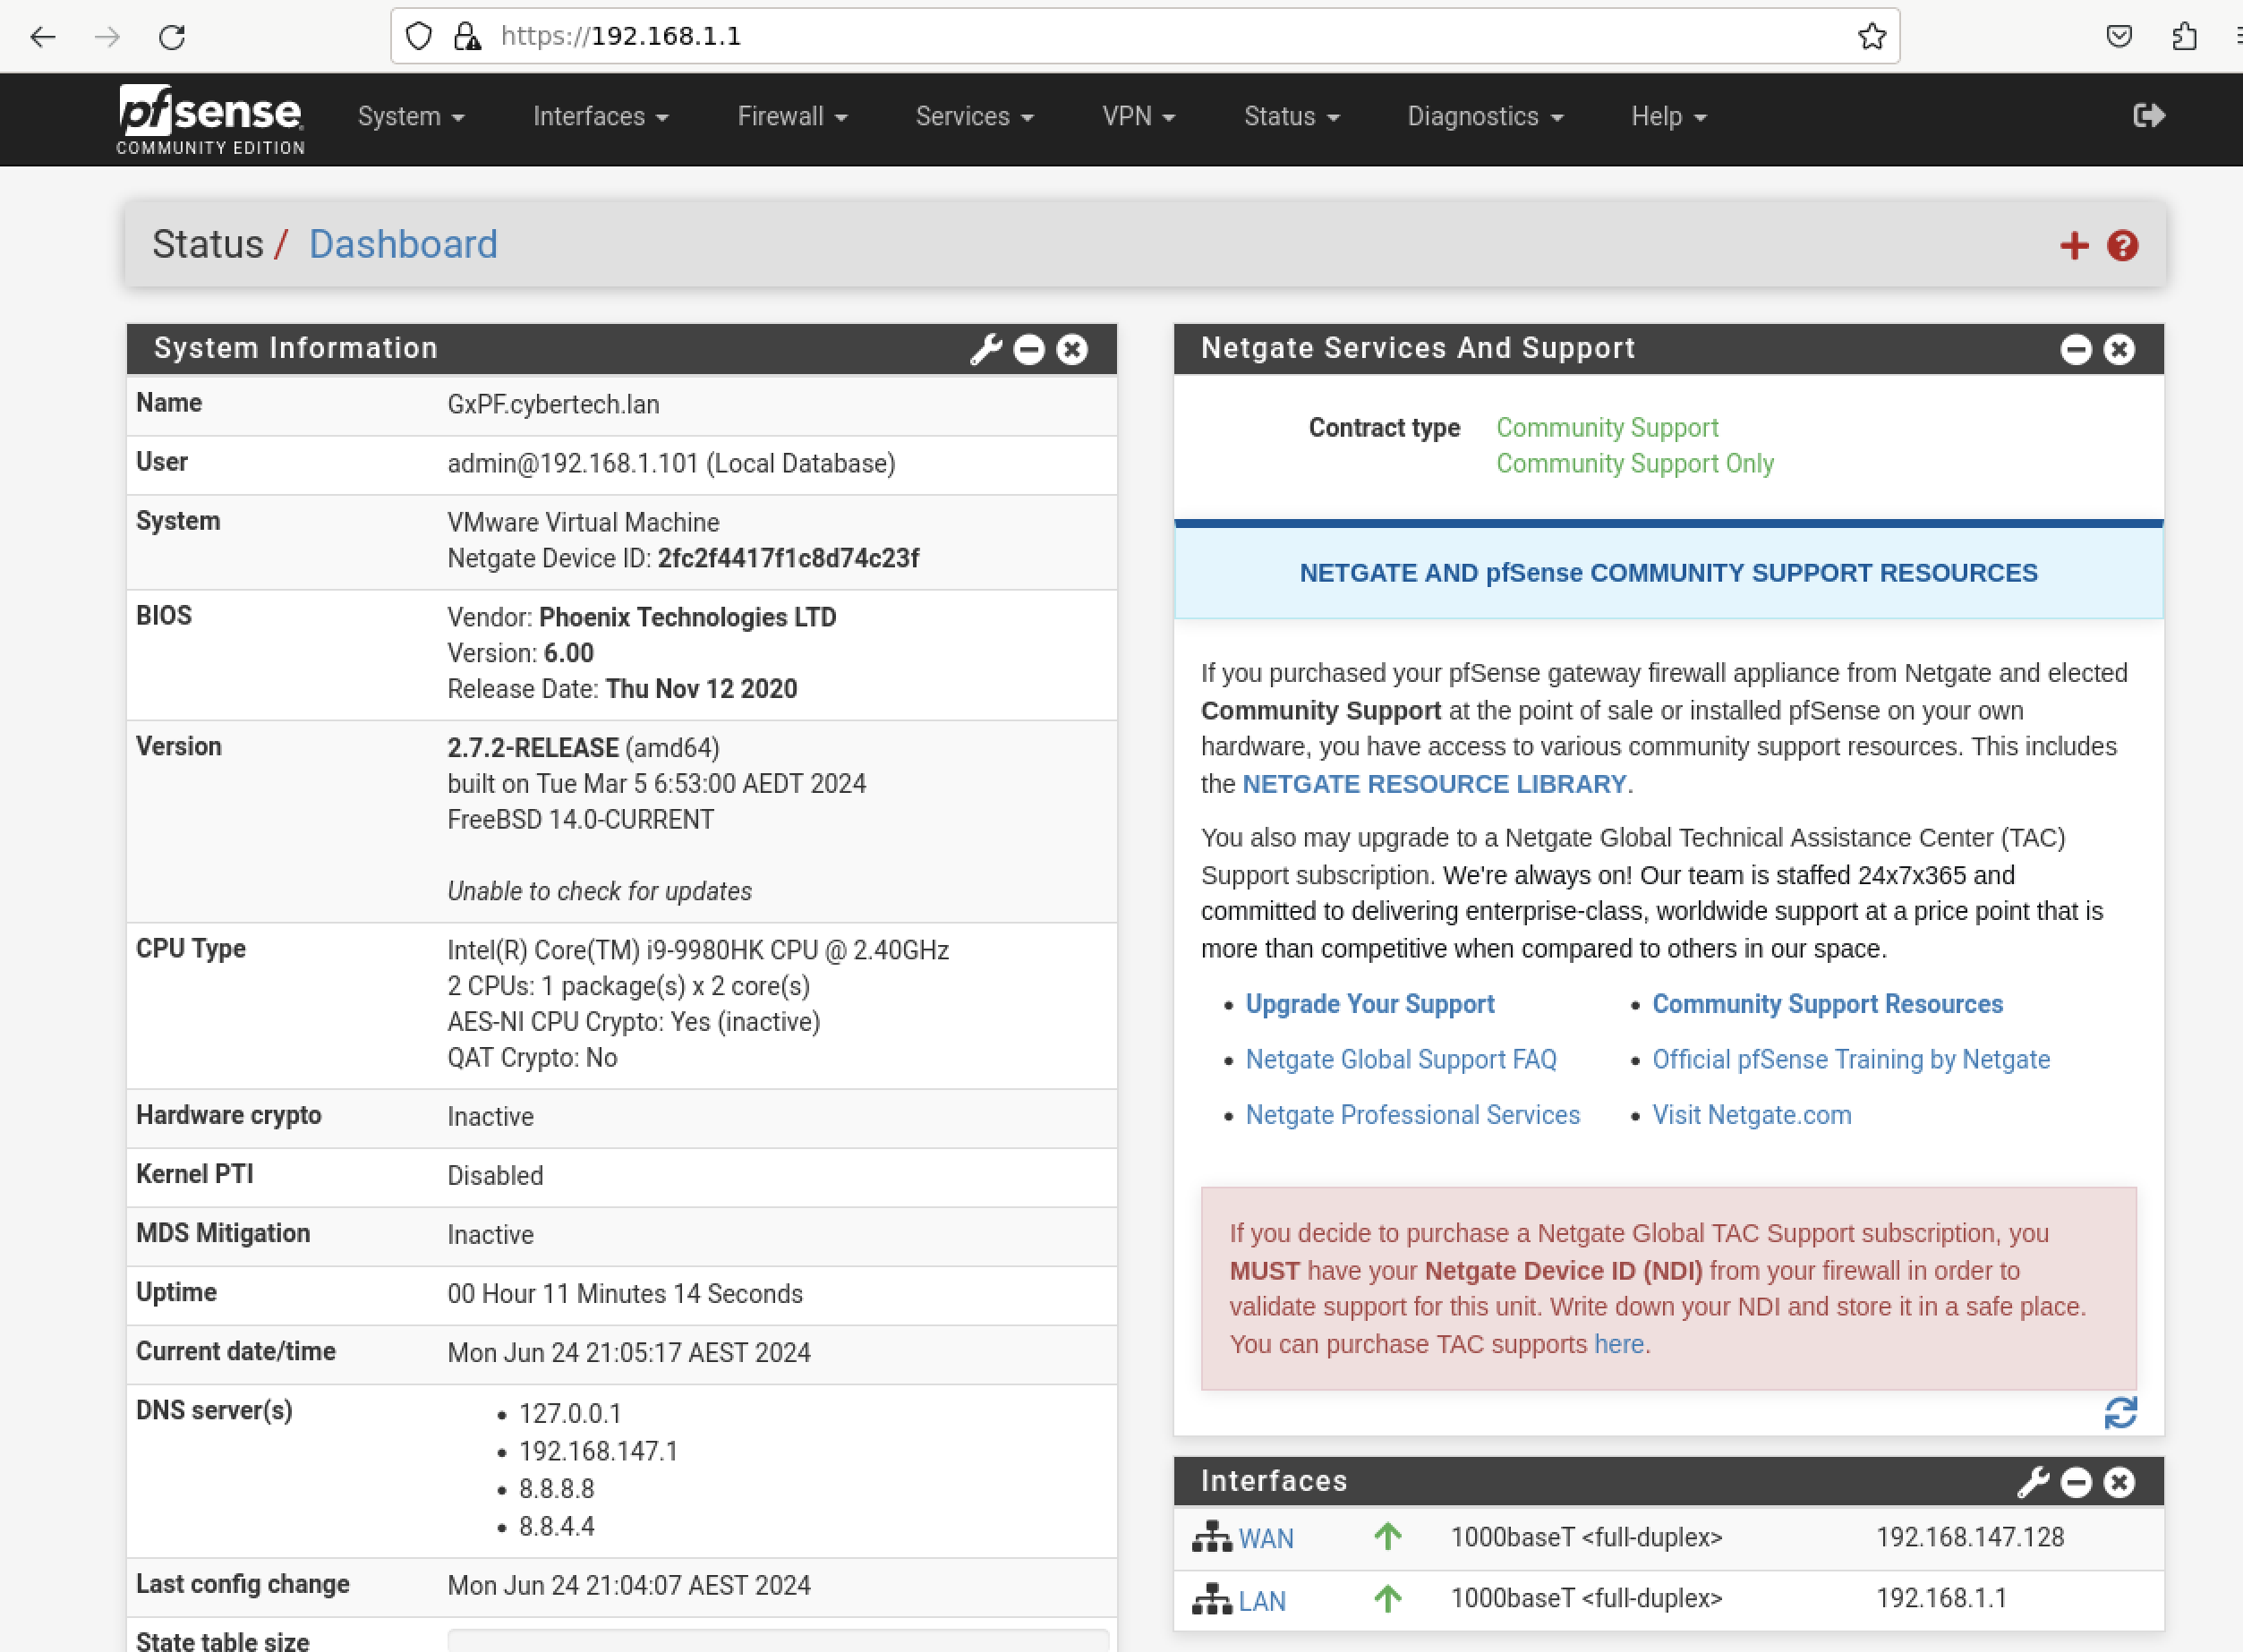
In this case it is 192.168.147.128

Task 5 – Configuring Windows 10 Client

Step 1: Change Windows registry

For this to work we need to change windows registry key.
Open regedit

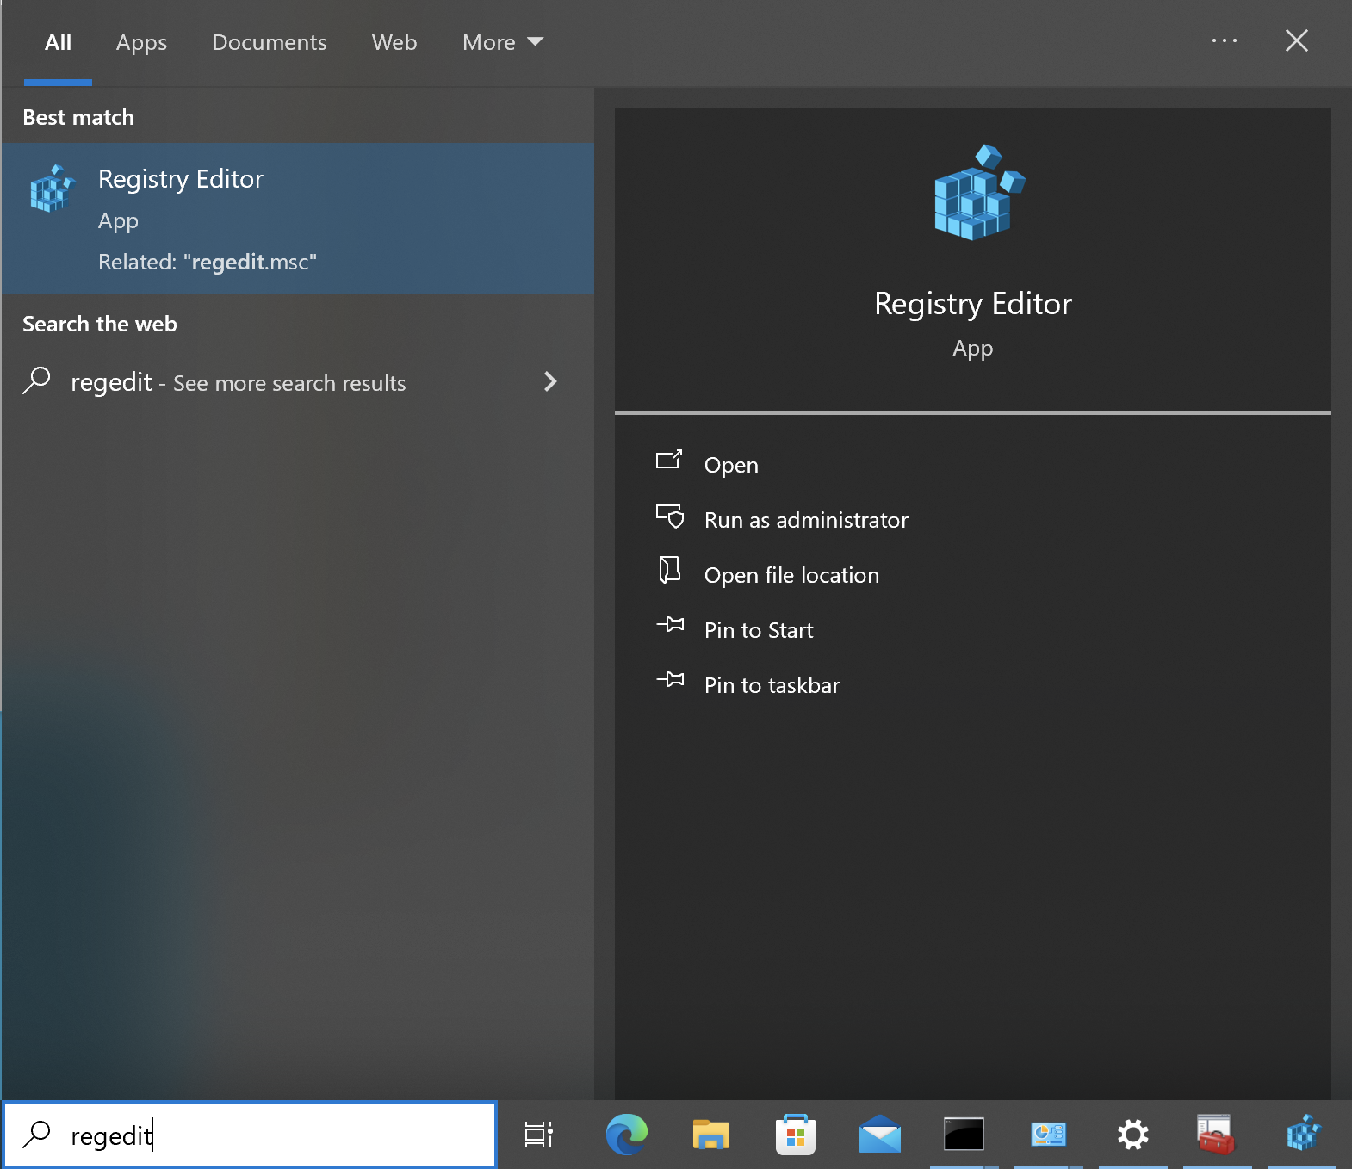
Navigate to:
Computer\HKEY_LOCAL_MACHINE\SYSTEM\CurrentControlSet\Services\RasMan\Parameters

Add new DWORD
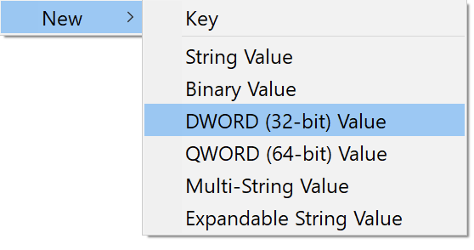
Value name: DisableIKENameEkuCheck
Value data: 1
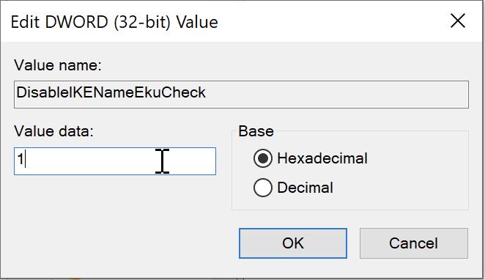

Step 2: Import the CA to the Client

- Copy CybertechCA certificate from Host PC to Windows VM
If you do not have CybertechCA go to LINK
- Right click on CybertechCA > Install Certificate
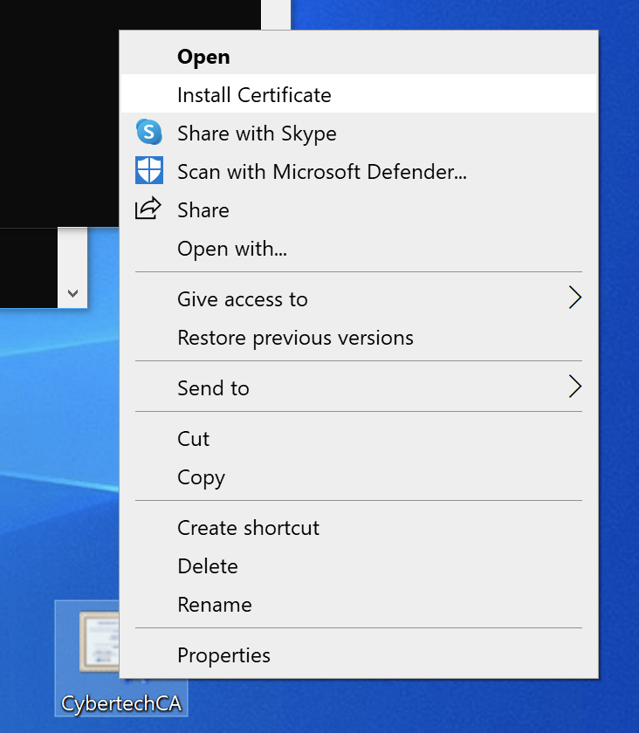
- Click on Install Certificate Button
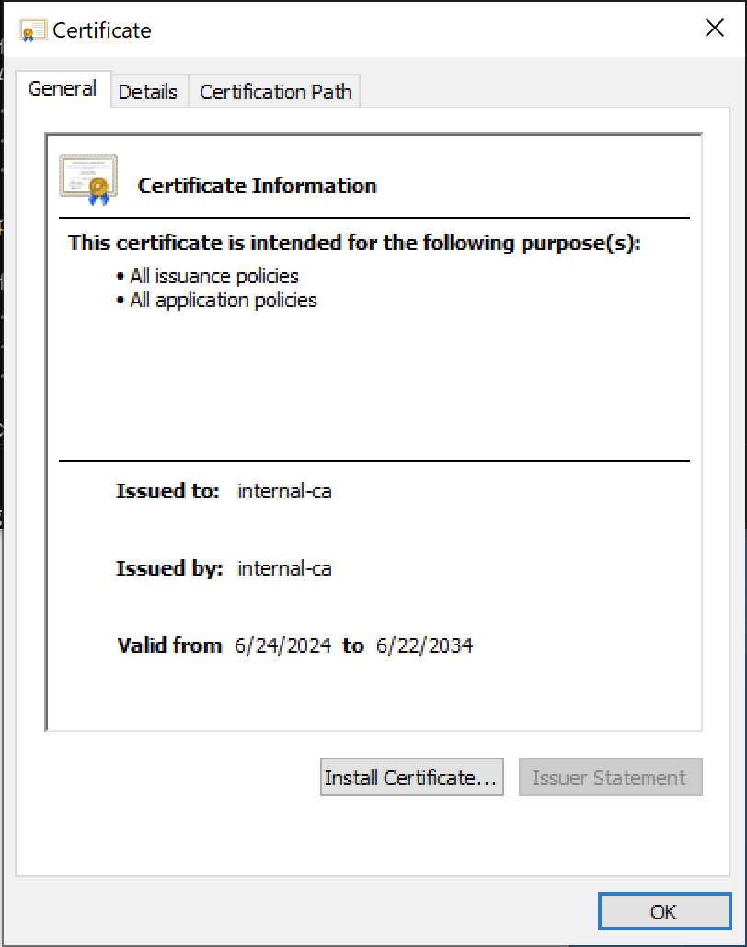
- Store Location: Local Machine
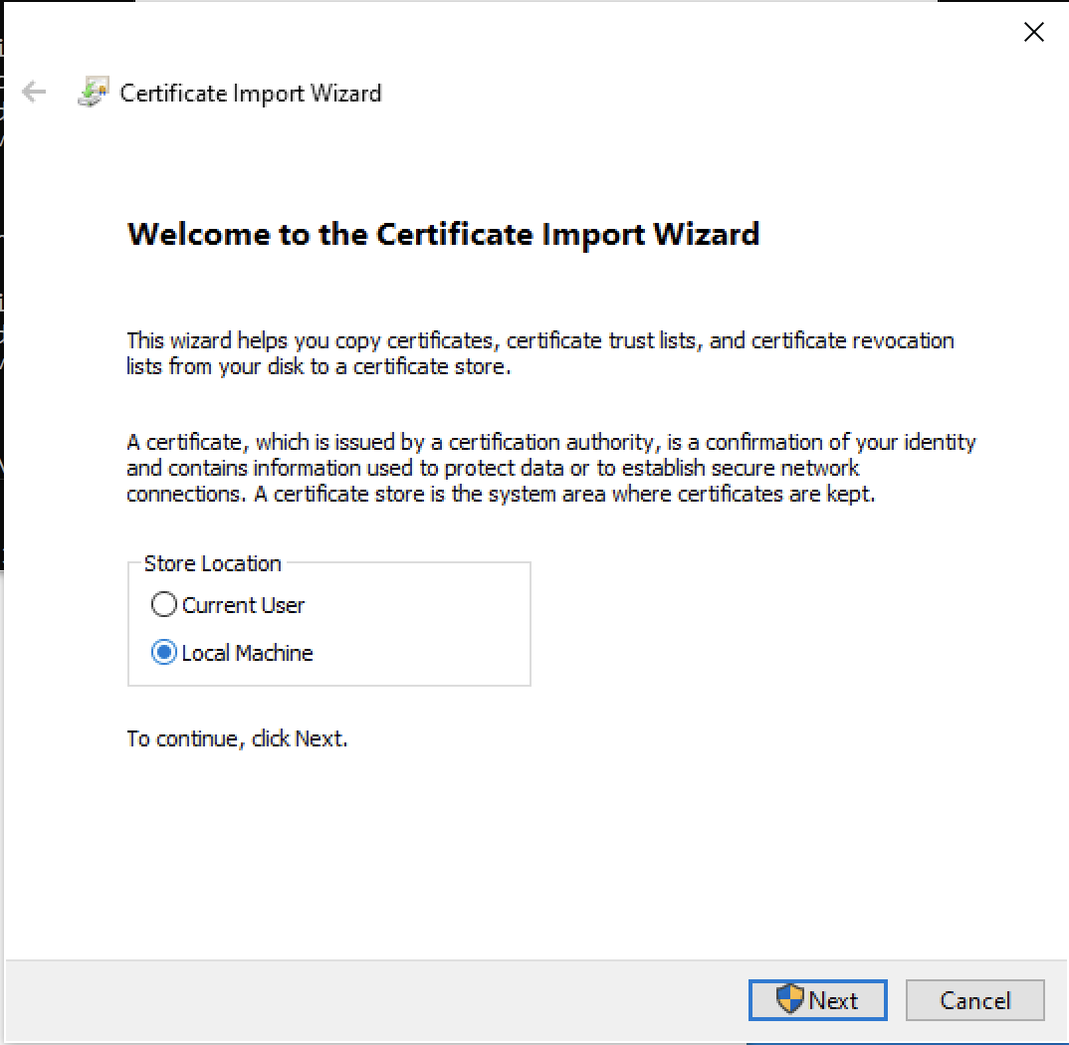
- Click on Yes
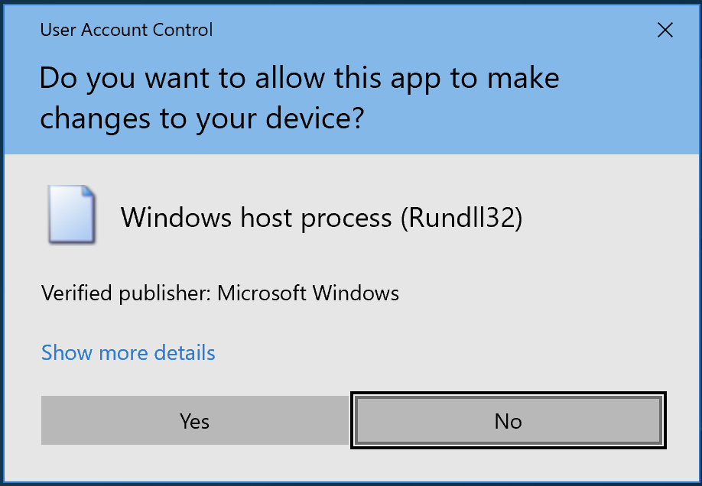

- Select Place all Certificates in the following store
- Click Browse
- Click Trusted Root Certification Authorities as shown in screenshot.
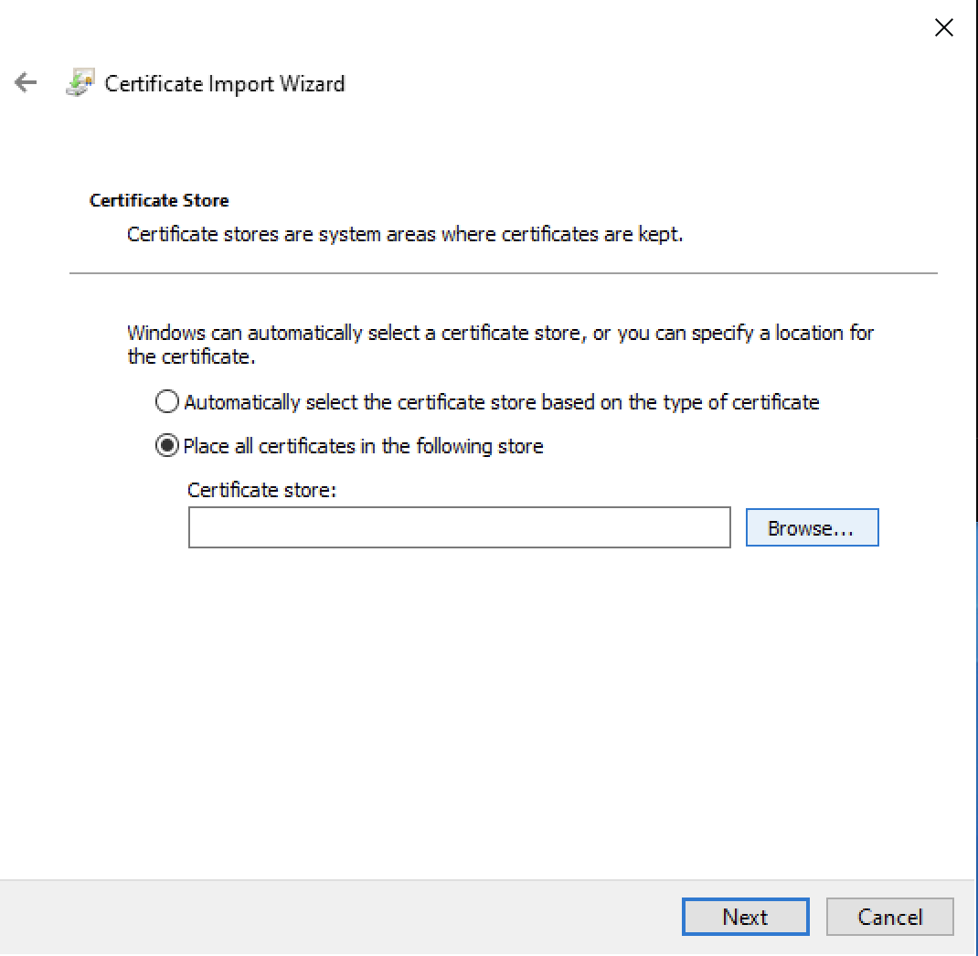
- Click Trusted Root Certification Authorities
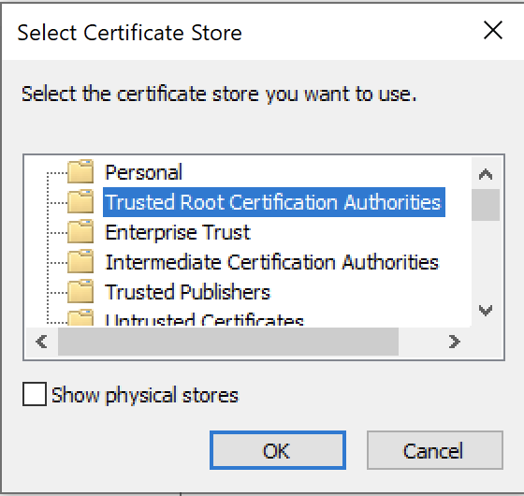
- Click OK
- Click Next
- Review the details, they should match those in screenshot
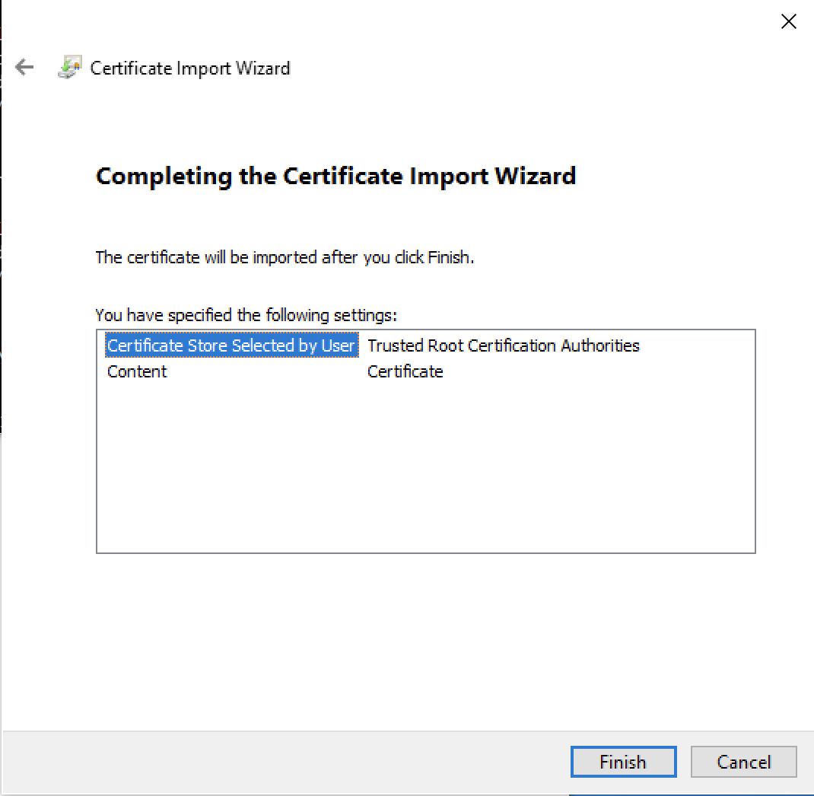
- Click Finish
- Click OK
- Click OK

Step 3: Verify that Certificate has been imported

- Open Manage User Certificates
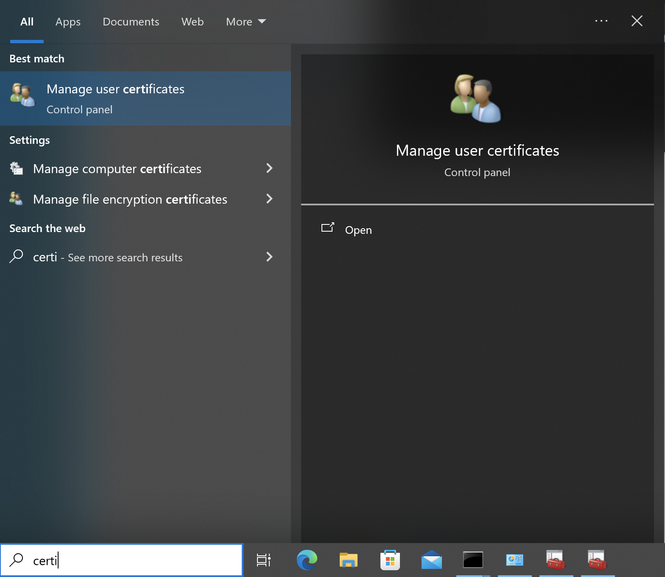
- Navigate
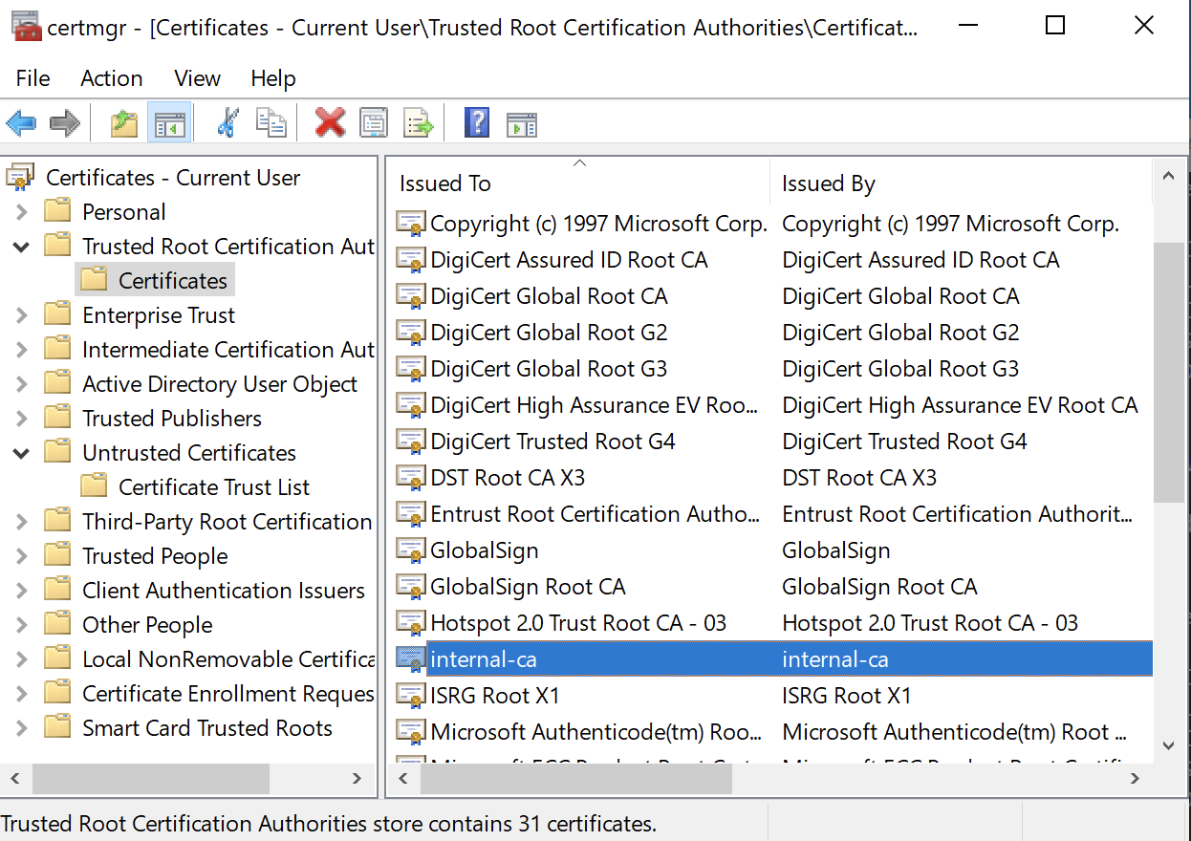
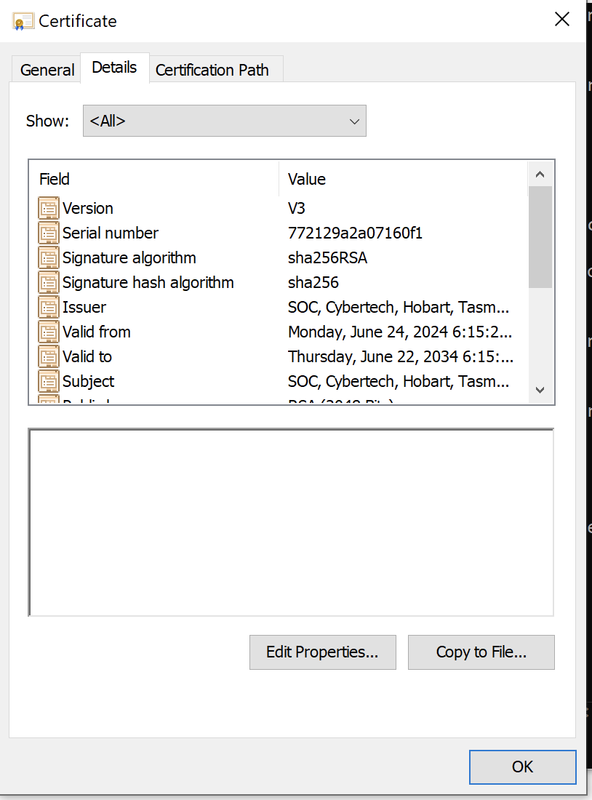

Step 3: Configure VPN client connection

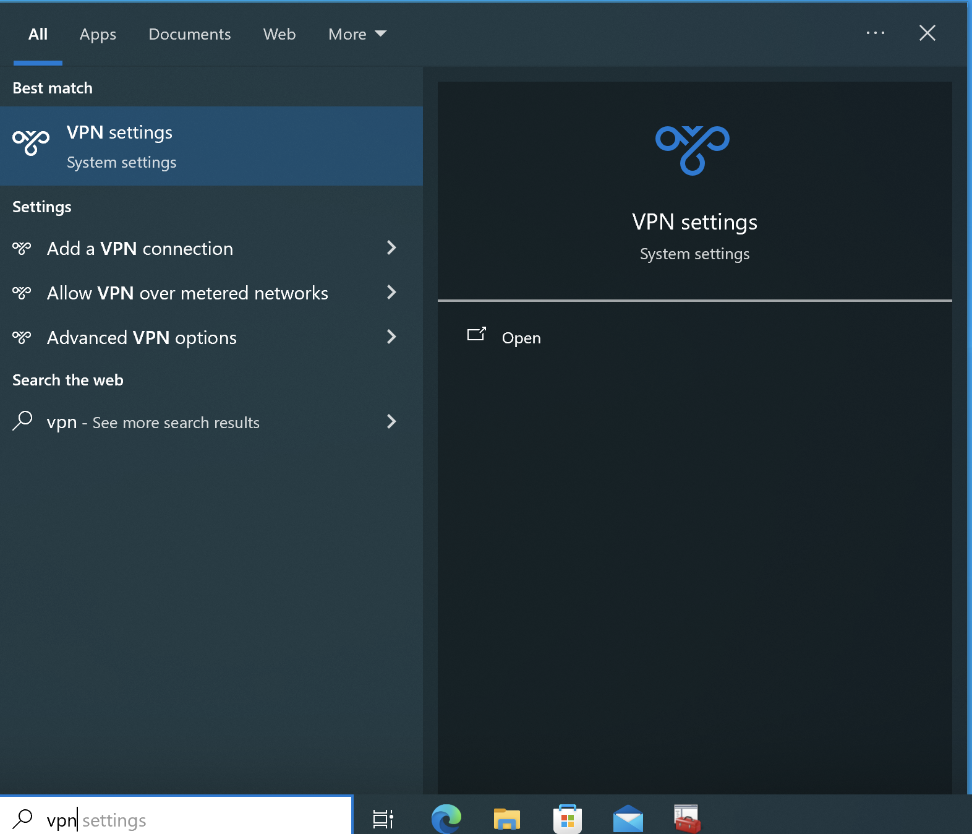
- Add a VPN Connection
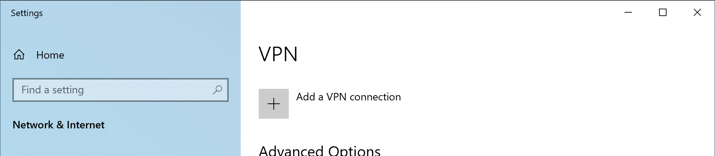
- Configure as per screenshot
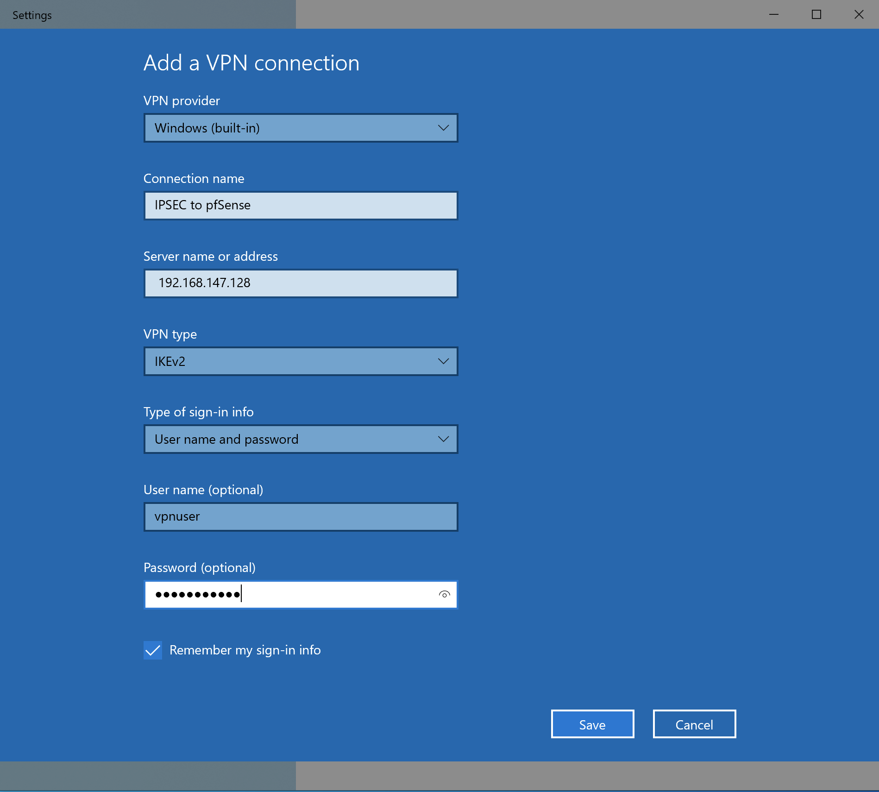
Username: vpnuser
Password: vpnpassword
- Click on Save
- Click on new icon to expand options and click on Connect.
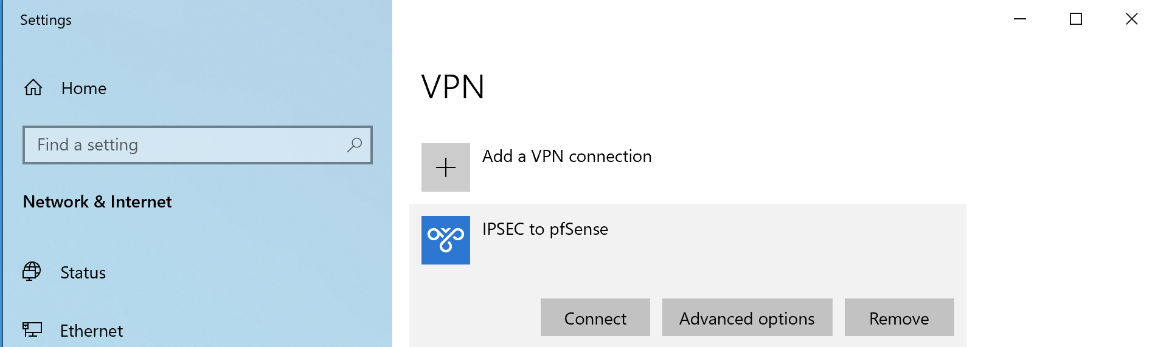
- Happy Days \0/
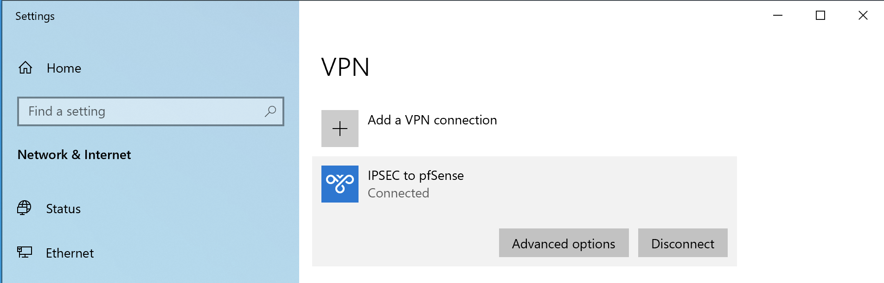
- Verify IPv4
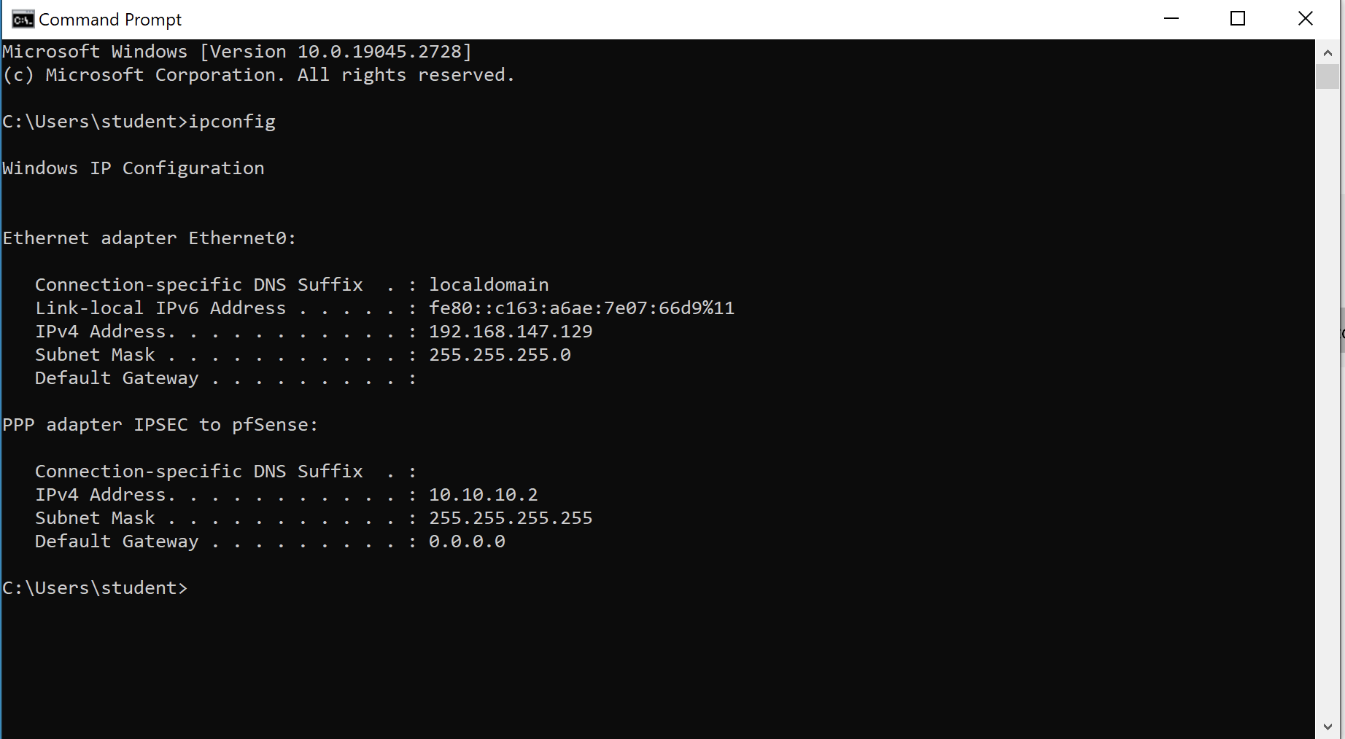
- Verify status of IPSEC on pfSense
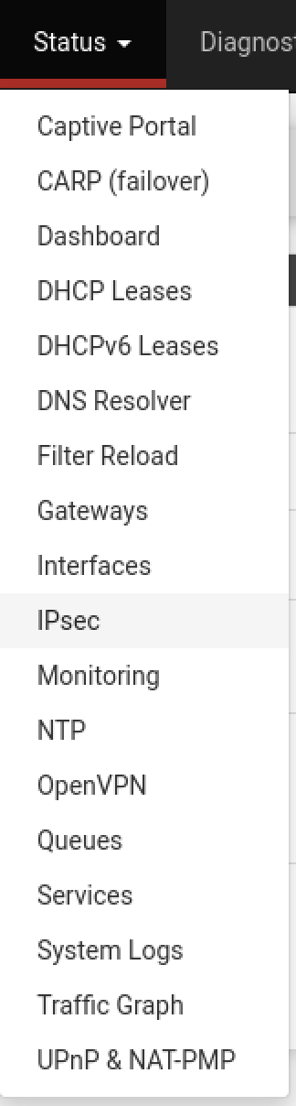
- Analyse output
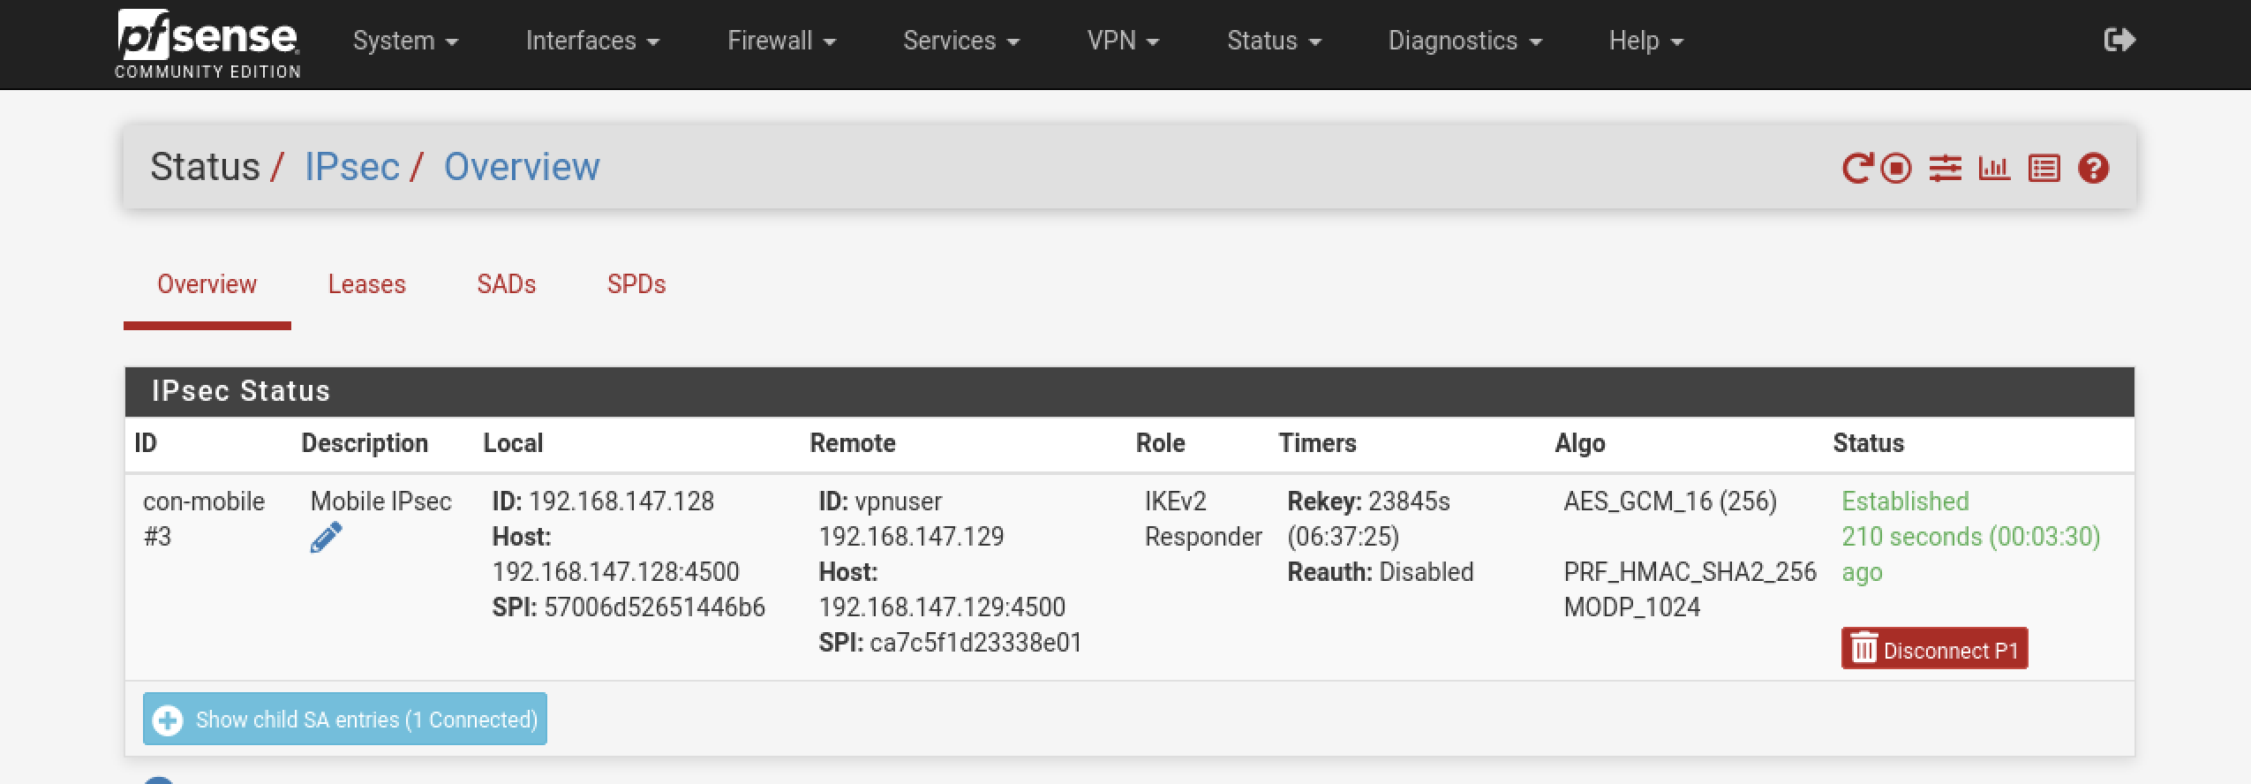
- IP Leases
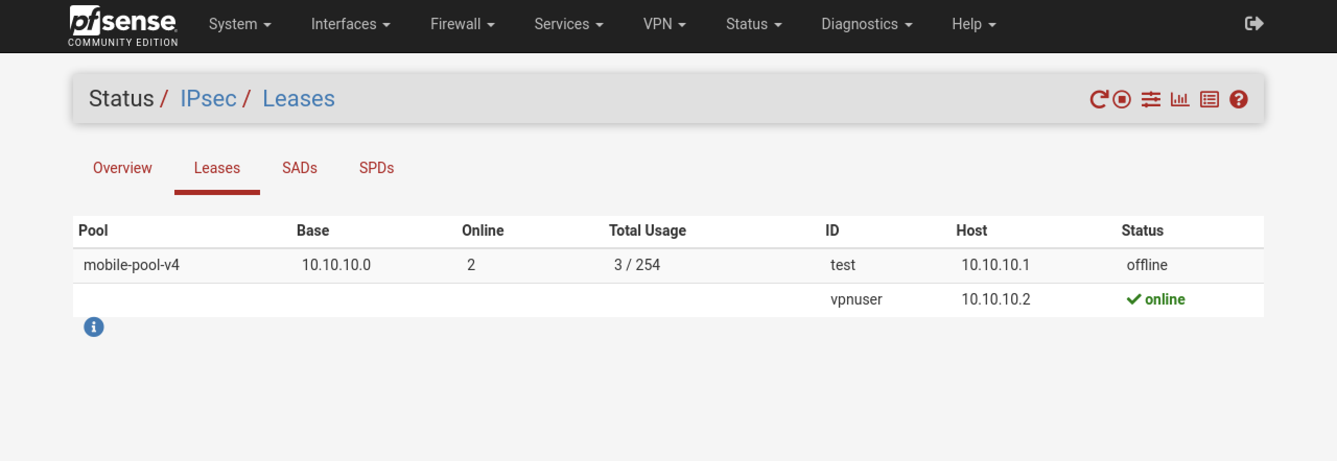

]

References:

Configuring IPsec IKEv2 Remote Access VPN Clients on Windows
https://docs.netgate.com/pfsense/en/latest/recipes/ipsec-mobile-ikev2-client-windows.html
IPsec Remote Access VPN Example Using IKEv2 with EAP-MSCHAPv2
https://docs.netgate.com/pfsense/en/latest/recipes/ipsec-mobile-ikev2-eap-mschapv2.html

