Basic Networking configuration and securing local and remote access.

Table of Contents
Task 1: Basic sw1 Configuration: 1
Task 2 : Basic R1 Configuration 5
Task 3: Basic SW2 Configuration: 6
Task 4 : Configure PC1 and test connectivity between PC0 and PC1 6

`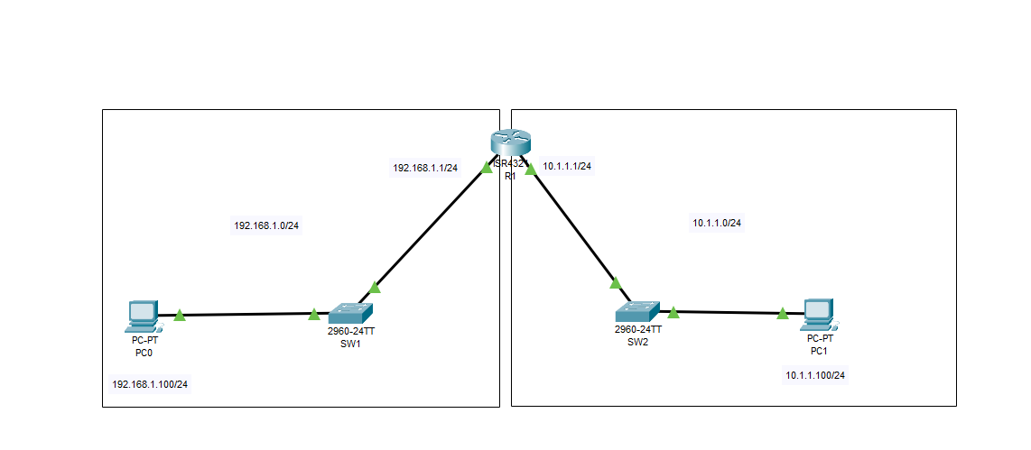

Goal for the Lab:
- Implement initial switch and router configuration based on specification.
- Secure local access (console lines, AUX).
- Secure remote access to all devices (VTY Lines).

Device Name | Port | IPV4 | Gateway
PC0 | Fa0 | 192.168.1.100/24 | 192.168.1.1/24
PC1 | Fa0 | 10.1.1.100/24 | 10.1.1.1/24
SW1 | Fa0/1 | N/A | N/A
 | Fa0/2 | N/A | N/A
 | VlAN1 | 192.168.1.200/24 | 192.168.1.1/24
SW2 | Fa0/1 | N/A | N/A
 | Fa0/2 | N/A | N/A
 | VlAN1 | 10.1.1.200/24 | 10.1.1.1/24
R1 | Gig0/0/0 | 192.168.1.1/24 | N/A
 | Gig0/0/1 | 10.1.1.1/24 | N/A

Task 1: Basic sw1 Configuration:

- Connect to Console port.
- Enter Priv Exec Mode.

enable

- Enter configuration mode.

configure terminal

- Set up hostname

hostname sw1

- Secure Priv Exec access

enable secret ciscoen

- Assign VLAN 1 IP

int vlan 1
ip add 192.168.1.200 255.255.255.0
no shut

- Check ip configuration:

do show ip interfaces brief

You should see same output as in screenshot.

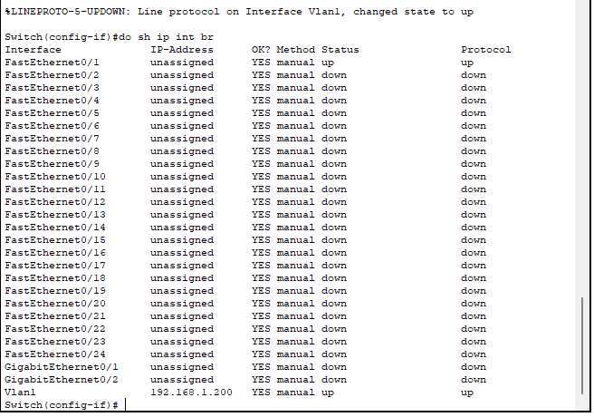

- Configure PC0 as per specifications and ping SW1 VLAN 1 interface IP

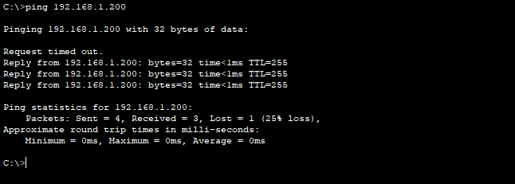
- Disable DNS domain lookup.
no ip domain-lookup

- Enable service encryption that will encrypt all plain text passwords

service password-encryption

- Configure SSH server

- Configure Domain name

ip domain-name sw1.local

- Generate RSA keys

crypto key generate rsa general-keys modulus 2048

- Set up SSH to V2

ip ssh version 2

- Configure inactivity timer to 180 seconds

ip ssh time-out 180

- Configure maximum unsuccessful login attempts to 2.

ip ssh authentication-retries 2

- Create Local username and password - privilege 15 is CISCO way to assign user to admin group.

username student privilege 15 password cisco

- Configure Console line to use local database for authentication:

line con 0
login local

- Configure VTY lines to use local database for authentication and enforce ssh only to be used.

line vty 0 15
login local
transport input ssh

- Test Console lines

Exit until you reach login screen
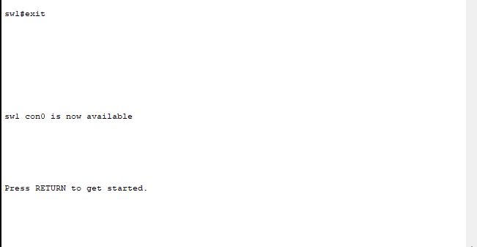

If all is configured correctly you should see prompt for username and password.

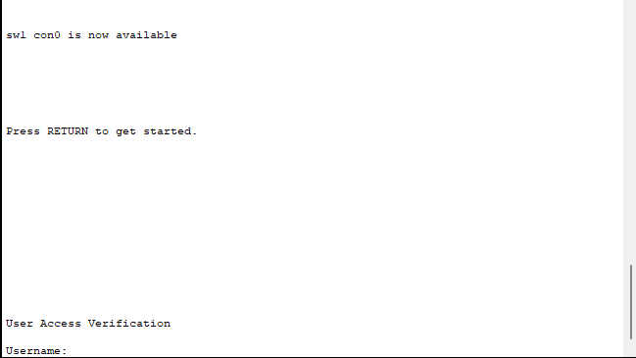

- Connect from PC0 using ssh

ssh -l student 192.168.1.200

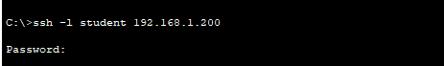

- Configure sw1 default gateway
ip default-gateway 192.168.1.1
- Save configuration:

copy running-config startup-config

Task 2 : Basic R1 Configuration

- Set Hostname to R1
- Secure Priv Exec access - enable secret ciscoen
- Disable dns domain lookup
- Enable service encryption that will encrypt all plain text passwords
- Configure SSH server
- Configure Domain name - r1.local
- Generate RSA keys – length 2048
- Set up SSH to V2
- Configure inactivity timer to 180 seconds
- Configure maximum unsuccessful login attempts to 2
- Create Local username and password - username student privilege 15 password cisco
- Assign interface Gig0/0/0 IP to 192.168.1.1/24
- Assign interface Gig0/0/0 IP to 10.1.1.1/24
- Check Interface status:
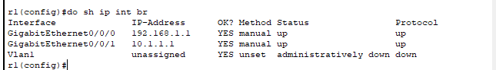
- Configure Console line to use local database for authentication:
- Configure VTY lines to use local database for authentication – enable ssh access only
- In Configuration mode limit number of unsuccessful attempts
Note additional options.
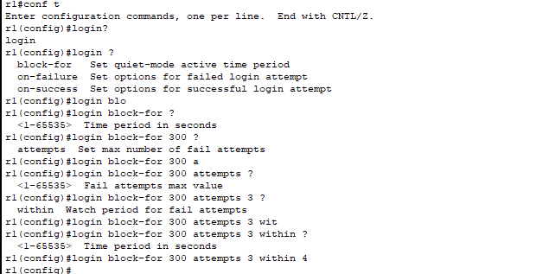
login block-for 300 attempts 3 within 4
this command will block user for 300 seconds if there has been 3 unsuccessful login attempt within 4 seconds

- Test Connectivity from PC0
- Save configuration:

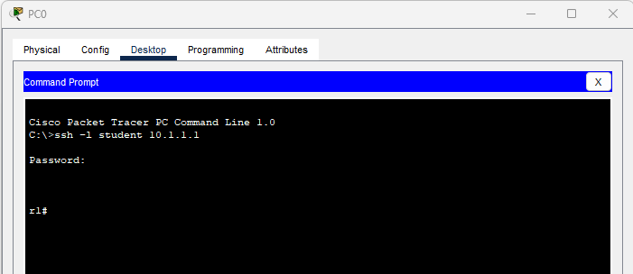

Task 3: Basic SW2 Configuration:
1) Set Hostname to sw2
2) Secure Priv Exec access - enable secret ciscoen
3) Disable dns domain lookup
4) Enable service encryption that will encrypt all plain text passwords
5) Configure SSH server
6) Configure Domain name - r1.local
7) Generate RSA keys – length 2048
8) Set up SSH to V2
9) Configure inactivity timer to 180 seconds
10) Configure maximum unsuccessful login attempts to 2
11) Create Local username and password - username student privilege 15 password cisco
12) Assign VLAN 1 IP - 10.1.1.200/24
13) Configure default gateway - 10.1.1.200

Task 4: Configure PC1 and test connectivity between PC0 and PC1
- SSH from PC1 to sw1
- SSH from PC1 to r1
- SSH from PC1 to sw2

Troubleshooting commands:

Connectivity:
ping 10.1.1.1
traceroute 10.1.1.1
telnet 10.1.1.1
show interface g0/0/0
show ip interface g0/0/0
show ip interface brief
SSH:
show ip ssh - verify the optional SSH command settings.
show ssh - verify the status of the client connections.

