## Examining SSL Certificate

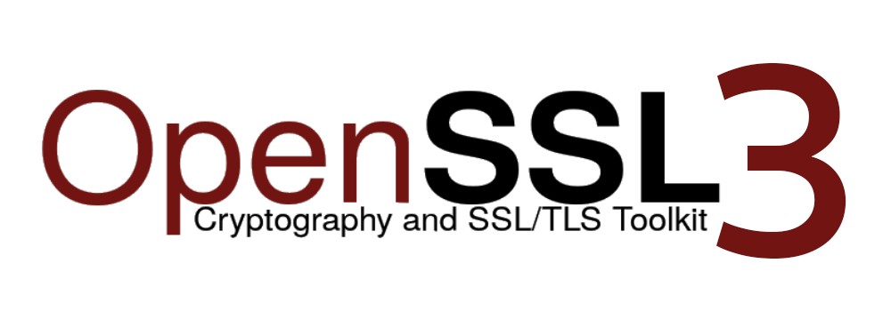

Examining SSL Certificate 1

Checking certificate validity 3

Checking certificate expiry date 3

Checking certificate extensions 3

Checking deprecated TLS ciphers or versions 3

Inspecting google.com certificate included with Mozilla. 3

Inspecting online www.google.com certificate using Firefox 5

Download PEM compare content with locally stored certificate 9

Challange: 10

Bonus challenge: 10

### Checking certificate validity

Let’s examine google.com certificate validity

***openssl s_client -connect google.com:443 –brief***

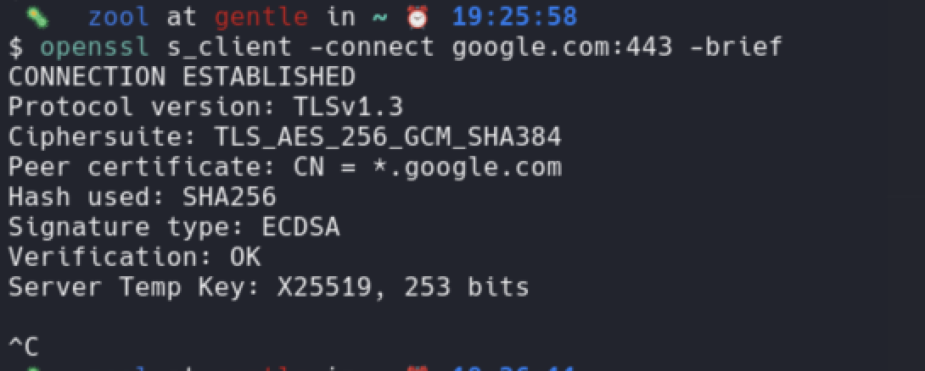

Analyze output:

What hashing algorithm is used?

### Checking certificate expiry date

***echo | openssl s_client -connect google.com:443 2>/dev/null | openssl x509 -noout -dates***

### Checking certificate extensions

***echo | openssl s_client -connect google.com:443 2>/dev/null | openssl x509 -noout -ext subjectAltName***

### Checking deprecated TLS ciphers or versions

***openssl ciphers -s -tls1_3***

### Inspecting google.com certificate included with Mozilla.

Let's examine one of certificates that are included with mozilla system.

***openssl x509 -text -noout -in /usr/share/ca-certificates/mozilla/GTS_Root_R1.crt***

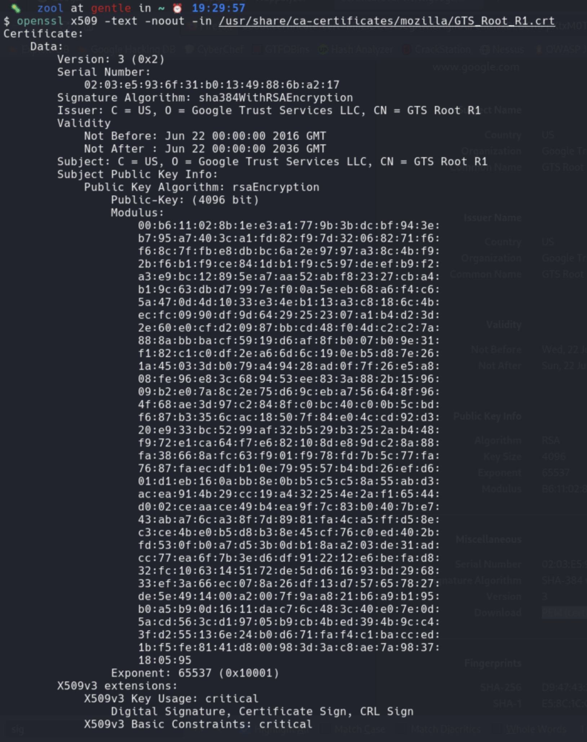

Examine content of:

/usr/share/ca-certificates/mozilla/

### Inspecting online www.google.com certificate using Firefox

Open Firefox and navigate to [www.google.com](http://www.google)

Click on padlock and follows screenshots.

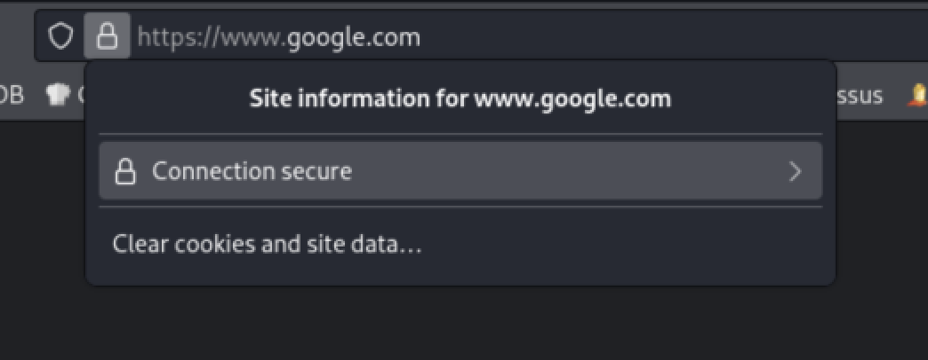

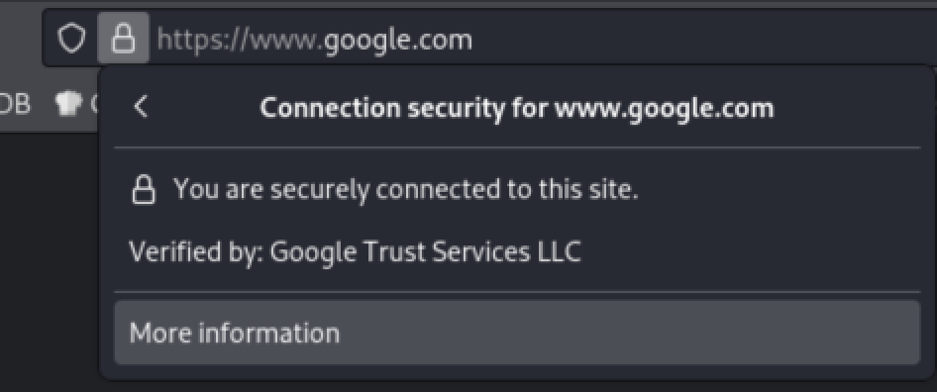

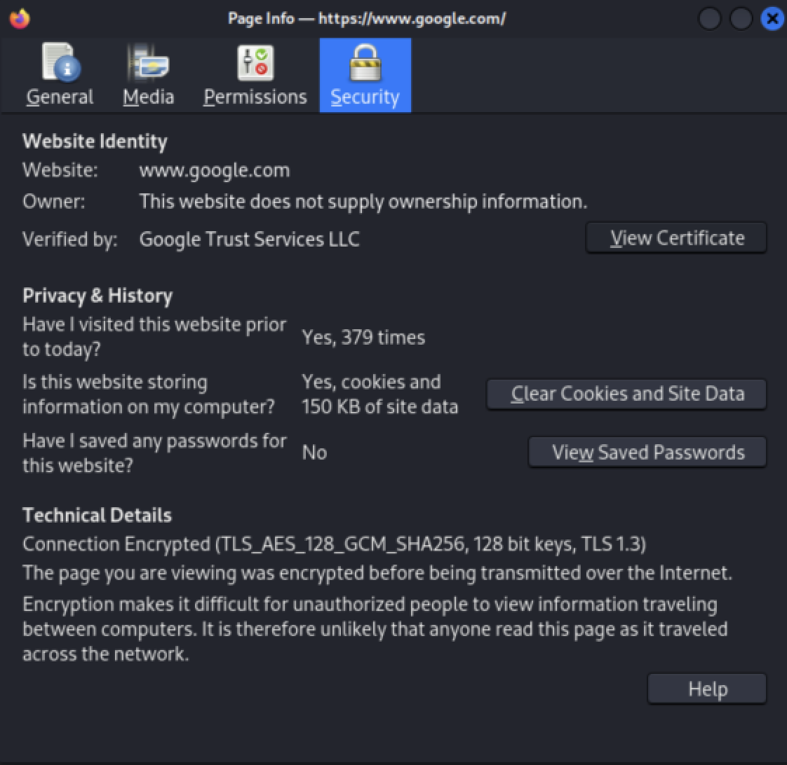

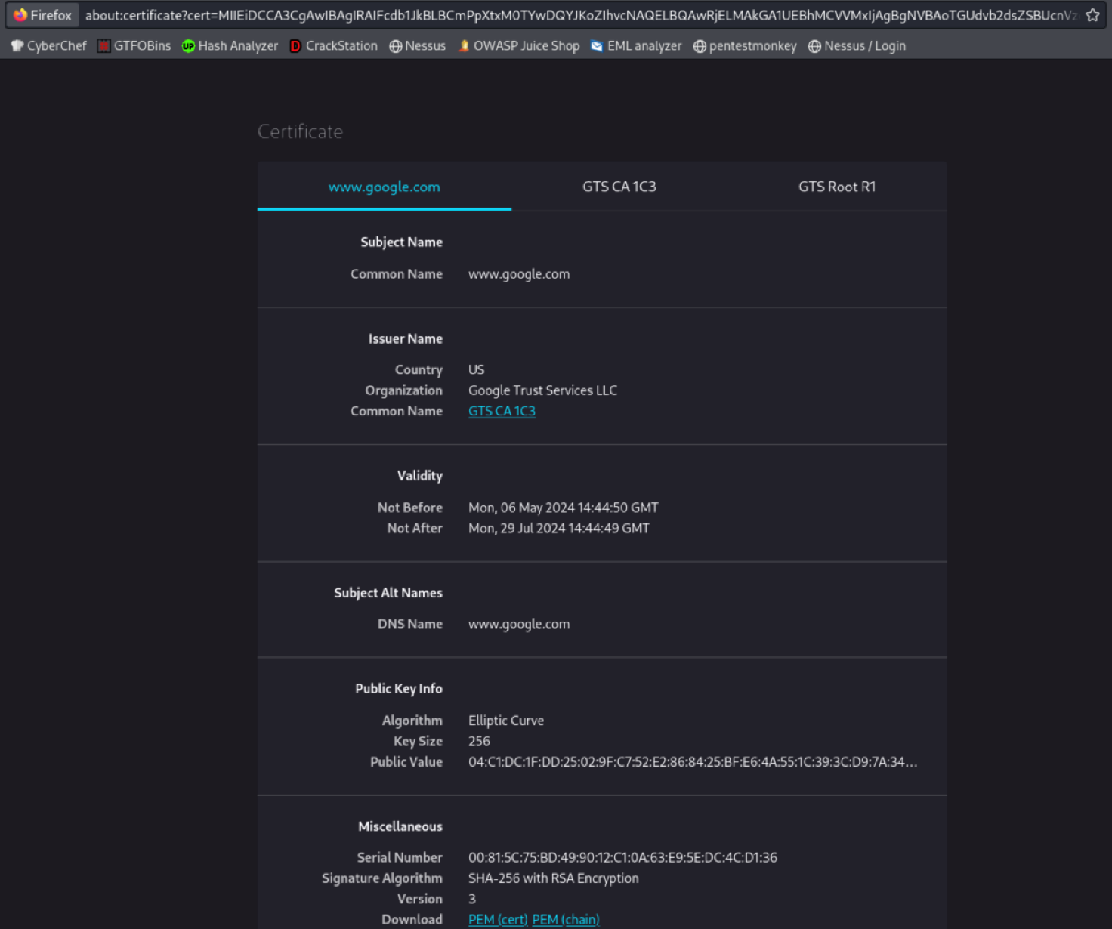

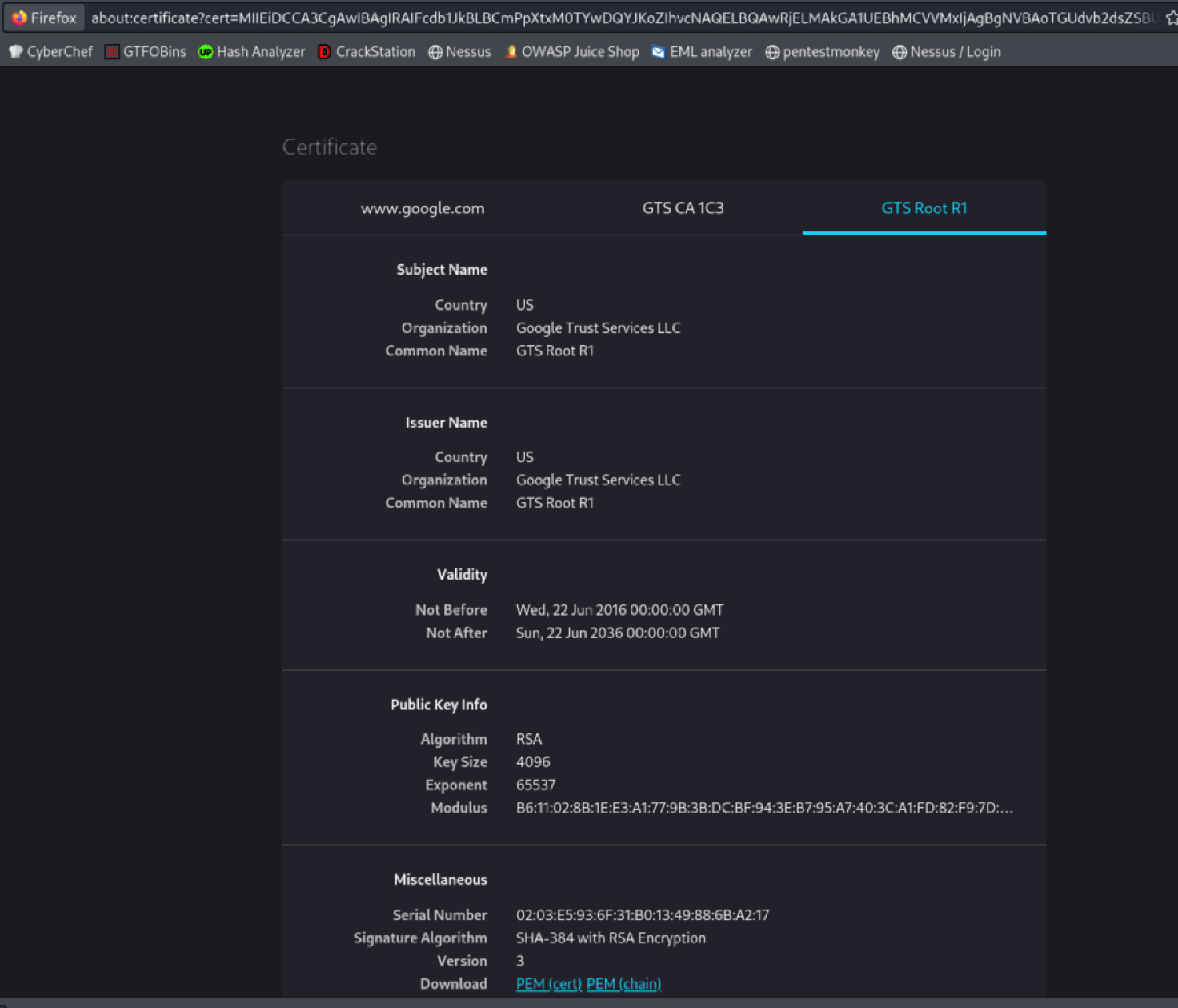

Download PEM

Compare Serial Number and other fields between locally stored and online certificate

Click on

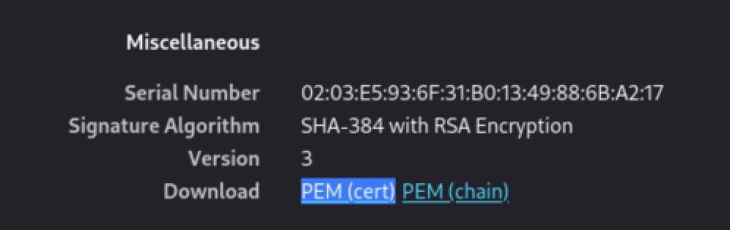

### Download PEM compare content with locally stored certificate

PEM:

“Privacy-Enhanced Mail (PEM) is a de facto file format for storing and sending cryptographic keys, certificates, and other data, based on a set of 1993 IETF standards defining "privacy-enhanced mail." While the original standards were never broadly adopted and were supplanted by PGP and S/MIME, the textual encoding they defined became very popular. The PEM format was eventually formalized by the IETF in RFC 7468.[1]”

Reference: <https://en.wikipedia.org/wiki/Privacy-Enhanced_Mail>

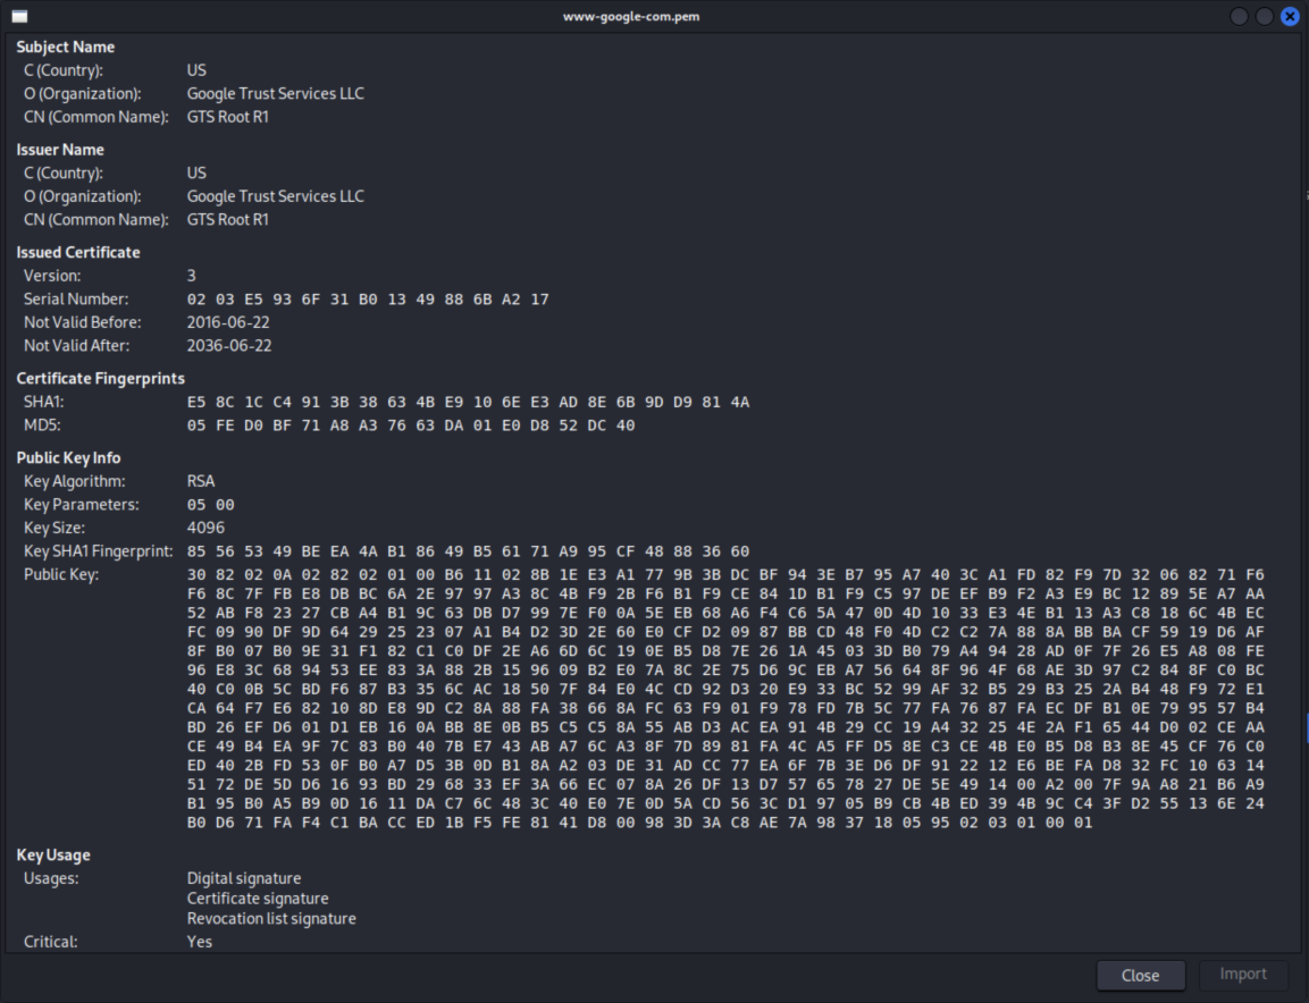

### Challange:

Using cli tools of your choice crate file named crt_list.txt on your desktop.

### Bonus challenge:

Command needs to be one liner.