## Telnet vs SSH

## Installing telnet server:

### Configure Telnet Server

On Debian:

Sudo apt update && sudo apt upgrade -y && sudo apt install telnetd

Edit inet.conf file:

/etc/inetd.conf

Uncomment telnet section

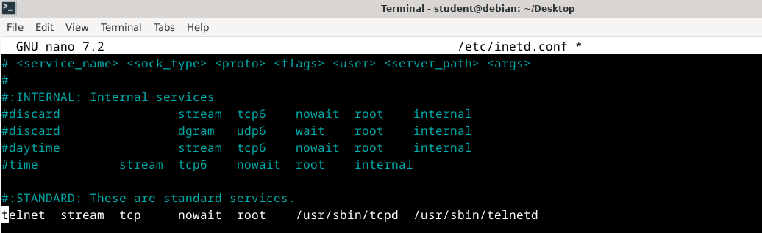

Restart inetd

sudo /etc/init.d/inetutils-inetd restart

#### Install WIreshark On Debian:

Sudo apt install telnet

Start wireshark:

#### Starting Wireshark capture on **KALI:**

sudo wireshark &

select appropriate adapter and start capture:

#### Starting Wireshark capture on **Debian:**

Repeat same steps:

**Connect to Debian Telnet Server from Kali:**

 telnet <ip of server>

**Execute few commands:**

**ls –la**

**ps auxw**

**Follow TCP stream**

### SSH communication:

Start ssh server

Start capture

Connect and do some commands

Stop capture

Follow TCP stream

 Compare outputs of both captures.

 Challenge:

1. Bridge your Kali
2. On switch:
3. Configure ssh server
4. Under line vty:

password ciscovty

login

login local

WORK in progress 😊