# VMware Networking

Table of Contents

VMware Networking 1

VMware VMnet Configuration: Step-by-Step Instructions 1

## VMware VMnet Configuration: Step-by-Step Instructions

VMware Workstation Pro includes three default virtual network adapters:

Vmnet0 – Default bridged network

Vmnet1 – Default host-only network

Vmnet8 – Default NAT network

To create additional networks for your virtual machines, follow these steps:

**Step 1:** Open the Virtual Network Editor via the Edit menu at the top left of VMware Workstation Pro.

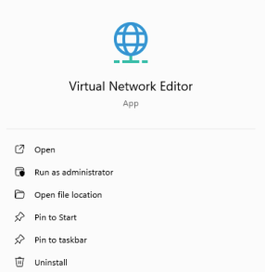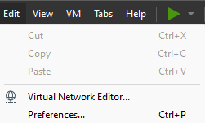

**Step 2:** Click "Change Settings." This will require local administrator privileges.  
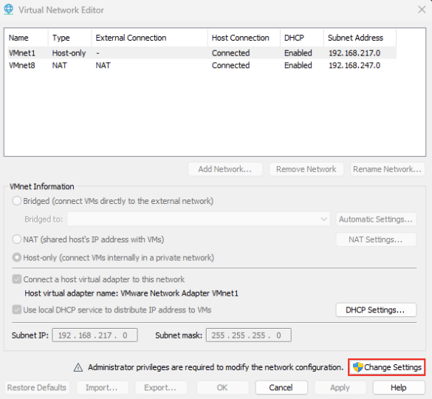

**Step 3:** Click "Add Network" to create additional VMnet configurations.

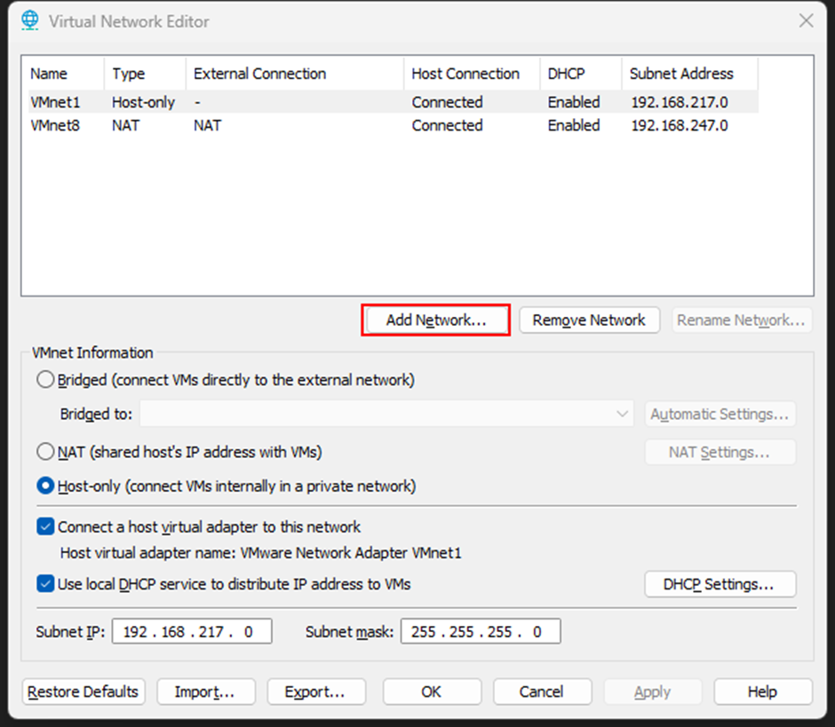

**Step 4:** Create four additional VMnets in this order: VMnet2, VMnet3, VMnet4, VMnet5. Set each to "Host-only" and uncheck "Connect a host virtual adapter" and "Use local DHCP service."

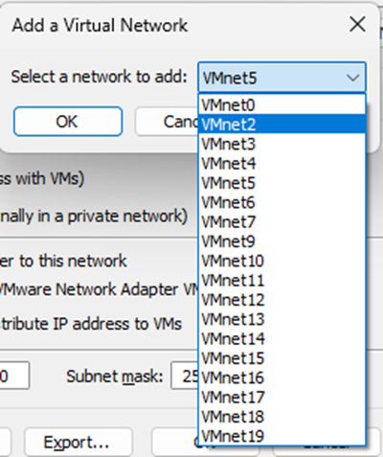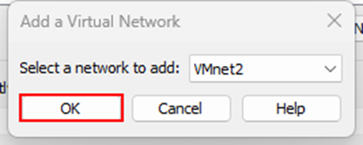

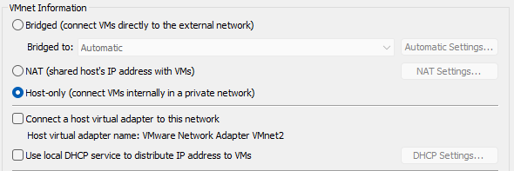

**Step 5:** Name the adapters as follows:

1. VMnet2: BLUE
2. VMnet3: RED
3. VMnet4: DMZ
4. VMnet5: LAN

**Step 6:** Click on Apply Button to apply changes.



Your completed Virtual Network Editor configuration should look like this.

